**Syrian Arab Republic**

**Syrian Private University**

**Faculty of Engineering**

**Department of Software &**

**Information Systems Engineering.**

**Event Management and Organization**

**Event management and organization**

Project(senior-2)- Completed the requirements for obtaining a bachelor's degree in Informatics Engineering - Software Engineering and Information Systems

**Prepared by**:

Mohammed Bakr Safi Ibrahim Ahmed Al-Ali

**Supervised by**:

Eng. Maher Sarem

2026/1

**Abstract**

An electronic system for organizing various events and activities, providing an easy-to-use and customizable online platform for users. This system aims to facilitate the process of finding the appropriate venue for parties, weddings, and various occasions, as well as finding service providers specialized in organizing and coordinating them.

Current systems suffer from several aspects that need improvement. These include difficulties in connecting clients with event management and organization providers efficiently, providing accurate information to customers, and failing to meet user needs. Furthermore, existing platforms lack the ability to allow users to select the services they desire or request services from multiple locations. This project offers a comprehensive solution to address these challenges and achieve the desired goals.

This project aims to improve the user experience when booking venues for various events and facilitate access to the various services user's desire. It also seeks to improve the efficiency of offerings and increase competition, allowing users to access a wide range of offers that suit their needs and financial capabilities. The project also provides a platform for service providers and venue owners to showcase their services and publications, enabling them to reach a wider segment of users and increase their chances of acquiring customers.

This project aims to facilitate quick and easy booking of event venues and provide a variety of services to meet users' needs. The project includes various tools that facilitate communication between users, service providers, and venue owners. Additionally, users participate in the process of managing and organizing events to meet their needs and can express their opinions and share their ratings of the venues and services they engage with.

**Table of Contents**

**LIST OF TABLES……………………………………………………………………………………………………………… VII**

**LIST OF FIGURES………………….……………………………………………………………………..………………… VIII**

**LIST OF ABBREVIATIONS……………………………………………………………………………….………………… IX**

**Chapter One - Introduction**

**1. Introduction.............................................................................................................. 5**

**2. The problem ............................................................................................................. 6**

**3. goal of the project..................................................................................................... 7**

**4. The proposed system................................................................................................ 9**

**5. Organizing the report...............................................................................................10**

**6. Conclusion ...............................................................................................................11**

**Chapter Two - Basic Concepts and Reference Study**

**1. Introduction ........................................................................................................... 13**

**2. Basic Concepts …………………………………..................................................................... 14**

**3. Reference Study ..................................................................................................... 15**

**4. Importance of the project ....................................................................................... 18**

**5. The proposed system .............................................................................................. 19**

**6. Conclusion .............................................................................................................. 21**

**Chapter Three - Analytical Study of the Proposed System**

**1. Introduction ........................................................................................................... 23**

**2. Project Charter.......................................................................................................... 23**

**3. Statement of Work (SOW).......................................................................................... 25**

**4. Project Plan - Gantt Char............................................................................................ 29**

**5. Risk Management.................................................................................................... 33**

**6. Version Control and Configuration Management............................................................47**

**7. Conclusion................................................................................................................ 64**

**Chapter Four - Analytical Study of the Proposed System**

**1. Introduction ................................................................................................................ 23**

**2. Feasibility study........................................................................................................... 23**

**3. System Requirements Specification (SRS).................................................................... 25**

**4. Requirements Modeling.............................................................................................. 29**

**5. Unit Testing................................................................................................................. 33**

**6. Requirements Traceability Matrix.................................................................................47**

**7. System Architecture.................................................................................................... 64**

**8. Conclusion..................................................................................................................**

**Chapter Five - System Design Study**

**1. Introduction ..............................................................................................................…89**

**2. Design Models (Logical Level)………………………………………………..……………………………………90**

**3. Design Models (Physical Level)……………………………………………………..…………………………….91**

**4. Diagrams ……………………………………………………………………………………………….…………………..92**

**5. Algorithms Used ………………………………………………………………………………………………………..93**

**6. Updated Unit Testing ……………………………………………………………………………….………………..93**

**7. Updated Requirements Traceability Matrix ………………………………………………….…………….93**

**8. Conclusion …………………………………………………………………………………….…………………………..93**

**Chapter Six - Practical Application**

**1. Introduction ........................................................................................................... 96**

**2. Tools used .............................................................................................................. 96**

**3. Miniature Models .................................................................................................. 98**

**4. Test Execution........................................................................................................100**

**5. Updating the Requirements Traceability Matrix……………………………………………………101**

**6. Results Analysis……………………………………………………………………………………………………111**

**7. Conclusion……………………………………………………………………………………………………………112**

**Chapter Seven - Conclusions and Future Prospects**

**1. Introduction ......................................................................................................... 106**

**2. Conclusions .......................................................................................................... 106**

**3. Future Prospects ................................................................................................... 107**

**4. The reviewer......................................................................................................... 108**

**LIST OF TABLES**

Table 2.1 Comparative table of the reference study……………………………………………………………

Table 3.1 Modified Requirements………………………………………………………………………………………

Table 3.2 Milestones…………………………………………………………………………………………………………

Table 3.3 Risk Register……………………………………………………………………………………………………….

Table 4.1 Recommendation & immediate next steps…………………………………………………………..

Table 4.2 Scenario Comparison……………………………………………………………………………………………

Table 4.4 login description……………………………………………………………………………….

Table 4.5 register (User Registration) description

Table 4.6 Register Logout description

Table 4.7 view venues description

Table 4.8 view venues details description

Table 4.9 view bookings description

Table 4.10 add booking description

Table 4.11 edit booking description

Table 4.12 delete booking description

Table 4.13 view events description

Table 4.14 view events details description

Table 4.15 unified search for venues description

Table 4.16 unified search for events description

Table 4.18 filter venues by specific criteria description

Table 4.18 filter events by specific criteria description

Table 4.19 view registration description

Table 4.20 add registration description

Table 4.21 edit registration description

Table 4.22 delete registration description

Table 4.23 view venue ratings description

Table 4.24 add venue rating description

Table 4.25 edit venue rating description

Table 4.26 delete venue rating description

Table 4.27 view event ratings description

Table 4.28 add event rating description

Table 4.29 edit event rating description

Table 4.30 delete event rating description

Table 4.31 view organizers description

Table 4.32 view providers description

Table 4.34 filter providers by specific criteria description

Table 4.33 filter Organizers by specific criteria description

Table 4.35 upvote description

Table 4.36 downvote description

Table 4.37 view recent activities description

Table 4.38 display map of event and venue locations description

Table 4.39 browse venues (provider) description

Table 4.40 brows archived venues description

Table 4.41 add venue description.

Table 4.42 edit venue description

Table 4.43 delete venue description

Table 4.44 archive venue description

Table 4.45 unarchive venue description

Table 4.47 accept booking description

Table 4.48 reject booking description

Table 4.49 cancel booking description

Table 4.50 browse events (organizer) description

Table 4.51 browse archived events description

Table 4.52 create event description

Table 4.53 edit event description

Table 4.54 delete event description

Table 4.55 archive event description

Table 4.56 unarchive event description

Table 4.57 browse registrations description

Table 4.58 accept registration description

Table 4.59 reject registration description

Table 4.60 cancel registration description

Table 4.61 explore registration as excel file description

Table 4.62 view booking (organizer) description

Table 4.63 add booking (organizer) description

Table 4.64 edit booking (organizer) description

Table 4.65 delete booking (organizer) description

**LIST OF FIGURES**

**Figure 4.4 login activity diagram  
Figure 4.5 register (User Registration) activity diagram  
Figure 4.6 Register Logout activity diagram  
Figure 4.7 view venues activity diagram  
Figure 4.8 view venues details activity diagram  
Figure 4.9 view bookings activity diagram  
Figure 4.10 add booking activity diagram  
Figure 4.11 edit booking activity diagram  
Figure 4.12 delete booking activity diagram  
Figure 4.13 view events activity diagram  
Figure 4.14 view events details activity diagram  
Figure 4.15 unified search for venues activity diagram  
Figure 4.16 unified search for events activity diagram  
Figure 4.17 filter venues by specific criteria activity diagram  
Figure 4.18 filter events by specific criteria activity diagram  
Figure 4.19 view registration activity diagram  
Figure 4.20 add registration activity diagram  
Figure 4.21 edit registration activity diagram  
Figure 4.22 delete registration activity diagram  
Figure 4.23 view venue ratings activity diagram  
Figure 4.24 add venue rating activity diagram  
Figure 4.25 edit venue rating activity diagram  
Figure 4.26 delete venue rating activity diagram  
Figure 4.27 view event ratings activity diagram  
Figure 4.28 add event rating activity diagram  
Figure 4.29 edit event rating activity diagram  
Figure 4.30 delete event rating activity diagram  
Figure 4.31 view organizers activity diagram  
Figure 4.32 view providers activity diagram  
Figure 4.33 filter providers by specific criteria activity diagram  
Figure 4.33 filter organizers by specific criteria activity diagram  
Figure 4.35 upvote activity diagram  
Figure 4.36 downvote activity diagram  
Figure 4.37 view recent activities activity diagram  
Figure 4.38 display map of event and venue locations activity diagram  
Figure 4.39 browse venues (provider) activity diagram  
Figure 4.40 brows archived venues activity diagram  
Figure 4.41 add venue activity diagram  
Figure 4.42 edit venue activity diagram  
Figure 4.43 delete venue activity diagram  
Figure 4.44 archive venue activity diagram  
Figure 4.45 unarchive venue activity diagram  
Figure 4.46 browse bookings activity diagram  
Figure 4.47 accept booking activity diagram  
Figure 4.48 reject booking activity diagram  
Figure 4.49 cancel booking activity diagram  
Figure 4.50 browse events (organizer) activity diagram  
Figure 4.51 browse archived events activity diagram  
Figure 4.52 create event activity diagram  
Figure 4.53 edit event activity diagram  
Figure 4.54 delete event activity diagram  
Figure 4.55 archive event activity diagram  
Figure 4.56 unarchive event activity diagram  
Figure 4.57 browse registrations activity diagram  
Figure 4.58 accept registration activity diagram  
Figure 4.59 reject registration activity diagram  
Figure 4.60 cancel registration activity diagram  
Figure 4.61 explore registration as excel file activity diagram  
Figure 4.62 view booking (organizer) activity diagram  
Figure 4.63 add booking (organizer) activity diagram  
Figure 4.64 edit booking (organizer) activity diagram  
Figure 4.65 delete booking (organizer) activity diagram**

**Figure 4.4 login sequence diagram**

**Figure 4.5 register (User Registration) sequence diagram**

**Figure 4.6 Register Logout sequence diagram**

**Figure 4.7 view venues sequence diagram**

**Figure 4.8 view venues details sequence diagram**

**Figure 4.9 view bookings sequence diagram**

**Figure 4.10 add booking sequence diagram**

**Figure 4.11 edit booking sequence diagram**

**Figure 4.12 delete booking sequence diagram**

**Figure 4.13 view events sequence diagram**

**Figure 4.14 view events details sequence diagram**

**Figure 4.15 unified search for venues sequence diagram**

**Figure 4.16 unified search for events sequence diagram**

**Fi****gure 4.17 filter venues by specific criteria sequence diagram**

**Figure 4.18 filter events by specific criteria sequence diagram**

**Figure 4.19 view registration sequence diagram**

**Figure 4.20 add registration sequence diagram**

**Figure 4.21 edit registration sequence diagram**

**Figure 4.22 delete registration sequence diagram**

**Figure 4.23 view venue ratings sequence diagram**

**Figure 4.24 add venue rating sequence diagram**

**Figure 4.25 edit venue rating sequence diagram**

**Figure 4.26 delete venue rating sequence diagram**

**Figure 4.27 view event ratings sequence diagram**

**Figure 4.28 add event rating sequence diagram**

**Figure 4.29 edit event rating sequence diagram**

**Figure 4.30 delete event rating sequence diagram**

**Figure 4.31 view organizers sequence diagram**

**Figure 4.32 view providers sequence diagram**

**Figure 4.33 filter providers by specific criteria sequence diagram**

**Figure 4.33 filter organizers by specific criteria sequence diagram**

**Figure 4.35 upvote sequence diagram**

**Figure 4.36 downvote sequence diagram**

**Figure 4.37 view recent activities sequence diagram**

**Figure 4.38 display map of event and venue locations sequence diagram**

**Figure 4.39 browse venues (provider) sequence diagram**

**Figure 4.40 brows archived venues sequence diagram**

**Figure 4.41 add venue sequence diagram.**

**Figure 4.42 edit venue sequence diagram**

**Figure 4.43 delete venue sequence diagram**

**Figure 4.44 archive venue sequence diagram**

**Figure 4.45 unarchive venue sequence diagram**

**Figure 4.46 browse bookings sequence diagram**

**Figure 4.47 accept booking sequence diagram**

**Figure 4.48 reject booking sequence diagram**

**Figure 4.49 cancel booking sequence diagram**

**Figure 4.50 browse events (organizer) sequence diagram**

**Figure 4.51 browse archived events sequence diagram**

**Figure 4.52 create event sequence diagram**

**Figure 4.53 edit event sequence diagram**

**Figure 4.54 delete event sequence diagram**

**Figure 4.55 archive event sequence diagram**

**Figure 4.56 unarchive event sequence diagram**

**Figure 4.57 browse registrations sequence diagram**

**Figure 4.58 accept registration sequence diagram**

**Figure 4.59 reject registration sequence diagram**

**Figure 4.60 cancel registration sequence diagram**

**Figure 4.61 explore registration as excel file sequence diagram**

**Figure 4.62 view booking (organizer) sequence diagram**

**Figure 4.63 add booking (organizer) sequence diagram**

**Figure 4.64 edit booking (organizer) sequence diagram**

**Figure 4.65 delete booking (organizer) sequence diagram**

**LIST OF ABBREVIATIONS**

|  |  |
| --- | --- |
| **Abbreviation** | **Definition** |
| UI | User Interface |
| UX | User Experience |
| API | Application Programming Interface |
| DB | Database |
| CRUD | Create Read Update Delete |
| RSVP | Répondez s'il vous plaît (event response) |
| CSV | Comma Separated Values |
| XLSX | Microsoft Excel Open XML Spreadsheet |
| JWT | JSON Web Token |
| SSO | Single Sign‑On |
| OAuth | Open Authorization (authorization framework) |
| SSL | Secure Sockets Layer |
| TLS | Transport Layer Security |
| KPI | Key Performance Indicator |
| SLA | Service Level Agreement |
| QA | Quality Assurance |
| UAT | User Acceptance Testing |
| CI/CD | Continuous Integration / Continuous Deployment |
| REST | Representational State Transfer |
| JSON | JavaScript Object Notation |
| HTML | Hypertext Markup Language |
| CSS | Cascading Style Sheets |
| SQL | Structured Query Language |
| CDN | Content Delivery Network |
| GDPR | General Data Protection Regulation |

**Chapter One**

**introduction**

**1.introduction**

In recent years, the event and activity organization industry has witnessed a radical shift toward relying on technology and online platforms. Given the importance of this sector and its growing demand, the idea of ​​providing an electronic system that helps facilitate event organization has begun to attract attention. Through this project, the company aims to provide an online platform that provides an effective and convenient user experience for users to organize events with ease and convenience.

In this project, the company focuses on providing reliable services to meet users' needs when organizing various events and occasions. The electronic system is an effective solution to many of the challenges that directs it users in this field face challenges such as finding a venue that fits their needs and budget, dealing with multiple service providers and waiting for responses, and determining the exact dates and details of events.

Through this project, the company aims to provide a convenient and efficient experience for users, helping them organize their events with ease and convenience, in addition to providing various services that help them find the right solutions to meet their needs. With the increasing reliance on technology in all aspects of life.

**2.The problem**

An event management platform addresses many of the problems and challenges faced by individuals and organizations when planning events. When organizing an event, whether it's a wedding, conference, or business meeting, there are many details that need to be coordinated. It can be difficult to keep track of all the necessary elements and ensure they run smoothly. The platform provides a central interface to manage all aspects of the event from one place, reducing complexity and minimizing errors.

Additionally, planners must communicate with a variety of vendors and suppliers, such as caterers, set designers, and sound and lighting teams. The online platform provides an internal communication system through which messages and notes can be exchanged effectively, ensuring everyone is on the same page.

Budget management can be one of the most challenging aspects of event planning. The platform provides tools for tracking expenses, setting budgets, and comparing offers from different vendors, helping users stay within their budget and avoid unexpected expenses.

Every occasion has its own unique character and specific requirements. The platform provides a comprehensive database of suppliers and services, along with ratings and reviews from previous users, making it easy for users to choose the best one that best suits their needs.

Managing invitations and attendees is another thing that can become cumbersome. The platform enables users to send electronic invitations, track responses, and manage the attendee list with ease. It is also possible to send Souvenirs and alerts to attendees to ensure actual attendance at the event.

After the event concludes, it's important to evaluate whether the goals were achieved and what can be improved in the future. The platform provides tools for analysis and data collection, helping provide a comprehensive assessment of the event's success and suggestions for future improvement.

Finally, the platform seeks to enhance the user experience when organizing events, through an easy-to-use interface that facilitates navigation between various options and the customization of its services in a simple and efficient manner. In this way, the platform contributes to making the event planning process easier and more efficient, ensuring greater success and providing an enjoyable and stress-free experience for users.

**3.the goal**

The goal of an event management platform is to provide a comprehensive and integrated solution to facilitate the process of organizing events efficiently and effectively. Organizing events is often a complex and stressful process that requires coordination between multiple parties, managing budgets, and paying attention to both small and large details. Hence, the need for a specialized platform that contributes to facilitating this process.

The platform aims to provide a central interface that enables users to manage all aspects of an event from one place. Users can easily plan events with advanced tools that allow them to track every element of the event, from venue selection and guest list creation to coordination with vendors and suppliers such as caterers, interior designers, and sound and lighting teams. All of this helps reduce complexity and increase efficiency.

One of the main challenges in organizing events is budget management. The platform provides accurate tools for tracking expenses, setting budgets, and comparing offers from different vendors, helping users control costs and stay within budget. The platform also helps avoid unexpected expenses by providing detailed financial reports and analyses.

Additionally, the platform aims to improve communication and coordination among all stakeholders. It provides an internal communication system through which messages and feedback can be exchanged effectively, ensuring everyone is on the same page and reducing the chances of errors or misunderstandings.

The platform also focuses on providing a personalized and unique experience for every occasion. Through a comprehensive database of suppliers and services, users can choose the most appropriate and suitable for their specific needs, while leveraging the ratings and reviews of previous users to ensure quality service.

The invitation and attendance management are another element the platform seeks to improve. By sending electronic invitations, tracking responses, and easily managing the attendee list, users can ensure that all invitees are informed of event details and receive reminders to ensure physical attendance.

Finally, the platform aims to provide advanced analytical tools to measure event success and offer suggestions for future improvement. By collecting and analyzing data, users can assess whether goals were achieved and what can be improved upon in future events, contributing to greater success and a more enjoyable and stress-free experience for users.

**4.Proposed system**

This report provides a comprehensive overview of an integrated electronic system designed to efficiently and professionally manage and organize events. The system aims to simplify the planning and organizing process by offering advanced tools and features that help users coordinate all aspects of the event with ease. Whether planning large events such as weddings and conferences or special occasions, the system provides a centralized solution that includes budget management, coordination with suppliers, and sending electronic invitations. By offering an enhanced user experience and analytical tools to measure success, the system contributes to greater efficiency and smoothness in event organization, ensuring that goals are met and providing a pleasant, stress-free experience for users.

The integrated electronic event management system simplifies and enhances the event planning process through a central interface and advanced tools for tracking expenses, coordinating vendors, and managing invitations. The system aims to reduce complexity and increase efficiency, allowing users to organize successful, hassle-free events. Problems in addition, the system provides analytical tools to evaluate success and suggest future improvements, enhancing the user experience and ensuring the achievement of desired goals.

**5.Organizing the report**

The report consists of six chapters covering the project's work stages:

1. Chapter One: Introduction

2. Chapter Two: Basic Concepts and Reference Study

3. Chapter Three: Analytical Study of the Proposed System

4. Chapter Four: Design Study of the Proposed System

5. Chapter Five: Practical Application

6. Chapter Six: Response and Future Prospects

**6.Conclusion**

The Event Management and Organization System is an integrated electronic system that aims to facilitate and simplify the process of planning and organizing various events. The system provides advanced analytical tools for tracking expenses, evaluating event success, and suggesting future improvements. This helps achieve event goals and provides a pleasant, stress-free experience for users. Through this system, users have access to a comprehensive database of suppliers and services, complete with ratings and reviews from previous users, making it easier to choose the best fit for their specific needs.

**Chapter Two**

**Basic concepts and reference study**

**1.introduction**

This chapter addresses the basic concepts related to the event management and organization system, explaining the theoretical aspects upon which the project is based. At the beginning of this chapter, we review the basic concepts that form the foundation of this system, including the importance of good planning and organization in the success of events, and advanced event management tools and techniques that contribute to simplifying the process and achieving the best results. Additionally, this chapter includes a detailed benchmark study of a website similar to our project, called "Mnasabati" This study examines the similarities and differences between the "Mnasabati" website and the system we are developing. We evaluate the strengths and weaknesses of each project, highlighting the competitive advantages of our system. Through this benchmark study, we seek to understand the lessons learned from the "Mnasabati" website and how to apply them to better develop our system. The focus is on elements that could be improved or enhanced in our system, based on the successes and challenges faced by the "Mnasabati" website. This in-depth analysis aims to provide a comprehensive and practical vision for developing a more efficient and successful event management and organization system.

**2.Basic concepts**

1. **Event planning and organization:** Planning is setting the goals and initial details of an event, such as determining the location, time, and budget. Organization comes next, where the plan is implemented and all practical aspects of the event are coordinated to ensure it runs smoothly.
2. **Event management tools and techniques:** Software and applications used to coordinate and organize events include event planning software, tracking tools, and communication apps that help keep different teams updated with real-time details.
3. **Internal communication system and coordination between suppliers:** This system enables instant communication between event organizers and various suppliers, such as catering, décor, and sound providers. It helps quickly exchange information and resolve urgent issues efficiently.
4. **Budget Management and Expense Tracking:** This involves monitoring and recording all event-related expenses and ensuring adherence to the allocated budget. Budget management tools provide financial analysis and reports to help control costs.
5. **Service allocation and supplier evaluation:** This allows us to identify and select the most appropriate services and suppliers for the event based on specific requirements and previous user reviews. This ensures quality service and optimally meets the event's needs.
6. **Invitation and attendance management**: These tools include sending out electronic invitations, tracking responses, and registering attendees. These tools help ensure all invitees are aware of event details and remind them of the event date to ensure their attendance.
7. **Analytical tools to evaluate the success of events:** Provide analytics and data on event performance, such as attendee satisfaction and success. These tools help assess whether specific goals were met and what can be improved upon in future events
8. **Strategies to improve user experience:** Focusing on improving every aspect of the user experience during event planning, we use user-friendly interfaces, customize services based on individual needs, and ensure efficient and seamless communication between all parties. These strategies help provide a pleasant and stress-free experience for users.

**3.Reference study**

**Study my occasions application:**

1. **Application Information:**

* **Application name:** My occasions
* **Application Description: Application** To manage and implement events
* **Application Type: Mobile** (Designed to work on tablets and mobile devices)
* **Target audience:** Customers and service providers (owners of halls and event venues, people who wish to book these venues)
* **App Features/Requirements:**

1. **Feature/Requirement Analysis:**

* Browse halls and shows
* reservation
* Modify reservation
* Halls and services evaluation
* Contact the hall
* Electronic payment
* Show the hall and its services
* Additional features
* View hall prices and specifications before booking
* Choose the type of event
* Share the location of the hall with others
* Show lounge availability times
* Setting a budget

1. **User Interface Analysis:**

* User Interface Design: Easy to use and simple.
* User Interface Functions: Easy to navigate, efficient.
* User Interface Notes:
* Improvements: Redesigned user interface to be more modern.
* New ideas:
* Integrate the maps feature with the booking feature
* Allowing requests for additional services from outside the hall
* Send electronic invitations
* Allowing owners of restaurants, cafes, farms, and other venues suitable for holding events to display their locations on the website.
* Allowing logistics service providers to offer their services on the site.
* Expand the event type options to be more inclusive.
* Allow visitors to browse the site before subscribing.

1. **Performance evaluation:**

* **Application speed:** Fast, short page load time.
* **Application stability:** stable.
* **Performance Notes:**
* **Improvements:** Improve image loading speed.
* **Problem solver:** Solve the problem of limited payment methods.

1. **Strengths and weaknesses analysis:**

Table 2.1 Comparison table of the reference study

|  |  |  |  |
| --- | --- | --- | --- |
| **Attribute** | **Munasabati (مناسبتي)** | **Azzam (عزام)** | **EventApp / Eventap** |
| **Primary focus** | Digital invitations + marketplace for event services | Professional event management & ticketing | Full-featured event app for conferences and attendee engagement |
| **Core features** | Invitation templates; WhatsApp invitations; guest tracking | Event creation; ticket sales; attendance tracking; certificates | Agenda, QR check-in, live Q&A, networking, analytics |
| **Target users** | Individuals & small businesses organizing social events | Organizations, conferences, festivals, training providers | Conferences, expos, trade shows, corporate events |
| **Organizer tools** | Simple dashboard; packages for guest counts | Advanced reports; multi-attendee tracking; retargeting | Organizer backend; speaker management; sponsor tools |
| **Attendee experience** | WhatsApp-based RSVP; mobile-friendly | Ticketing + multiple attendance options | Mobile app with QR check-in, session selection, live interaction |
| **Monetization / Pricing** | Tiered packages per guest count (flexible plans) | Subscription / per-event pricing for enterprises | Custom pricing; white-label and add-ons for large events |
| **Notable strengths** | Ease of use; fast setup; strong WhatsApp integration | Robust event lifecycle features; trusted by many entities | Rich engagement features (networking, live polls, AR options) |
| **Typical use case** | Weddings, small gatherings, digital invitations | Large conferences, ticketed events, training courses | Professional conferences, expos, networking-heavy events |

1. **Customer needs:**

* Easy to book a lounge.
* Electronic payment.
* Contact the hall.
* View lounge and service prices before ordering.
* Know the location of the hall.
* Lounge and service evaluation.
* Choose the type of event.
* Choose the time and date of the reservation.

1. **Gym owners' needs:**

* Receiving reservation requests.
* Communicate with customers.
* Knowing the type of occasion.
* Knowing the time and date of the reservation and the number of attendees.
* Knowing the required services.

**4.Importance of the project**

An event management and organization system are of great importance for several reasons, related to facilitating the planning and organization process, achieving efficiency, and ensuring a pleasant experience. Happy and successful for users. Here are some points: Which illustrates the importance of this project:

**1.Simplify and improve efficiency**: This system makes it easy for users to manage all aspects of the event from one place, reducing complexity and contributing to more efficient organization. Users can track expenses, coordinate with suppliers, and send invitations easily and efficiently.

**2. Improving user experience:** With an easy-to-use interface and advanced tools, the system provides a seamless and enjoyable experience for users. Services can be customized to suit the needs of each event, increasing customer satisfaction and ensuring the achievement of set goals.

**3. Effectively manage the budget:** The system provides tools for tracking expenses and setting budgets, helping you control costs and avoid unexpected expenses. You can compare offers from different vendors and choose the best one to ensure you stay within budget.

**4. Improve communication and coordination:** The system provides an internal communication system that enables users to exchange messages and notes with suppliers and vendors effectively. This ensures consistency and coordination. efforts, and reduces the chances of errors or misunderstandings.

**5. Analytical tools to evaluate success**: After the event concludes, analytical tools can be used to assess the extent to which objectives were achieved and provide detailed performance reports. This helps identify strengths and weaknesses and suggest improvements for the future.

**6. Increase the chances of success:** By facilitating the planning and organizing process and providing advanced tools, the system increases the chances of event success. The system can be relied upon to provide a stress-free and enjoyable experience for users, enhancing the reputation of the events and occasions it organizes.

**4.Proposed system**

The proposed event management and organization system could include a variety of tools and technologies to improve the planning, organization, and communication process.

### **1-Components of the proposed system:**

* **User-friendly interface:** Intuitive interface design allows users to access all tools easily.
* **Planning and organizing tools:** Includes tools for setting location, time, and budget, as well as schedules and reminders.
* **Invitation and attendance management:** Includes sending electronic invitations, tracking responses, and registering attendance. It may also include options for customizing invitations and sending reminders.
* **Intercom system:** It enables instant communication between event organizers and various suppliers, such as caterers, decorators, and sound.
* **Budget tracking tools:** Monitor and record all event-related expenses and ensure adherence to the allocated budget. It also provides detailed financial reports.
* **Supplier Management:** Includes a system for identifying and selecting suppliers based on specific requirements and previous user reviews.
* **Performance Analytics:** Tools to evaluate event success by collecting and analyzing data to provide detailed reports on event performance.
* **Improved user experience:** It includes user-friendly interfaces, service customization options, and ensures efficient and seamless communication between all parties.

### **2- Additional features:**

* **Mobile applications:** Provides access to the system through smartphones and tablets.
* **Electronic payment:** Allows users to pay fees online in safe and convenient ways.
* **Interactive maps:** Allows users to easily find event locations and share them with others.
* **Multilingual support:** To meet the needs of users from different linguistic backgrounds.
* **Advanced Reports:** Provides advanced analytics and detailed reporting on event performance, helping to improve future operations.

### **3- Benefits of the proposed system:**

* **Increase efficiency:** Thanks to advanced organization and planning, users can save time and effort and achieve efficient event planning.
* **Improving user experience:** With user-friendly interfaces and advanced tools, users can enjoy a smooth and enjoyable experience.
* **Better budget management:** Budget tracking and financial analytics tools allow you to control costs and avoid unexpected expenses.
* **Enhancing communication:** Thanks to the intercom system, users can coordinate effectively with suppliers and vendors.

The proposed system aims to provide a comprehensive and integrated solution for managing and organizing events, ensuring the achievement of specific objectives and increasing the chances of success.

**6.Conclusion**

The proposed event management and organization system offers a comprehensive and integrated solution to improve the planning and organization process. It features an easy-to-use user interface and advanced tools for managing invitations and attendees, tracking budgets, and communicating instantly with suppliers. The system also provides analytical tools to evaluate event success and detailed financial reports. By providing a smooth and enjoyable user experience, the proposed system helps improve efficiency, better manage budgets, and enhance communication and coordination among all parties. In summary, the proposed system aims to provide an effective and comprehensive solution that ensures the success of events and the achievement of specific objectives.

**Chapter Three**

**Project Management**

**1.Introduction**

This chapter addresses the administrative and organizational aspects of the **AI Student Assistant (Moein)** project and aims to provide a clear framework for managing project execution from initiation through delivery. It focuses on documenting the project’s formal authorization, defining the scope and objectives, and allocating roles and responsibilities among team members and supervisors, while highlighting the tools and methodologies used to ensure effective workflow.

The chapter includes key elements such as the Project Charter, the Statement of Work (SOW), the project plan with a Gantt chart for tracking deadlines, stakeholder analysis, and risk management with mitigation plans. It also presents version and configuration control policies, branching and merging strategies for Git repositories, and release procedures to ensure code stability and traceability.

Through these documents and plans, the chapter provides mechanisms for performance monitoring and quality assurance and establishes an organized working environment for developing the backend, frontend, and AI services. It serves as an administrative and methodological foundation that links design requirements to practical implementation, paving the way for the following chapters on detailed design, implementation, and testing.

**2. Project Charter**

#### 1. General Information

* **Project Title:** Event Management and Organization
* **Planned Start Date:** 2025-10-16
* **Planned End Date:** 2026-01-07
* **Project Manager:** Eng. Maher Sarem
* **Sponsoring / Supervising Entity:** Eng. Maher Sarem

#### 2. Executive Summary and Objective

**Executive Summary:** The project aims to deliver an integrated online platform for event management and organization, enabling clients, venue providers, and event organizers to interact through dedicated interfaces with tools for venue booking, schedule management, and basic reporting.  
**Objective:** Digitize and streamline event organization processes to reduce manual errors and improve the user experience for all stakeholders.

#### 3. Project Scope

* **In Scope:** Development of three main user interfaces and their integrated functions for the three actor types (client, venue provider, event organizer); user registration and account management; event management features; preliminary booking workflow; administrative dashboard; basic reporting.
* **Out of Scope:** Physical logistical services (e.g., transportation, on-site equipment, physical supplier management).

#### 4. Deliverables and Acceptance Criteria

* **Expected Deliverables:** Web application with three user interfaces; functional database; core APIs; brief user guide; final project report.
* **Acceptance Criteria:**

#### 5. Core Team and Roles

* **Supervisor / Project Manager:** Eng. Maher Sarem
* **Lead Developer (Coding):** Mohammad Bakr Safi
* **Report, Analysis, and Design Lead:** Ibrahim Ahmed Nouman Al-Ali

#### 6. Schedule and Major Milestones

* **Final Delivery Date:** After 2026-01-07 (final submission and approval).

#### 7. Budget Estimate (Preliminary)

* **Hosting and Cloud Services (development + initial deployment):** $150 – $400
* **AI / Third‑party API Costs:** $100 – $500
* **Tools and Project Management:** $50 – $200
* **Contingency:** Add ~10% of the total as a reserve.

**Note:** Estimates are indicative.

#### 8. Initial Risks and Mitigation Plans

* **Human Resource Risk:** Loss or unavailability of a key team member → Mitigation: task redistribution, incremental documentation, backup assignment plan.
* **Scope Creep:** Additional feature requests delaying delivery → Mitigation: change control process and supervisor approval for scope changes.
* **Third‑party Dependency Risk:** API outages or unexpected costs → Mitigation: evaluate alternatives, set usage limits, and test fallback options.
* **Security and Privacy Risk:** Data breach or unauthorized access → Mitigation: basic encryption, access control policies, and security testing.
* **Schedule Risk:** Development or review delays → Mitigation: weekly progress monitoring and sprint reprioritization.

#### 9. Key Stakeholders

* **Supervisor:** Eng. Maher Sarem
* **Development Team:** Mohammad Bakr Safi; Ibrahim Ahmed Nouman Al-Ali
* **Intended End Users:** Clients, venue providers, event organizers (represented during development and testing).

#### 10. Assumptions and Constraints

* **Assumptions:** Team members remain available throughout the project; continuous internet access and availability of third‑party services; regular supervisor feedback and reviews.
* **Constraints:** Limited budget; fixed final delivery date; exclusion of physical logistics from project scope.

#### 11. Signatures and Approval (Proposed Format)

* **Project Manager / Supervisor:** Eng. Maher Sarem — Signature: ___________ — Date: ___________
* **Lead Developer:** Mohammad Bakr Safi — Signature: ___________ — Date: ___________
* **Report and Design Lead:** Ibrahim Ahmed Nouman Al-Ali — Signature: ___________ — Date: ___________

**3. The SOW document**

**Project:** Event Management and Organization

#### 1. Introduction

This document defines the detailed scope of work for the project, expected deliverables, acceptance criteria, assumptions, and constraints. It serves as an official reference to clarify what will be delivered and how project success will be measured among the development team, supervisor, and stakeholders.

#### 2. Detailed Description of Work

**Core Scope:**

* Design and develop a comprehensive web platform for event management and organization, supporting three types of users: **Client (Attendee)**, **Venue Provider**, and **Event Organizer**.
* Dedicated user interfaces for each actor, including registration/login, dashboards, and account management.
* Event creation and management system: create events, set schedules, capacity, descriptions, and upload media (images/files).
* Venue booking and preliminary payment system: check availability, reserve venues, simulate or integrate basic payment gateway.
* Venue provider dashboard to manage bookings, approvals, and scheduling.
* Event organizer dashboard to manage attendees, send notifications, and export basic reports.
* Basic notification system (email or in-app alerts).
* Core APIs (CRUD operations, search, filtering).
* Functional database with secure and simplified schema design.
* Basic user documentation and deployment guide.
* Unit testing, integration testing, and acceptance testing before delivery.

**Out of Scope:**

* Physical logistics (transportation, on-site equipment, supplier management).
* Advanced integrations with multiple payment gateways unless explicitly agreed.
* Multi-language support or advanced customization features beyond the agreed requirements.

#### 3. Deliverables

* Functional web application with three user interfaces (Client, Venue Provider, Event Organizer).
* Structured database and ER diagram.
* RESTful APIs for core operations.
* Basic user guide and deployment documentation.
* Final project report including design, testing, and validation results.
* Test package: unit test cases, integration tests, and test results log.
* Deployable version in a test/temporary hosting environment.

#### 4. Acceptance Criteria

* **Functional:** All core features operate as specified (login/registration, event creation, venue booking, booking management, notifications).
* **Usability:** Interfaces are navigable and user-friendly.
* **Performance:** Page load times within acceptable limits (e.g., dashboard loads ≤ 3 seconds under typical test conditions).
* **Security:** Authentication and authorization implemented; passwords stored securely (encrypted).
* **Testing:** ≥ 90% of defined test cases pass successfully.
* **Documentation:** User guide and deployment documentation included with delivery.

Note: Acceptance criteria can be further detailed with functional and non-functional requirements upon supervisor approval.

#### 5. Assumptions

* Team members remain available throughout the development cycle.
* Stable internet connectivity and access to hosting services for testing.
* Availability of representative test data for booking and event scenarios.
* Supervisor provides periodic reviews and feedback within agreed timeframes.
* Payment simulation or basic gateway integration is feasible during development.

#### 6. Constraints

* Limited budget and resources may restrict third-party integrations.
* Fixed final delivery date (2026-01-07) unless formally extended.
* Physical logistics excluded from project scope.
* Dependence on third-party services (APIs, cloud hosting) may impose limitations or costs.

#### 7. Success Measurement

* Delivery of all defined functional outputs within project scope and meeting acceptance criteria.
* Successful completion of unit and integration testing, with supervisor approval of final delivery.
* Stakeholder satisfaction (supervisor and development team) with documentation quality and functional outcomes.

**4.Project plan - Gantt Chart**

Work is organized according to the Scrum methodology across five short sprints, with regular ceremonies including Sprint Planning, daily standups, Sprint Reviews, and Retrospectives. Results from each Sprint Review are used to update priorities in the Product Backlog and to adjust the Gantt chart as necessary, ensuring execution flexibility and gradual improvement of product quality.

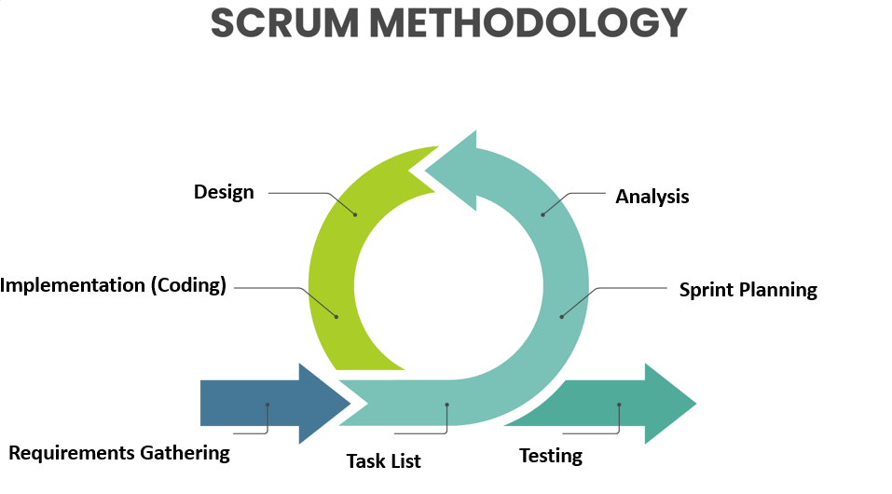

#### Technical reasons

* **Stack fit:** Django + DRF enables fast, secure API development, and React provides a reusable interactive frontend, accelerating MVP delivery.
* **Easy integrations:** Relying on Stripe Sandbox, Leaflet/OSM, and SMTP simplifies connecting external services without early architectural complexity.
* **Migration capability:** Starting with SQLite for development and migrating to PostgreSQL for production reduces initial complexity while preserving future scalability.
* **Early testing of critical features:** Implementing webhooks, QR, and payment flows in early sprints uncovers technical issues sooner and lowers later fix costs.

#### Business and methodological reasons

* **Fast demand validation:** A sprint‑organized MVP allows a quick pilot (10–20 providers, 30–50 bookings) to measure demand before major investment.
* **Revenue model flexibility:** The MVP structure supports experimenting with transaction commissions, premium subscriptions, and paid listings without major structural changes.
* **Market risk reduction:** Local pilots and differentiators (multi‑vendor booking, simplified booking flow) help position the product against established competitors.

#### User experience reasons

* **Improve conversion rate:** A multi‑step booking flow with QR generation and smooth payment reduces abandonment and increases conversions.
* **Value for providers and organizers:** Dashboards, reports, and CSV export give operational tools that encourage onboarding and retention.
* **User trust:** Notifications, email confirmations, and QR tickets increase credibility and attendee confidence.

#### Operational and managerial reasons

* **Simple experimental operations:** Dev/staging environments and lightweight CI enable frequent, safe releases and simple A/B testing.
* **Risk management:** Sprint-based delivery with DoD and integration tests reduces payment and compliance risks and ensures webhook logs for auditing.
* **Automation readiness:** Adding Celery for background tasks (notifications, scheduled reports) later is possible without major redesign.

#### Academic and graduation report reasons

* **Rich technical documentation:** The stack, ER diagram, API docs, tests, and Gantt/Sprint Backlogs provide comprehensive material for the design and implementation chapters.
* **Clear evaluation criteria:** Measurable acceptance criteria and KPIs (conversion rate, average booking value, API latency) make academic assessment straightforward.

**Modified Requirements Table**

The following table shows the distribution of core requirements across the five sprints adopted in the Scrum methodology. Each row indicates the targeted user group and the main requirements to be implemented during that sprint. This breakdown is used to ensure the team focuses on a clear scope in each development cycle and to facilitate progress measurement and priority review at the end of each sprint.

Table 3.1 Modified Requirements

|  |  |  |
| --- | --- | --- |
| **Sprint** | **Group** | **Main Requirements (features)** |
| Sprint 1 | General basics & account management | Login, Logout, Register (User Registration), Password recovery, Manage personal account, Change password, Delete account |
| Sprint 2 | Content discovery & search | Unified search for venues and events, Filter venues and events by specific criteria, Display map of event and venue locations, View venue and event ratings, Browse venues events |
| Sprint 3 | Venue Provider | Browse venues (Provider), Manage venue(add-edit-delete-archive-unarchive), Browse bookings (Provider), Manage booking (Provider), Reject-Cancel-Accept, Manage files and images |
| Sprint 4 | Event Organizer | Browse events (Organizer),Manage event(add-edit-delete-archive-unarchive), Manage event tickets (Create/Edit/Delete), Manage registrations, Create/manage attendee evaluation forms, View statistics and reports, Export attendee list, Manage speakers, Send attendee invitations (QR / e-ticket) |
| Sprint 5 | Attendee / Client interaction | View bookings, Manage booking(add-edit-delete), View registrations, Manage registration(add-edit-delete), Manage venue rating, Manage event rating, Upvote, Downvote, View recent activities, Manage notifications |

The table defines the content of each sprint in terms of target groups and main requirements, while the Gantt chart places this content in a clear temporal context that shows the sequence of sprints, task dependencies, and delivery milestones. In other words, the table is used to specify *what* will be implemented in each development cycle, and the Gantt chart is used to specify *when*, who will do it, and how activities overlap; by updating the detailed sprint tables in the appendix and linking them to the timeline in the Gantt chart, the team gains an integrated planning and tracking tool, where progress is measured through Sprint Reviews and dependencies and durations in the Gantt chart are adjusted as needed.

**Gantt Chart**

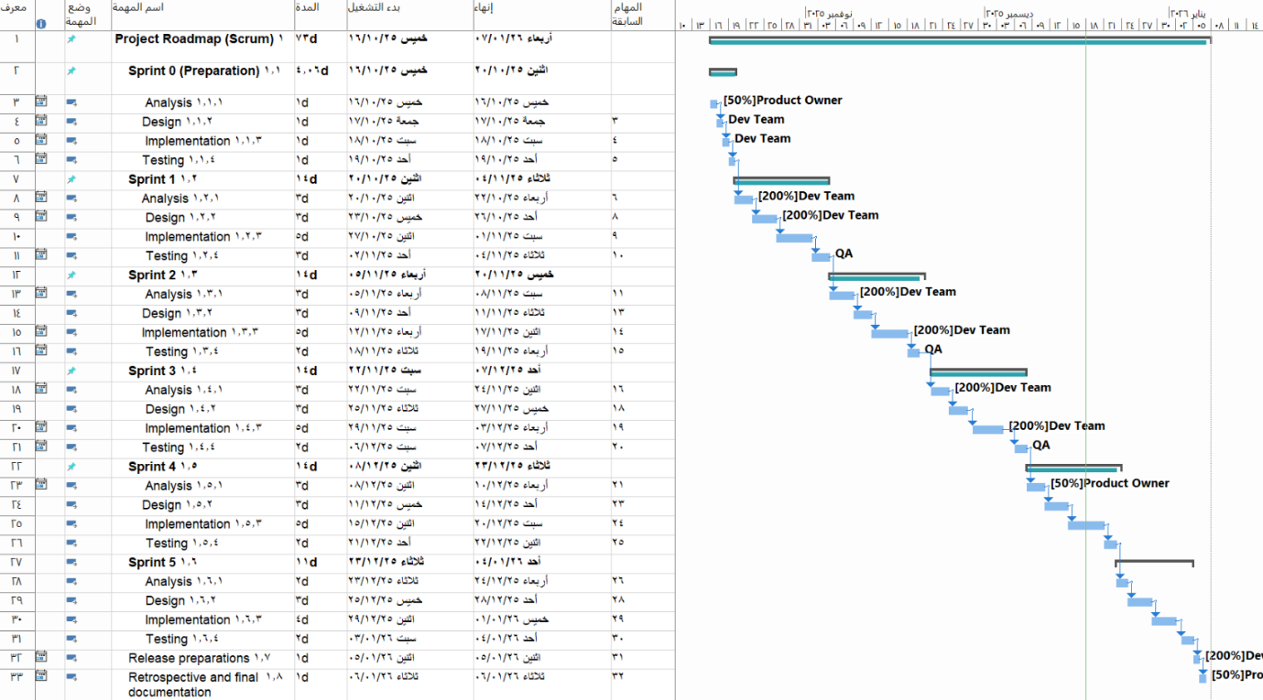

The timeline above shows the distribution of work across an initial preparation phase and five consecutive sprints, followed by release preparations and a final review. Each sprint follows an **Analyze → Design → Implement → Test** cycle, and the chart displays temporal dependencies between tasks and delivery milestones. The text below translates the chart into a practical description suitable for inclusion in the Project Plan chapter.

### **Sprint summaries and main tasks**

* **Sprint 0 — Preparation (12 days)**  
  **Tasks:** requirements analysis, preliminary design, basic infrastructure implementation, and preparatory testing.  
  **Deliverables:** repository and dev/staging environments ready, ER diagram, simple CI setup, basic authentication.
* **Sprint 1 (14 days)**  
  **Tasks:** detailed analysis, UI design, implement CRUD for venues, local media upload, initial tests.  
  **Deliverables:** API endpoints and venue UI, basic search engine, initial unit tests.
* **Sprint 2 (14 days)**  
  **Tasks:** analysis, design, and implementation of advanced search and filtering, map display, and ratings display.  
  **Deliverables:** unified search for venues and events with filters and location map, improved detail pages.
* **Sprint 3 (14 days)**  
  **Tasks:** analysis, design, and implementation of venue provider features: venue management, bookings calendar, media management.  
  **Deliverables:** working provider dashboard, bookings calendar, accept/reject booking actions, basic statistics.
* **Sprint 4 (14 days)**  
  **Tasks:** analysis, design, and implementation of event organizer tools: create events, manage ticket types, export attendees.  
  **Deliverables:** multi‑step event creation, ticket management, CSV export for attendee lists.
* **Sprint 5 (11 days)**  
  **Tasks:** improve booking UX, attendee interfaces, reviews system, and final testing.  
  **Deliverables:** final booking flow, attendee interfaces for managing bookings and reviews, notifications.
* **Release preparations (2 days) and final review/documentation (2 days)**  
  **Tasks:** final reviews, staging deployment, operational guide and final documentation, conduct Retrospective.  
  **Deliverables:** pilot release ready, final test report, improvement notes for the next phase.

### **Milestones**

### Table 3.2 Milestones

|  |  |
| --- | --- |
| **Milestone** | **Description** |
| End of Sprint 0 | Environment ready + ER diagram + basic authentication |
| End of Sprint 2 | Search, filtering, and location map working |
| End of Sprint 3 | Provider dashboard and bookings calendar working |
| End of Sprint 4 | Event creation and ticketing flow + CSV export |
| End of Sprint 5 | Full booking flow + reviews system + pilot release |

### **Suggested acceptance criteria**

* **Core functions work:** registration/login, create venue/event, and create booking up to pending state.
* **Payment sandbox integration:** payment flow in Sandbox receives webhook and updates booking to confirmed.
* **QR generation:** QR ticket is generated after booking confirmation and can be verified via an endpoint.
* **Testing:** basic unit tests pass for each model and critical API endpoint.
* **Usability:** multi‑step booking UI is clear and validated via a simple user test.

**5. Risk Management:**

This section outlines the methodology for identifying, assessing, and addressing risks that may affect the success of the **Event Management and Organization** project. The objective is to reduce the likelihood and impact of risks through clear mitigation plans and regular monitoring.

#### Risk Management Methodology

* **Identify risks:** Gather potential risks from the team, supervisor, and stakeholders during planning sessions.
* **Assess risks:** Classify each risk by **likelihood** (Low/Medium/High) and **impact** (Low/Medium/High) to prioritize responses.
* **Plan mitigation:** Define preventive and responsive actions for prioritized risks.
* **Monitor and follow up:** Review risk status weekly and update mitigation actions and owners.
* **Document:** Maintain a central Risk Register with descriptions, owners, mitigation plans, and status.

#### Risk Register (proposed)

### Table 3.3 Risk Register

|  |  |  |  |  |
| --- | --- | --- | --- | --- |
| **Risk ID** | **Risk Title** | **Likelihood** | **Impact** | **Mitigation / Owner / Status** |
| RK-01 | Key team member unavailability | High | High | Redistribute tasks; document work; Owner: Lead Dev; Status: Active |
| RK-02 | Scope creep / feature requests | Medium | Medium | Change control; supervisor approval for scope changes; Owner: PM; Status: Active |
| RK-03 | Third‑party API or service outage | Medium | High | Identify alternatives; set usage limits; Owner: Lead Dev; Status: Under Mitigation |
| RK-04 | Security or data privacy incident | Low | High | Implement access controls; encrypt sensitive data; Owner: PM; Status: Active |
| RK-05 | Schedule delays in development | Medium | High | Weekly progress reviews; re-prioritize sprints; Owner: PM; Status: Active |
| RK-06 | Budget overrun | Low | Medium | Monitor expenses; maintain contingency reserve (~10%); Owner: PM; Status: Active |

#### Detailed Mitigation Plans (examples)

* **Key team member unavailability:** Maintain incremental documentation, cross-train team members, and assign temporary backups to reduce single-person dependency.
* **Schedule slippage:** Break work into shorter sprints, defer non-critical features, and allocate buffer days for testing before milestones.
* **Third‑party integration issues:** Early testing of alternatives, use mock interfaces during development, and set consumption limits to avoid unexpected costs.
* **Security risks:** Implement basic authentication and authorization, store passwords securely (hashed), and perform a simple security check before delivery.

#### Monitoring and Reporting

* **Follow-up frequency:** Weekly risk review meetings to update the Risk Register and mitigation statuses.
* **Key indicators:** Number of active risks, percentage of mitigated risks, and schedule impact measured in days delayed.
* **Escalation:** Any high-impact risk that cannot be mitigated is escalated immediately to the supervisor for administrative decisions or additional resource allocation.

**6. Version Control and Configuration Management**

**7. Conclusion**

The Project Management chapter establishes the governance, planning, and control mechanisms necessary to deliver the **Event Management and Organization** platform successfully. By defining the project charter, a detailed Statement of Work, a structured project plan with milestones, a risk register with mitigation measures, and a clear version-control and configuration strategy, the team gains a shared roadmap and accountability framework that reduces ambiguity and supports coordinated execution.

Key outcomes of this chapter include a clarified project scope that separates digital deliverables from physical logistics, a timeline that sequences analysis, design, development, testing, and delivery, and a set of operational practices (branching strategy, CI/CD pipeline, and backup/rollback procedures) that promote code stability and repeatable releases. The documented risk-management approach ensures that likely threats—such as resource unavailability, scope creep, third‑party dependencies, and schedule slippage—are monitored and mitigated proactively.

With these management artifacts in place, the project is positioned to move into detailed design and implementation with controlled change processes, measurable acceptance criteria, and regular supervisory checkpoints. Continued adherence to the plans and timely communication among stakeholders will be essential to meet the final delivery date and achieve the project’s objective of providing a reliable, user-centered event management platform.

**Chapter four**

**Analytical study**

**1.introduction**

This chapter presents a rigorous analytical foundation for the event management system by translating high‑level goals into actionable plans and verifiable specifications. It frames the project’s feasibility across technical, economic, and operational dimensions, defines the scope and deliverables, and establishes measurable criteria for success. The chapter details the System Requirements Specification (SRS), models the functional and non‑functional requirements, and maps use cases to data and process flows. It also describes the project plan and timeline, outlines unit testing strategies, and provides a Requirements Traceability Matrix to ensure every requirement is implemented and validated. Finally, the chapter concludes with a clear system architecture that aligns design choices with identified risks and mitigation strategies, setting the stage for the subsequent design and implementation phases.

**2.Feasibility study**

### **Quick decision guide (key considerations & questions)**

* **Target first:** Organizers and venue providers or end attendees? Prioritize the group that will pay (organizers/providers).
* **Payment gateway:** Stripe (international) or a local gateway—choose based on target market support.
* **Hosting plan:** Start with low‑cost cloud (Heroku/Vercel/AWS free tier) and plan for S3 + PostgreSQL at scale.  
  **Decision points:** MVP scope (search, venue pages, booking/tickets, organizer dashboard); go/no‑go metrics (MVP ready in 8 weeks; 30 pilot bookings).

### **Market & opportunity**

* **Growing market:** The event‑management platform market is expanding rapidly with **double‑digit CAGR** and strong demand for cloud and hybrid event tools.
* **Addressable niche:** Focus on **multi‑vendor booking** (ability to add services from multiple providers in one booking) and **transparent price comparison** to differentiate from incumbents.

**Technical feasibility**

* **Stack:** Django + Django REST Framework (backend), React (frontend), SQLite for development, **PostgreSQL for production**.
* **Core integrations:** Payment (Stripe sandbox), maps (Leaflet/OpenStreetMap), email service (SMTP/SendGrid), optional Celery+Redis for background tasks.
* **Security:** JWT or HTTP Only cookies, HTTPS, input sanitization, webhook signature verification.

**Financial snapshot (estimates)**

* **Initial development:** **$3,000–$10,000** (developer time, domain, basic hosting, Stripe fees) for a functional MVP.
* **Monthly ops:** **$50–$300** (hosting, storage, email/SMS).
* **Revenue model:** commission per booking (5–10%), premium organizer subscriptions, promoted listings.

### **Risks, limitations, and mitigations**

* **Technical risk — SQLite in production:** SQLite limits concurrency; **mitigation:** plan and test migration to PostgreSQL before public launch.
* **Market risk — competition & adoption:** incumbents and SaaS suites dominate; **mitigation:** launch focused MVP with unique multi‑vendor booking and aggressive pilot outreach.
* **Payment & legal risk:** compliance with gateway rules and refund policies; **mitigation:** use sandbox testing, document clear T&Cs, and log transactions for audits.
* **Operational risk — vendor onboarding:** low supply of quality venues; **mitigation:** offer onboarding incentives and simple provider dashboards.

### **Recommendation & immediate next steps**

1. **Build MVP (8–12 weeks):** search/venue pages, booking/tickets, organizer/provider dashboards, QR e‑ticket generation.
2. **Pilot:** onboard **10–20 venues** and run **30–50 pilot bookings** to validate UX and pricing.
3. **Prepare production migration:** configure PostgreSQL, S3 storage, and HTTPS; finalize payment integration.
4. **Measure:** track conversion rate, average booking value, and churn; iterate based on pilot feedback.

### **Table 4.1** Recommendation & immediate next steps

|  |  |  |  |
| --- | --- | --- | --- |
| **Scenario** | **Initial cost** | **Time to MVP** | **Scalability** |
| Low budget | **$1k–3k** | 6–8 weeks | Limited |
| Medium (recommended) | **$3k–10k** | 8–12 weeks | Good (with migration) |
| High scale | **$10k+** | 12+ weeks | High |

### **Implementation Plan and Timeline**

* **Phase 0 (Week 0):** Define MVP scope; set up repositories and development environments.
* **Phase 1 (Weeks 1–3):** Data models, authentication, CRUD for venues and events, basic search UI.
* **Phase 2 (Weeks 4–6):** Ticketing and booking flows, organizer/provider dashboards, QR ticket generation, payment integration in sandbox.
* **Phase 3 (Weeks 7–8):** Functional and security testing, pilot launch with 30–50 bookings, collect feedback and iterate.
* **Deliverables:** Working MVP, ER diagram, API documentation, test report, and production migration plan.

### **Scenario Comparison**

### Table 4.2 Scenario Comparison

|  |  |  |  |  |
| --- | --- | --- | --- | --- |
| **Scenario** | **Scope** | **Time to MVP** | **Scalability** | **Priority focus** |
| Proof of Concept | Basic booking + QR | 6–8 weeks | Low | Attendee UX and booking flow |
| Local Adoption (recommended) | Search, dashboards, payments sandbox | 8–10 weeks | Medium | Balanced across attendees/providers/organizers |
| Scale Ready | Reports, PostgreSQL, S3, marketing | 10–14 weeks | High | Scalability, security, growth |

**3.** **Software Requirements Specification (SRS) document**

**Introduction**

This section provides an introductory overview of the Software Requirements Specification (SRS) document for the **Venue and Events Booking System**. The document describes the system’s functional and non‑functional requirements and expected behavior in a structured, testable way to serve as a single reference for technical teams and stakeholders throughout the project lifecycle. Its goal is to align expectations and facilitate design, development, and testing.

**Purpose of the Document**

The purpose of this document is to record all requirements that the Venue and Events Booking System must satisfy, including use cases, acceptance criteria, and performance and security constraints. The document will be used as a reference by engineers, designers, testers, project managers, and business stakeholders to define scope, estimate effort, and verify the final product against agreed requirements.

**System Scope**

The system supports management of venues and events for the main user roles: **attendee/client, venue providers, event organizers**. Scope includes: venue and event listing and display, search and filtering, booking and registration management, content management (add/edit/archive venues and events), ratings and reviews, payment interfaces, and integrations with map providers, payment gateways, and notification services.

**Functional Requirements**

**UC-01 Login** — User authentication flow: credential validation, session/token issuance, redirect to appropriate dashboard, and login event logging.

**UC-02 Logout** — End user session or revoke token, redirect to login, and log the logout event.

**UC-03 Register (User Registration)** — User sign-up flow with field validation, duplicate email check, account creation, confirmation email, and activation granting basic permissions.

**UC-04 View Venues** — Display a list of available venues as cards with basic info (name, location, capacity, price, thumbnail, rating) with a default sort and pagination support.

**UC-05 View Venue Details** — Show a venue detail page including image gallery, full description, pricing, capacity, availability schedule, and action buttons (book, share, reviews); handle venue-not-found.

**UC-06 View Bookings** — Show the user’s current and past bookings with booking number, venue, date/time, status, and sorting/filtering options.

**UC-07 Add Booking** — Create a new booking via a form with immediate availability checks, conflict prevention, atomic transaction, and confirmation notification.

**UC-08 Edit Booking** — Modify allowed fields of an existing booking with revalidation of availability and audit logging of changes.

**UC-09 Delete Booking** — Cancel or delete a booking after confirmation, applying cancellation policies and logging the reason.

**UC-10 View Events** — Display a list of events with name, date, location, thumbnail and pagination for large result sets.

**UC-11 View Event Details** — Show event detail page with time/date, venue, description, ticket options, organizers, registration/purchase links, and map if available.

**UC-12 Unified Search for Venues** — Unified keyword search across venues, returning categorized results (Venues), supporting partial matches and pagination.

**UC-13 Unified Search for Events**— Unified keyword search across events, returning categorized results (Events), supporting partial matches and pagination.

**UC-14 Filter Venues by Specific Criteria** — Multi-criteria filtering (location, price, capacity, type, date) with immediate or applied updates and easy reset.

**UC-15 Filter Events by Specific Criteria** — Multi-criteria filtering (location, price, capacity, type, date) with immediate or applied updates and easy reset.

**UC-16 View Registrations** — Show the user’s event registrations with attendance status and event details; support pagination.

**UC-17 Add Registration** — Register a user for an event with availability check, payment processing if required, and ticket/confirmation delivery.

**UC-18 Edit Registration** — Edit an existing registration within organizer policy limits, with availability checks and confirmation notification.

**UC-19 Delete Registration** — Cancel a registration after confirmation, showing cancellation implications and updating ticket availability.

**UC-20 View Venue Ratings** — Display venue reviews and ratings: average, total count, individual reviews (reviewer or anonymous), with sorting/filtering.

**UC-21 Add Venue Rating** — Submit a numeric rating (1–5) and optional comment, validate eligibility, prevent unauthorized duplicates, and update averages.

**UC-22 Edit Venue Rating** — Allow the reviewer to edit their rating within an allowed time window and record the edit in the audit trail.

**UC-23 Delete Venue Rating** — Delete the user’s rating after confirmation, update the venue average, and log the deletion.

**UC-24 View Event Ratings** — Display event ratings and comments, average rating and total count; encourage first rating if none exist.

**UC-25 Add Event Rating** — Submit an event rating subject to attendance policy, prevent unauthorized duplicates, and optionally notify the organizer.

**UC-26 Edit Event Rating** — Edit an existing event rating within the allowed timeframe, update averages and record the change.

**UC-27 Delete Event Rating** — Delete an event rating after confirmation, update averages and log the action.

**UC-28 View Organizers** — List organizers with name, short bio, number of past events, overall rating, and link to organizer details.

**UC-29 View Providers** — List venue providers with name, number of venues, overall rating, and links to contact or view their venues.

**UC-30 Filter Organizers by Specific Criteria** — Filter organizers by city, rating, experience, combine filters and reset them.

**UC-31 Filter Providers by Specific Criteria** — Filter providers by city, rating, experience, combine filters and reset them.

**UC-32 Upvote** — Record an upvote on content or a review, increment the UI count immediately, prevent duplicate votes, and log voter identity and timestamp.

**UC-33 Downvote** — Record a downvote on content or a review, update the UI count immediately, prevent duplicate votes, and log voter identity and timestamp.

**UC-34 View Recent Activities** — Show the user’s recent activity timeline (bookings, registrations, ratings, votes) with timestamps, links, and filters by type/date.

**UC-35 Display Map of Event and Venue Locations** — Interactive map showing venue/event pins with info windows and links; support zoom, clustering, and filtering.

**UC-36 Browse Venues (Provider)** — Provider dashboard listing the provider’s venues as cards with search, filters, and links to edit each venue.

**UC-37 Browse Archived Venues** — List archived venues with archive date/reason and actions to restore or permanently delete per policy.

**UC-38 Add Venue** — Provider creates a venue with required fields (name, description, location, capacity, pricing, amenities, images, coordinates), validation, and media handling.

**UC-39 Edit Venue** — Provider edits venue data with validation (e.g., schedule conflicts), saves changes, updates public listing, and records audit trail.

**UC-40 Delete Venue** — Delete or soft-delete a venue after checking for active bookings/obligations; block deletion if constraints exist and log the action.

**UC-41 Archive Venue** — Archive a venue (change status to Archived), hide it from public listings, and record archive metadata.

**UC-42 Unarchive Venue** — Restore an archived venue after verifying conditions, reindex it, and log the restoration.

**UC-43 Browse Bookings (Provider)** — Provider view of bookings for their venues with filters and action buttons to manage each booking.

**UC-44 Accept Booking (Provider)** — Provider accepts a pending booking after rechecking availability, updates status to Accepted, reserves resources, and notifies the client.

**UC-45 Reject Booking (Provider)** — Provider rejects a pending booking with optional reason, releases resources, notifies the client, and logs the action.

**UC-46 Cancel Booking (Provider)** — Provider cancels an accepted/confirmed booking after confirmation, handles refunds if applicable, notifies the client, and logs the cancellation.

**UC-47 Browse Events (Organizer)** — Organizer dashboard listing their events with status (Active/Draft/Archived) and management actions.

**UC-48 Browse Archived Events** — List organizer’s archived events with archive metadata and options to restore or delete per policy.

**UC-49 Create Event** — Organizer creates an event (title, description, dates, sessions, ticket types, speakers, images, coordinates), with venue availability checks and option to save as draft or publish.

**UC-50 Edit Event** — Organizer edits event details, system validates impacts (tickets, schedules), saves updates, and notifies affected attendees if needed.

**UC-51 Delete Event** — Delete or archive an event after checking for refunds/disputes; block deletion if unresolved obligations exist and notify registrants.

**UC-52 Archive Event** — Archive an event, hide it from public listings, and record archive metadata.

**UC-53 Unarchive Event** — Restore an archived event after verifying conditions and reindex it.

**UC-54 Browse Registrations (Organizer)** — Organizer view of registrations with filters and quick actions to manage each registration.

**UC-55 Accept Registration** — Organizer accepts a pending registration after verifying ticket availability, updates status, notifies the registrant, and updates ticket counts.

**UC-56 Reject Registration** — Organizer rejects a registration with optional reason, releases tickets, notifies the registrant, and logs the action.

**UC-57 Cancel Registration** — Organizer or attendee cancels a registration with confirmation, handles refunds/fees per policy, updates ticket availability, and logs the action.

**UC-58 Export Registrations as Excel file** — Generate an XLSX export of registrations for a selected range/criteria and provide it for download while logging the export.

**UC-59 View Booking (Organizer)** — Organizer view of bookings for their events with details, filters, and management actions.

**UC-60 Add Booking (Organizer)** — Organizer creates a booking on behalf of a client, validates availability, processes payment if needed, and sends confirmations.

**UC-61 Edit Booking (Organizer)** — Organizer edits a booking, system validates conflicts, saves changes, notifies the client, and records the audit trail.

**UC-62 Delete Booking (Organizer)** — Organizer deletes or cancels a booking with confirmation, handles refunds if applicable, notifies the client, and logs the operation.

**Functional Requirements Description**

Table 4.4 login description

|  |  |
| --- | --- |
| **Field** | **Details** |
| **ID** | UC-01 |
| **Use Case Name** | Login |
| **Actors** | User (Attendee, Provider, Organizer, Admin) |
| **Preconditions** | User account exists; authentication service available |
| **Main Flow** | 1. User opens the login page and enters credentials (email/username and password).  2. System validates input format and authenticates credentials.  3. On success, system creates an issue a token and redirects user to the appropriate dashboard.  4. System logs the login event. |
| **Alternate Flows** | Invalid credentials → system shows error; locked account → system shows recovery instructions. |
| **Postconditions** | User authenticated; session active. |

Table 4.5 register (User Registration) description

|  |  |
| --- | --- |
| **Field** | **Details** |
| **ID** | UC-02 |
| **Use Case Name** | Register (User Registration) |
| **Actors** | user |
| **Preconditions** | Registration forms available; email service for confirmation available |
| **Main Flow** | 1. Visitor opens home page and selects the type of account (client, venue provider, organizer) he wants to create.  2. Visitor fills required fields (name, username, email, password, confirm password).  3. System validates field formats and password strength.  4. System checks for duplicate email.  5. On success, system creates the account and sends a confirmation email.  6. system redirect the user to login page.  7. After activation, system grants basic permissions to the user. |
| **Alternate Flows** | Duplicate email → system shows error;  invalid input → system requests correction;  weak password → system shows error |
| **Postconditions** | User account created and activated after verification. |

Table 4.6 Register Logoutdescription

|  |  |
| --- | --- |
| **Field** | **Details** |
| **ID** | UC-03 |
| **Use Case Name** | Logout |
| **Actors** | Authenticated User; System |
| **Preconditions** | Active user session |
| **Main Flow** | 1. User clicks logout.  2. System invalidates the revokes the token.  3. System redirects user to the login page and displays confirmation.  4. System logs the logout event. |
| **Alternate Flows** | Session already expired → system redirects to login immediately. |
| **Postconditions** | Session terminated; user unauthenticated. |

Table 4.7 view venuesdescription

|  |  |
| --- | --- |
| **Field** | **Details** |
| **ID** | UC-04 |
| **Use Case Name** | View Venues |
| **Actors** | Attendee |
| **Preconditions** | Venues database prepared; listing UI available |
| **Main Flow** | 1. User opens the venues page.  2. System retrieves venues ordered by default.  3. System displays venues as cards.  4. For each item the system shows: **name**, **location (city/short address)**, **capacity**, **price**, **thumbnail image**, **rating**, **number of reviewers**. |
| **Alternate Flows** | No venues → system displays message **"No venues available"**. |
| **Postconditions** | Venues list displayed or appropriate status message shown. |

Table 4.8 view venuesdetails description

|  |  |
| --- | --- |
| **Field** | **Details** |
| **ID** | UC-05 |
| **Use Case Name** | View Venue Details |
| **Actors** | Attendee |
| **Preconditions** | Complete venue record exists (images; specifications; schedules) |
| **Main Flow** | 1. User selects a venue.  2. System retrieves the full venue record.  3. System displays image gallery, full description, pricing, capacity, availability schedule.  4. System shows action buttons: **Book**, **View reviews**, **Share location**. |
| **Alternate Flows** | Venue not found or deleted → system displays **"Venue not available"**. |
| **Postconditions** | Venue details page displayed or an appropriate error message shown. |

Table 4.9 view bookings description

|  |  |
| --- | --- |
| **Field** | **Details** |
| **ID** | UC-06 |
| **Use Case Name** | View Bookings |
| **Actors** | Attendee |
| **Preconditions** | User is logged in as Attendee; booking records associated with the user exist |
| **Main Flow** | 1. User opens the bookings page.  2. System retrieves current and past bookings.  3. System displays for each booking: **booking number**, **venue**, **date & time**, **status** (Confirmed / Pending / Cancelled).  4. System provides sorting/filtering options. |
| **Alternate Flows** | No bookings → system displays message **"No bookings"**. |
| **Postconditions** | Bookings list displayed or appropriate status message shown. |

Table 4.10 add booking description

|  |  |
| --- | --- |
| **Field** | **Details** |
| **ID** | UC-07 |
| **Use Case Name** | Add Booking |
| **Actors** | Attendee |
| **Preconditions** | Logged in as attendee; venue available for requested date; valid booking form |
| **Main Flow** | 1. User fills booking form (venue; start date; end/date-time; number of attendees; contact details).  2. System immediately checks availability, capacity, and field validity.  3. System checks for duplicate bookings and time conflicts with other bookings.  4. If available, system creates the booking and sends confirmation notification. |
| **Alternate Flows** | Time conflict → system shows error explaining the reason. |
| **Postconditions** | Booking recorded with number and details and confirmation sent, or booking in pending state. |

Table 4.11 edit booking description

|  |  |
| --- | --- |
| **Field** | **Details** |
| **ID** | UC-08 |
| **Use Case Name** | Edit Booking |
| **Actors** | Attendee (Owner of Booking) |
| **Preconditions** | Logged in as attendee; Editable booking exists; user has permission |
| **Main Flow** | 1. User opens booking details and edits allowed fields (dates; number of attendees; notes).  2. System rechecks availability and applies validation rules.  3. If valid, system saves changes and displays success message. |
| **Alternate Flows** | Edit causes conflict → system shows error and prevents save. |
| **Postconditions** | Changes saved and audit trail updated. |

Table 4.12 delete booking description

|  |  |
| --- | --- |
| **Field** | **Details** |
| **ID** | UC-09 |
| **Use Case Name** | Delete Booking |
| **Actors** | Attendee (Owner) |
| **Preconditions** | Booking exists; user has deletion permission |
| **Main Flow** | 1. User clicks delete.  2. System displays confirmation dialog explaining cancellation implications (fees/lead time).  3. After confirmation, system marks booking as cancelled or deletes record per policy.  4. System logs deletion reason and sends notification. |
| **Alternate Flows** | Deletion blocked due to cancellation policy or financial links → system shows reason and provides instructions. |
| **Postconditions** | Booking cancelled or deleted and operation logged. |

Table 4.13 view events description

|  |  |
| --- | --- |
| **Field** | **Details** |
| **ID** | UC-10 |
| **Use Case Name** | View Events |
| **Actors** | Attendee |
| **Preconditions** | Events are registered in the system |
| **Main Flow** | 1. User opens the events page.  2. System retrieves events list.  3. System displays for each event: **name**, **date**, **location**, **thumbnail image**.  4. System supports pagination when results are large. |
| **Alternate Flows** | No events → system displays message **"No events"**. |
| **Postconditions** | Events list displayed or appropriate status message shown. |

Table 4.14 view events details description

|  |  |
| --- | --- |
| **Field** | **Details** |
| **ID** | UC-11 |
| **Use Case Name** | View Event Details |
| **Actors** | Attendee |
| **Preconditions** | Complete event record exists (description, schedule, tickets, organizers, coordinates) |
| **Main Flow** | 1. User selects an event from the list.  2. System retrieves the full event record.  3. System displays **time & date**, **venue**, **event description**, **ticket options**, **organizers list**, and **registration/purchase links**.  4. System displays a map of the location if available. |
| **Alternate Flows** | Event not found → system shows a clear alert in the notifications area: **"Event not available"**. |
| **Postconditions** | Event details page displayed or an alert shown. |

Table 4.15 unified search for venues description

|  |  |
| --- | --- |
| **Field** | **Details** |
| **ID** | UC-12 |
| **Use Case Name** | Unified Search for Venues |
| **Actors** | User (Attendee, Venue Provider, Event Organizer) |
| **Preconditions** | Venues and events indexed and searchable |
| **Main Flow** | 1. User enters keywords or phrase in the search field.  2. System executes the query against the index and returns results grouped by category (Venues).  3. System supports partial matches and is case-insensitive.  4. System supports pagination for large result sets. |
| **Alternate Flows** | No matches → system displays **"No matching results"** and suggests broadening the search. |
| **Postconditions** | Search results displayed and categorized. |

Table 4.16 unified search for events description

|  |  |
| --- | --- |
| **Field** | **Details** |
| **ID** | UC-13 |
| **Use Case Name** | Unified Search for Events |
| **Actors** | User (Attendee, Event Organizer) |
| **Preconditions** | Venues and events indexed and searchable |
| **Main Flow** | 1. User enters keywords or phrase in the search field.  2. System executes the query against the index and returns results grouped by category (Events).  3. System supports partial matches and is case-insensitive.  4. System supports pagination for large result sets. |
| **Alternate Flows** | No matches → system displays **"No matching results"** and suggests broadening the search. |
| **Postconditions** | Search results displayed and categorized. |

Table 4.18 filter venues by specific criteria description

|  |  |
| --- | --- |
| **Field** | **Details** |
| **ID** | UC-14 |
| **Use Case Name** | Filter Venues by Specific Criteria |
| **Actors** | User (Attendee, Venue Provider, Event Organizer) |
| **Preconditions** | Data contains filterable attributes (location, price, capacity, type, date) |
| **Main Flow** | 1. User selects filter criteria via the UI.  2. Client sends filter criteria to the server.  3. System executes optimized queries or uses the search engine to return matching items.  4. System displays filtered results and shows counts per filter.  5. User can reset filters easily. |
| **Alternate Flows** | Invalid filter values → system ignores invalid values or shows a warning;  No results → system displays an appropriate message. |
| **Postconditions** | Filtered list displayed; filters can be reset. |

Table 4.18 filter events by specific criteria description

|  |  |
| --- | --- |
| **Field** | **Details** |
| **ID** | UC-15 |
| **Use Case Name** | Filter Events by Specific Criteria |
| **Actors** | User (Attendee, Event Organizer) |
| **Preconditions** | Data contains filterable attributes (location, price, capacity, type, date) |
| **Main Flow** | 1. User selects filter criteria via the UI.  2. Client sends filter criteria to the server.  3. System executes optimized queries or uses the search engine to return matching items.  4. System displays filtered results and shows counts per filter.  5. User can reset filters easily. |
| **Alternate Flows** | Invalid filter values → system ignores invalid values or shows a warning;  No results → system displays an appropriate message. |
| **Postconditions** | Filtered list displayed; filters can be reset. |

Table 4.19 view registration description

|  |  |
| --- | --- |
| **Field** | **Details** |
| **ID** | UC-16 |
| **Use Case Name** | View Registrations |
| **Actors** | Attendee |
| **Preconditions** | User is logged in; registration records associated with the user exist |
| **Main Flow** | 1. User opens the registrations page.  2. System retrieves the user's registrations.  3. System displays each registration with **attendance status** and **event details**.  4. System supports pagination when results are large. |
| **Alternate Flows** | No registrations → system displays **"No registrations"**. |
| **Postconditions** | Registrations list displayed or appropriate status message shown. |

Table 4.20 add registration description

|  |  |
| --- | --- |
| **Field** | **Details** |
| **ID** | UC-17 |
| **Use Case Name** | Add Registration |
| **Actors** | Attendee |
| **Preconditions** | Seats/tickets available; user is logged in |
| **Main Flow** | 1. User opens the event page and fills the registration form (name, email, number of tickets, additional data).  2. System checks availability.  3. On success, system creates the registration, displays confirmation, and sends notification with ticket details. |
| **Alternate Flows** | Tickets sold out → system shows error and offers waitlist option if available. |
| **Postconditions** | Registration created or pending; confirmation sent. |

Table 4.21 edit registration description

|  |  |
| --- | --- |
| **Field** | **Details** |
| **ID** | UC-18 |
| **Use Case Name** | Edit Registration |
| **Actors** | Attendee (Owner of Registration) |
| **Preconditions** | Logged in; Editable registration exists; organizer policy allows edits |
| **Main Flow** | 1. User opens their registration and selects edit.  2. User updates allowed fields (ticket quantity, contact details).  3. System validates changes and checks availability.  4. If valid, system saves changes and sends confirmation notification. |
| **Alternate Flows** | Edit not allowed → system displays reason (organizer policy or sold-out status). |
| **Postconditions** | Registration updated and audit trail recorded. |

Table 4.22 delete registration description

|  |  |
| --- | --- |
| **Field** | **Details** |
| **ID** | UC-19 |
| **Use Case Name** | Delete Registration |
| **Actors** | Attendee (Owner); System |
| **Preconditions** | Logged in; Registration exists; cancellation policy defined |
| **Main Flow** | 1. User initiates cancellation. 2. System displays confirmation with cancellation implications (refunds/fees/lead time). 3. After confirmation, system cancels the registration and updates ticket availability. 4. System sends confirmation to the user. |
| **Alternate Flows** | Cancellation not permitted → system shows reason and alternative steps (contact support or partial refund). |
| **Postconditions** | Registration cancelled and ticket availability updated. |

Table 4.23 view venue ratings description

|  |  |
| --- | --- |
| **Field** | **Details** |
| **ID** | UC-20 |
| **Use Case Name** | View Venue Ratings |
| **Actors** | User (Attendee, Venue Provider, Event Organizer) |
| **Preconditions** | Ratings and reviews exist for the venue |
| **Main Flow** | 1. User opens the venue page.  2. System retrieves average rating, total reviews, and review details (reviewer name or anonymous, numeric rating, comment, publish date). 3. System displays star distribution and provides sort/filter options for reviews. |
| **Alternate Flows** | No reviews → system displays **"No reviews"** and prompts user to add the first review. |
| **Postconditions** | Ratings and reviews displayed; average rating calculated. |

Table 4.24 add venue rating description

|  |  |
| --- | --- |
| **Field** | **Details** |
| **ID** | UC-21 |
| **Use Case Name** | Add Venue Rating |
| **Actors** | Attendee |
| **Preconditions** | User is logged in; system policy defines who may rate (e.g., attendees who visited) |
| **Main Flow** | 1. User opens the rating form and selects a numeric value (1–5) and optional text.  2. User submits the rating.  3. System validates eligibility and content.  4. System saves the rating, updates the venue average, and displays success message. |
| **Alternate Flows** | Duplicate rating attempt → system enforces policy (reject or allow update per policy) and informs user. |
| **Postconditions** | Rating stored and venue average updated. |

Table 4.25 edit venue rating description

|  |  |
| --- | --- |
| **Field** | **Details** |
| **ID** | UC-22 |
| **Use Case Name** | Edit Venue Rating |
| **Actors** | Attendee (Owner of Rating); System |
| **Preconditions** | User has an existing rating; edit window is within allowed timeframe |
| **Main Flow** | 1. User opens their venue rating.  2. User edits allowed fields (numeric value, comment).  3. User submits the changes.  4. System validates eligibility and content.  5. System updates the rating and recalculates the venue average.  6. System records the edit in the audit trail and displays a success message. |
| **Alternate Flows** | Edit window expired → system prevents edit and shows reason. |
| **Postconditions** | Rating updated and audit trail recorded. |

Table 4.26 delete venue rating description

|  |  |
| --- | --- |
| **Field** | **Details** |
| **ID** | UC-23 |
| **Use Case Name** | Delete Venue Rating |
| **Actors** | Attendee (Owner) or Authorized Venue Provider |
| **Preconditions** | Logged in; User has an existing rating; deletion permitted by policy |
| **Main Flow** | 1. User initiates delete on the rating.  2. System shows confirmation explaining effect on average.  3. After confirmation, system deletes or marks the rating as removed and updates the venue average.  4. System logs the deletion. |
| **Alternate Flows** | Attempt to delete another user's rating → system blocks action and shows error. |
| **Postconditions** | Rating removed or flagged; venue average updated; deletion logged. |

Table 4.27 view event ratings description

|  |  |
| --- | --- |
| **Field** | **Details** |
| **ID** | UC-24 |
| **Use Case Name** | View Event Ratings |
| **Actors** | User (Attendee, Venue Provider, Event Organizer) |
| **Preconditions** | Ratings exist for the event |
| **Main Flow** | 1. User opens the event page.  2. System retrieves ratings and comments.  3. System displays reviewer details (or anonymous), numeric rating, comment, average rating, and total count. |
| **Alternate Flows** | No ratings → system displays an appropriate message and encourages adding the first rating. |
| **Postconditions** | Event ratings displayed and average calculated. |

Table 4.28 add event rating description

|  |  |
| --- | --- |
| **Field** | **Details** |
| **ID** | UC-25 |
| **Use Case Name** | Add Event Rating |
| **Actors** | Attendee |
| **Preconditions** | User is logged in; eligibility to rate determined by attendance policy |
| **Main Flow** | 1. User fills rating form (numeric value and optional comment).  2. User submits the rating.  3. System validates eligibility and content.  4. System saves the rating, updates event average, and optionally notifies the organizer. |
| **Alternate Flows** | Duplicate rating attempt → system enforces policy and informs user. |
| **Postconditions** | Rating saved and event average updated. |

Table 4.29 edit event rating description

|  |  |
| --- | --- |
| **Field** | **Details** |
| **ID** | UC-26 |
| **Use Case Name** | Edit Event Rating |
| **Actors** | Attendee (Owner of Rating) |
| **Preconditions** | Logged in; User has an existing event rating; edit window is within allowed timeframe |
| **Main Flow** | 1. User opens their event rating.  2. User edits allowed fields (numeric value, comment).  3. User submits the changes.  4. System validates eligibility and content.  5. System updates the rating and recalculates the event average.  6. System records the edit in the audit trail and displays a success message. |
| **Alternate Flows** | Edit window expired → system blocks the edit and shows the reason. |
| **Postconditions** | Rating updated; audit trail recorded. |
| **Performance & Security** | Protect against manipulation; log edits for auditing. |

Table 4.30 delete event rating description

|  |  |
| --- | --- |
| **Field** | **Details** |
| **ID** | UC-27 |
| **Use Case Name** | Delete Event Rating |
| **Actors** | Attendee (Owner) or Event Organizer |
| **Preconditions** | Logged in; User has an existing event rating; deletion permitted by policy |
| **Main Flow** | 1. User initiates delete on their event rating.  2. System shows confirmation explaining the effect on averages.  3. After confirmation, system deletes or flags the rating as removed.  4. System recalculates the event average.  5. System logs the deletion and notifies the user. |
| **Alternate Flows** | Attempt to delete another user's rating → system blocks the action and shows an error. |
| **Postconditions** | Rating removed or flagged; averages updated; deletion logged. |

Table 4.31 view organizers description

|  |  |
| --- | --- |
| **Field** | **Details** |
| **ID** | UC-28 |
| **Use Case Name** | View Organizers |
| **Actors** | User (Attendee, Venue Provider, Event Organizer) |
| **Preconditions** | Organizer records exist and are complete |
| **Main Flow** | 1. User opens the organizers page.  2. System retrieves organizer list.  3. System displays for each organizer: **name**, **short bio**, **number of past events**, **overall rating**.  4. System provides link to each organizer’s detail page. |
| **Alternate Flows** | No organizers → system displays an appropriate message. |
| **Postconditions** | Organizers list displayed; links to details available. |
| **Performance & Security** | Show only public information; protect contact details. |

Table 4.32 view providers description

|  |  |
| --- | --- |
| **Field** | **Details** |
| **ID** | UC-29 |
| **Use Case Name** | View Providers |
| **Actors** | User (Attendee, Venue Provider, Event Organizer) |
| **Preconditions** | Provider records exist and are complete |
| **Main Flow** | 1. User opens the provider's page.  2. System retrieves provider list.  3. System displays for each provider: **name**, **number of venues**, **overall rating**, and **links** to contact or view venues. |
| **Alternate Flows** | No providers → system displays an appropriate message. |
| **Postconditions** | Providers list displayed; action links available. |

Table 4.33 filter providers by specific criteria description

|  |  |
| --- | --- |
| **Field** | **Details** |
| **ID** | UC-30 |
| **Use Case Name** | Filter Providers by Specific Criteria |
| **Actors** | User (Attendee, Venue Provider, Event Organizer) |
| **Preconditions** | Filterable attributes exist (city, rating, experience) |
| **Main Flow** | 1. User opens provider page and selects filter criteria.  2. Client sends criteria to server.  3. System executes queries and returns matching items.  4. System displays results and shows counts per filter.  5. User can combine filters or reset them. |
| **Alternate Flows** | No matches → system displays a message and suggests broadening criteria. |
| **Postconditions** | Filtered list displayed; filters resettable. |

Table 4.34 filter providers by specific criteria description

|  |  |
| --- | --- |
| **Field** | **Details** |
| **ID** | UC-31 |
| **Use Case Name** | Filter Organizers by Specific Criteria |
| **Actors** | User (Attendee, Venue Provider, Event Organizer) |
| **Preconditions** | Filterable attributes exist (city, rating, experience) |
| **Main Flow** | 1. User opens Organizers page.  2. User selects filter criteria.  3. Client sends criteria to server.  4. System executes queries and returns matching items.  5. System displays results and shows counts per filter.  6. User can combine filters or reset them. |
| **Alternate Flows** | No matches → system displays a message and suggests broadening criteria. |
| **Postconditions** | Filtered list displayed; filters resettable. |

Table 4.35 upvote description

|  |  |
| --- | --- |
| **Field** | **Details** |
| **ID** | UC-32 |
| **Use Case Name** | Upvote |
| **Actors** | Attendee |
| **Preconditions** | User is logged in; target item is votable and exists |
| **Main Flow** | 1. User clicks the Upvote button on an item.  2. System records the vote and increments the displayed count immediately.  3. System stores voter identity and timestamp in the audit log.  4. System prevents duplicate votes per policy (or toggles vote if policy allows). |
| **Alternate Flows** | Duplicate vote attempt → system blocks or toggles per policy and informs the user. |
| **Postconditions** | Vote recorded; UI updated. |

Table 4.36 downvote description

|  |  |
| --- | --- |
| **Field** | **Details** |
| **ID** | UC-33 |
| **Use Case Name** | Downvote |
| **Actors** | Attendee |
| **Preconditions** | User is logged in; target item is votable and exists |
| **Main Flow** | 1. User clicks the Downvote button on an item.  2. System records the vote and updates the displayed count immediately.  3. System stores voter identity and timestamp in the audit log.  4. System prevents duplicate votes per policy (or toggles vote if policy allows). |
| **Alternate Flows** | Duplicate vote attempt → system blocks or toggles per policy and informs the user. |
| **Postconditions** | Vote recorded; UI updated. |

Table 4.37 view recent activities description

|  |  |
| --- | --- |
| **Field** | **Details** |
| **ID** | UC-34 |
| **Use Case Name** | View Recent Activities |
| **Actors** | Attendee |
| **Preconditions** | Logged in; Activity log exists for the user |
| **Main Flow** | 1. User opens the Recent Activities page.  2. System retrieves chronological activity entries (bookings, registrations, ratings, votes).  3. System displays each entry with timestamp and link to the related item.  4. System provides filters by activity type and date range. |
| **Alternate Flows** | No activities → system displays an appropriate message. |
| **Postconditions** | Activity timeline displayed; filters functional. |

Table 4.38 display map of event and venue locations description

|  |  |
| --- | --- |
| **Field** | **Details** |
| **ID** | UC-35 |
| **Use Case Name** | Display Map of Event and Venue Locations |
| **Actors** | User (Attendee, Venue Provider, Event Organizer) |
| **Preconditions** | Accurate geo-coordinates for venues/events; map provider integration available |
| **Main Flow** | 1. User opens the map page or an item detail page.  2. System requests map tiles from the map provider.  3. System places pins for each location.  4. User clicks a pin; system shows a brief info window with name and link to details.  5. User can zoom, pan, and apply filters to displayed locations. |
| **Alternate Flows** | Map provider unavailable → system shows a fallback list of locations and an error message. |
| **Postconditions** | Interactive map displayed or fallback list shown. |

Table 4.39 browse venues (provider) description

|  |  |
| --- | --- |
| **Field** | **Details** |
| **ID** | UC-36 |
| **Use Case Name** | Browse Venues (Provider) |
| **Actors** | Venue Provider |
| **Preconditions** | Provider is logged in; provider has venues in the system |
| **Main Flow** | 1. Provider opens their venues dashboard.  2. System retrieves the provider’s venues ordered by default.  3. System displays venues as cards.  4. For each item the system shows: **name**, **location (city/short address)**, **capacity**, **price**, **thumbnail image**, **rating**, **number of reviewers**.  5. Provider can search, filter, and navigate to each venue’s detail or edit page. |
| **Alternate Flows** | No venues → system displays **"No venues available"** and a link to add a new venue. |
| **Postconditions** | Provider’s venues listed and manageable. |

Table 4.40 brows archived venues description

|  |  |
| --- | --- |
| **Field** | **Details** |
| **ID** | UC-37 |
| **Use Case Name** | Browse Archived Venues |
| **Actors** | Venue Provider |
| **Preconditions** | Provider is logged in; archived venues exist for the provider |
| **Main Flow** | 1. Provider opens the “Archived Venues” section in the dashboard.  2. System retrieves archived venues with archive date and reason.  3. System displays archived venue with actions (Restore, Delete). |
| **Alternate Flows** | No archived venues → system displays an appropriate message. |
| **Postconditions** | Archived venues listed; restore/delete actions available per policy. |

Table 4.41 add venue description

|  |  |
| --- | --- |
| **Field** | **Details** |
| **ID** | UC-38 |
| **Use Case Name** | Add Venue |
| **Actors** | Venue Provider |
| **Preconditions** | Provider is logged in; add-venue form available; provider has creation permission |
| **Main Flow** | 1. Provider opens the Add Venue form.  2. Provider fills required fields (name, description, location, capacity, pricing, amenities, images, coordinates).  3. System validates fields and uploaded files.  4. System stores the venue record and media, shows preview and public/private link, and notifies the provider. |
| **Alternate Flows** | Missing or invalid data → system shows validation errors and requests correction. |
| **Postconditions** | Venue created and visible in provider dashboard (and public listings if published). |

Table 4.42 edit venue description

|  |  |
| --- | --- |
| **Field** | **Details** |
| **ID** | UC-39 |
| **Use Case Name** | Edit Venue |
| **Actors** | Venue Provider (Owner) |
| **Preconditions** | Provider is logged in; Venue exists and belongs to provider; provider has edit permission |
| **Main Flow** | 1. Provider opens the venue edit page.  2. System loads current fields and change history.  3. Provider updates fields and submits changes.  4. System validates updates (e.g., schedule conflicts) and saves changes. 5. System updates public listing and records audit trail. |
| **Alternate Flows** | Concurrent edits or validation failures → system shows conflict/error and prevents save until resolved. |
| **Postconditions** | Venue record updated; audit trail recorded. |

Table 4.43 delete venue description

|  |  |
| --- | --- |
| **Field** | **Details** |
| **ID** | UC-40 |
| **Use Case Name** | Delete Venue |
| **Actors** | Venue Provider (Owner) |
| **Preconditions** | Venue exists; provider has deletion permission; Provider is logged in; |
| **Main Flow** | 1. Provider requests venue deletion.  2. System displays warning and consequences (bookings, data retention).  3. System checks for active bookings or obligations.  4. If allowed, system performs soft-delete or permanent delete per policy, updates indexes, and notifies relevant parties.  5. System logs the deletion action. |
| **Alternate Flows** | Active bookings or financial obligations → system blocks deletion and provides instructions. |
| **Postconditions** | Venue deleted or archived per policy; logs updated. |

Table 4.44 archive venue description

|  |  |
| --- | --- |
| **Field** | **Details** |
| **ID** | UC-41 |
| **Use Case Name** | Archive Venue |
| **Actors** | Venue Provider (Owner) |
| **Preconditions** | Provider is logged in; Venue exists; no blocking active bookings |
| **Main Flow** | 1. Provider clicks “Archive” for a venue.  2. System shows confirmation explaining effects.  3. Provider confirms; system sets venue status to Archived, updates search index, and hides it from public listings.  4. System records archive date and reason. |
| **Alternate Flows** | Archive blocked due to active bookings → system shows reason and next steps. |
| **Postconditions** | Venue status set to Archived and reflected in UI and search. |

Table 4.45 unarchive venue description

|  |  |
| --- | --- |
| **Field** | **Details** |
| **ID** | UC-42 |
| **Use Case Name** | Unarchive Venue |
| **Actors** | Venue Provider (Owner) |
| **Preconditions** | Venue is archived; provider has restored permission; Provider is logged in; |
| **Main Flow** | 1. Provider requests to unarchive a venue.  2. System verifies conditions (no conflicts).  3. System sets venue status to Active, reindexes it, and confirms restoration.  4. System logs the restore action. |
| **Alternate Flows** | Restore blocked due to conflicts → system shows reason |
| **Postconditions** | Venue active and visible in listings per settings. |

Table 4.46 browse bookings description

|  |  |
| --- | --- |
| **Field** | **Details** |
| **ID** | UC-43 |
| **Use Case Name** | Browse Bookings (Provider) |
| **Actors** | Venue Provider |
| **Preconditions** | Provider is logged in; bookings exist for provider’s venues |
| **Main Flow** | 1. Provider opens the bookings page in the dashboard.  2. System retrieves bookings with filters (date, status, venue).  3. System displays bookings table with action buttons.  4. Provider selects a booking to view details and take actions (Accept/Reject/Cancel). |
| **Alternate Flows** | No bookings → system displays empty state and suggestions. |
| **Postconditions** | Bookings displayed and manageable; actions logged. |

Table 4.47 accept booking description

|  |  |
| --- | --- |
| **Field** | **Details** |
| **ID** | UC-44 |
| **Use Case Name** | Accept Booking (Provider) |
| **Actors** | Venue Provider |
| **Preconditions** | Provider is logged in; Pending booking exists; provider authorized to accept |
| **Main Flow** | 1. Provider opens pending booking details. 2. Provider clicks “Accept.” 3. System rechecks availability and conflicts. 4. If available, system updates booking status to Accepted, reserves resources, and notifies the client. 5. System logs the status change. |
| **Alternate Flows** | Conflict detected on recheck → system shows error and blocks acceptance or suggests alternatives. |
| **Postconditions** | Booking status set to Accepted; client notified; logs updated. |

Table 4.48 reject booking description

|  |  |
| --- | --- |
| **Field** | **Details** |
| **ID** | UC-45 |
| **Use Case Name** | Reject Booking (Provider) |
| **Actors** | Venue Provider |
| **Preconditions** | Pending booking exists; Provider is logged in; |
| **Main Flow** | 1. Provider reviews pending booking and selects “Reject” with optional reason.  2. System updates booking status to Rejected, releases reserved resources, and notifies the client with the reason.  3. System logs the rejection. |
| **Alternate Flows** | Error updating status → system shows error and requests retry. |
| **Postconditions** | Booking marked Rejected; resources freed; client notified; action logged. |

Table 4.49 cancel booking description

|  |  |
| --- | --- |
| **Field** | **Details** |
| **ID** | UC-46 |
| **Use Case Name** | Cancel Booking (Provider) |
| **Actors** | Venue Provider |
| **Preconditions** | Booking exists (Accepted/Confirmed); provider authorized to cancel |
| **Main Flow** | 1. Provider opens booking and selects “Cancel.”  2. System displays cancellation implications (fees/refunds).  3. Provider confirms; system updates booking status to Cancelled, processes refunds if applicable, and notifies the client.  4. System logs the cancellation. |
| **Alternate Flows** | Cancellation blocked due to policy or ongoing transaction → system shows reason and next steps. |
| **Postconditions** | Booking cancelled; refunds processed as needed; seats/resources freed; logs updated. |

Table 4.50 browse events (organizer) description

|  |  |
| --- | --- |
| **Field** | **Details** |
| **ID** | UC-47 |
| **Use Case Name** | Browse Events (Organizer) |
| **Actors** | Event Organizer |
| **Preconditions** | Organizer is logged in; organizer has events in the system |
| **Main Flow** | 1. Organizer opens the events dashboard.  2. System retrieves the organizer’s events with status (Active / Draft / Archived).  3. System displays events as a list or cards with key fields (title, date, venue, status).  4. Organizer can filter, sort, and navigate to event details or edit pages. |
| **Alternate Flows** | No events → system displays a message and a link to create a new event. |
| **Postconditions** | Organizer’s events listed and manageable. |

Table 4.51 browse archived events description

|  |  |
| --- | --- |
| **Field** | **Details** |
| **ID** | UC-48 |
| **Use Case Name** | Browse Archived Events |
| **Actors** | Event Organizer |
| **Preconditions** | Organizer is logged in; archived events exist for the organizer |
| **Main Flow** | 1. Organizer opens the “Archived Events” section.  2. System retrieves archived events with archive date.  3. System displays archived entries with actions (Restore, Delete ). |
| **Alternate Flows** | No archived events → system displays an appropriate message. |
| **Postconditions** | Archived events listed; restore/delete actions available per policy. |

Table 4.52 create event description

|  |  |
| --- | --- |
| **Field** | **Details** |
| **ID** | UC-49 |
| **Use Case Name** | Create Event |
| **Actors** | Event Organizer |
| **Preconditions** | Organizer is logged in; venue selected or venue details provided |
| **Main Flow** | 1. Organizer opens the Create Event form.  2. Organizer fills required fields (title, description, dates, sessions, ticket types, speakers, images, coordinates).  3. System validates inputs and checks venue availability and schedule conflicts.  4. Organizer chooses Draft or Publish; system saves the event accordingly and returns confirmation. |
| **Alternate Flows** | Venue conflict → system shows conflict details and suggests alternatives;  missing required fields → system highlights errors. |
| **Postconditions** | Event created as Draft or Published; audit log updated. |

Table 4.53 edit event description

|  |  |
| --- | --- |
| **Field** | **Details** |
| **ID** | UC-50 |
| **Use Case Name** | Edit Event |
| **Actors** | Event Organizer |
| **Preconditions** | Event exists and belongs to organizer; organizer has edit permission |
| **Main Flow** | 1. Organizer opens the event edit page.  2. System loads current event data and change history.  3. Organizer updates fields and submits changes.  4. System validates changes (ticket impacts, schedule conflicts) and saves updates.  5. System notifies affected attendees if required. |
| **Alternate Flows** | Changes conflict with sold tickets or schedules → system warns and requires confirmation or admin intervention. |
| **Postconditions** | Event updated; notifications and audit trail recorded. |

Table 4.54 delete event description

|  |  |
| --- | --- |
| **Field** | **Details** |
| **ID** | UC-51 |
| **Use Case Name** | Delete Event |
| **Actors** | Event Organizer |
| **Preconditions** | Event exists; check for unresolved obligations (refunds, disputes); Organizer is logged in; |
| **Main Flow** | 1. Organizer requests event deletion.  2. System displays consequences (registrations, refunds).  3. System checks for pending transactions or disputes.  4. If allowed, system deletes or archives the event per policy and notifies registrants.  5. System logs the deletion. |
| **Alternate Flows** | Pending refunds/disputes → system blocks deletion and provides next steps or escalates to admin. |
| **Postconditions** | Event deleted or archived; records retained per retention policy. |

Table 4.55 archive event description

|  |  |
| --- | --- |
| **Field** | **Details** |
| **ID** | UC-52 |
| **Use Case Name** | Archive Event |
| **Actors** | Event Organizer |
| **Preconditions** | Event exists and is eligible for archiving; no blocking obligations |
| **Main Flow** | 1. Organizer selects “Archive” for an event.  2. System shows confirmation and effects.  3. Organizer confirms; system sets event status to Archived, hides it from public listings, and records archive metadata. |
| **Alternate Flows** | Archive blocked due to obligations → system shows reason and remediation steps. |
| **Postconditions** | Event archived and excluded from public search/listings. |

Table 4.56 unarchive event description

|  |  |
| --- | --- |
| **Field** | **Details** |
| **ID** | UC-53 |
| **Use Case Name** | Unarchive Event |
| **Actors** | Event Organizer |
| **Preconditions** | Event is archived; organizer has restore permission |
| **Main Flow** | 1. Organizer requests to unarchive the event.  2. System verifies conditions (no conflicts).  3. System sets event status to Active or Draft, reindexes it, and confirms restoration. |
| **Alternate Flows** | Restore blocked due to conflicts → system shows reason and suggested fixes. |
| **Postconditions** | Event active or draft and visible per settings. |

Table 4.57 browse registrations description

|  |  |
| --- | --- |
| **Field** | **Details** |
| **ID** | UC-54 |
| **Use Case Name** | Browse Registrations |
| **Actors** | Event Organizer |
| **Preconditions** | Organizer is logged in; registrations exist for organizer’s events |
| **Main Flow** | 1. Organizer opens the registrations page.  2. System retrieves registrations with filters (status, date, ticket type).  3. System displays registrations list/table with quick actions.  4. Organizer selects a registration to view details or take action (Accept/Reject/Cancel). |
| **Alternate Flows** | No registrations → system displays an appropriate message. |
| **Postconditions** | Registrations displayed and manageable; actions logged. |

Table 4.58 accept registration description

|  |  |
| --- | --- |
| **Field** | **Details** |
| **ID** | UC-55 |
| **Use Case Name** | Accept Registration |
| **Actors** | Event Organizer |
| **Preconditions** | Pending registration exists; organizer authorized |
| **Main Flow** | 1. Organizer reviews the pending registration.  2. Organizer clicks “Accept.”  3. System verifies ticket availability and updates registration status to Accepted.  4. System notifies the registrant and updates ticket counts.  5. System logs the action. |
| **Alternate Flows** | Insufficient tickets → system blocks acceptance and suggests alternatives. |
| **Postconditions** | Registration accepted; registrant notified; ticket counts updated. |

Table 4.59 reject registration description

|  |  |
| --- | --- |
| **Field** | **Details** |
| **ID** | UC-56 |
| **Use Case Name** | Reject Registration |
| **Actors** | Event Organizer (owner) |
| **Preconditions** | Pending registration exists; organizer authorized |
| **Main Flow** | 1. Organizer selects “Reject” and optionally provides a reason.  2. System updates registration status to Rejected and releases any reserved tickets.  3. System notifies the registrant with the reason.  4. System logs the rejection. |
| **Alternate Flows** | Error updating status → system shows error and requests retry. |
| **Postconditions** | Registration rejected; tickets released; registrant notified; action logged. |

Table 4.60 cancel registration description

|  |  |
| --- | --- |
| **Field** | **Details** |
| **ID** | UC-57 |
| **Use Case Name** | Cancel Registration |
| **Actors** | Event Organizer or Attendee |
| **Preconditions** | Registration exists; cancellation policy defined |
| **Main Flow** | 1. Organizer or attendee initiates cancellation.  2. System displays confirmation with cancellation implications (refunds/fees/lead time).  3. User confirms cancellation.  4. System updates registration status to Cancelled and updates ticket availability.  5. System notifies affected parties (organizer/attendee) and logs the action. |
| **Alternate Flows** | Cancellation blocked by policy or ongoing transaction → system shows reason and next steps. |
| **Postconditions** | Registration cancelled; ticket availability updated; action logged. |
| **Performance & Security** | Process refunds if applicable; record audit trail; enforce authorization checks. |

Table 4.61 explore registration as excel file description

|  |  |
| --- | --- |
| **Field** | **Details** |
| **ID** | UC-58 |
| **Use Case Name** | Export Registrations as Excel file |
| **Actors** | Event Organizer |
| **Preconditions** | Registrations exist; user has export permission |
| **Main Flow** | 1. Organizer selects export criteria (date range, status, event).  2. System gathers matching registration data.  3. System generates an Excel (XLSX) file with the requested columns.  4. System provides the file for download and logs the export action. |
| **Alternate Flows** | Export fails due to large dataset → system suggests narrowing the range or paginated export and shows an error. |
| **Postconditions** | Excel file generated and available for download; export logged. |

Table 4.62 view booking (organizer) description

|  |  |
| --- | --- |
| **Field** | **Details** |
| **ID** | UC-59 |
| **Use Case Name** | View Booking (Organizer) |
| **Actors** | Event Organizer |
| **Preconditions** | Organizer is logged in; bookings exist for organizer’s events |
| **Main Flow** | 1. Organizer opens the bookings page.  2. System retrieves current and past bookings.  3. System displays for each booking: **booking number**, **venue**, **date & time**, **status** (Confirmed / Pending / Cancelled).  4. System provides sorting/filtering options. |
| **Alternate Flows** | No bookings → system displays an appropriate message. |
| **Postconditions** | Booking details accessible; organizer can take management actions. |

Table 4.63 add booking (organizer) description

|  |  |
| --- | --- |
| **Field** | **Details** |
| **ID** | UC-60 |
| **Use Case Name** | Add Booking (Organizer) |
| **Actors** | Event Organizer |
| **Preconditions** | Organizer authorized to create bookings; venue available |
| **Main Flow** | 1. Organizer fills booking form (venue; start date; end/date-time; number of attendees; contact details).  2. System immediately checks availability, capacity, and field validity.  3. System checks for duplicate bookings and time conflicts with other bookings.  4. If available, system creates the booking and sends confirmation notification. |
| **Alternate Flows** | Insufficient availability → system shows error and suggests alternatives. |
| **Postconditions** | Booking created and confirmations sent. |

Table 4.64 edit booking (organizer) description

|  |  |
| --- | --- |
| **Field** | **Details** |
| **ID** | UC-61 |
| **Use Case Name** | Edit Booking (Organizer) |
| **Actors** | Event Organizer |
| **Preconditions** | Booking exists; organizer has permission to modify |
| **Main Flow** | 1. User opens booking details and edits allowed fields (dates; number of attendees; notes).  2. System rechecks availability and applies validation rules.  3. If valid, system saves changes and displays success message. |
| **Alternate Flows** | Change causes conflict or violates policy → system blocks save and shows reason. |
| **Postconditions** | Booking updated; notifications sent; audit trail recorded. |
| **Performance & Security** | Protect payment and personal data; log edits. |

Table 4.65 delete booking (organizer) description

|  |  |
| --- | --- |
| **Field** | **Details** |
| **ID** | UC-62 |
| **Use Case Name** | Delete Booking (Organizer) |
| **Actors** | Event Organizer |
| **Preconditions** | Booking exists; deletion policy defined; Organizer authorized |
| **Main Flow** | 1. Organizer initiates booking deletion/cancellation.  2. System displays consequences (refunds/fees).  3. Organizer confirms action.  4. System cancels or deletes the booking per policy, processes refunds if needed, and notifies the client.  5. System logs the deletion. |
| **Alternate Flows** | Deletion blocked due to disputes or financial constraints → system shows reason and next steps. |
| **Postconditions** | Booking cancelled/deleted; refunds processed as applicable; logs updated. |
| **Performance & Security** | Enforce authorization; record financial actions; maintain audit trail. |

**Nonfunctional Requirements**

#### Performance

* **Response time targets**
  + **Search results:** median response ≤ **1 second** for common queries under typical load.
  + **Filter application and list updates:** response ≤ **2 seconds** for medium result sets.
  + **Page load:** First Meaningful Paint for main pages ≤ **1.5–2.5 seconds** on a typical broadband connection.
* **Concurrent user load**
  + Support **2,000** concurrent active users as a baseline; design to scale horizontally to **10,000+** concurrent users with autoscaling.
* **Pagination and throughput**
  + All endpoints must support pagination and return pages of configurable size (default **20**).
* **Payload size constraints**
  + Respect HTTP payload guidance per use case; detail and map pages may be larger. Lightweight actions (voting, rating, registration) should target small payloads (e.g., **< 1.5 KB** for ticketing actions; **< 15 KB** for rating/registration lists; search/list pages **15–250 KB** depending on media).
* **Performance testing**
  + Provide load and stress test reports demonstrating that targets are met for baseline and scaled scenarios.

#### Security

* **Authentication**
  + Support secure authentication (email/password) with passwords stored hashed (PBKDF2 with SHA‑256) and optional SSO/OAuth2 for providers/organizers.
  + Enforce account lockout and rate limiting on failed attempts.
* **Authorization**
  + Role‑based access control (RBAC) ensuring users can access only authorized resources (attendee, provider, organizer, admin).
* **Encryption**
  + All communications over TLS 1.2+ (HTTPS).
  + Encrypt sensitive data at rest (e.g., payment tokens, contact details) using strong algorithms (AES‑256).
* **Logging and audit**
  + Maintain immutable audit logs for critical actions (create/edit/delete bookings, payments, rating changes, exports) including actor, timestamp, and reason.
  + Protect logs from tampering and retain them according to the retention policy.
* **Input validation and protection**
  + Server‑side validation for all inputs; protect against injection (SQL/NoSQL), XSS, CSRF.
* **Privacy**
  + Mask or obfuscate personal contact data in public views; comply with applicable data protection laws and document retention policies.

#### Reliability Backup and Recovery

* **Availability**
  + Target **99.9%** availability for core services (excluding scheduled maintenance).
* **Backups and retention**
  + Daily backups for transactional data; weekly full backups for large datasets.
  + Define retention windows (e.g., **30–90 days**) and store backups in a secure offsite location.
* **Recovery objectives**
  + **RTO (Recovery Time Objective):** ≤ **2 hours** for critical services.
  + **RPO (Recovery Point Objective):** ≤ **15 minutes** for transactional data (bookings/registrations).
* **Fault tolerance**
  + Design for multi‑AZ or multi‑region deployment where feasible; automatic failover for databases and stateless services.
* **Monitoring and alerting**
  + Implement health checks, metrics (latency, error rates), and alerts for SLA breaches and security incidents.

#### Maintainability and Extensibility

* **Modular architecture**
  + Separate services (search, bookings, notifications) to enable independent deployment and scaling.
* **Scalability**
  + Stateless application tiers; horizontal scaling for web/API layers; database scaling strategy (read replicas, sharding plan if needed).
* **Code quality and documentation**
  + Provide API documentation (OpenAPI/Swagger) for all public endpoints.
  + Developer documentation: architecture overview, deployment steps, environment variables, and runbooks for common operations.

#### Usability and Accessibility

* **User interface requirements**
  + Responsive design supporting desktop and mobile; consistent UI patterns for listings, details, and forms.
  + Fast, clear feedback for user actions (success, validation errors, loading states).
* **Accessibility**
  + Conform to **WCAG 2.1 AA**: keyboard navigation, semantic markup, sufficient color contrast, and screen‑reader labels.
* **Internationalization**
  + Format dates, times, numbers, and currencies per user locale; display event times clearly with timezone awareness.

#### Technical Constraints

* **Supported platforms and clients**
  + Web: modern browsers (last two major versions of Chrome, Firefox, Edge, Safari).
  + Mobile: responsive web interface.
* **Datastores and storage**
  + Primary relational database (e.g., **SQLite** or other RDBMS) for transactional data.
  + Search index (e.g., Elasticsearch or managed search service) for unified search and filtering.
  + Object storage (e.g., S3) for media assets with a CDN for delivery.
* **External integrations**
  + **Map provider:** Google Maps or alternative; secure API keys and monitored usage quotas.
* **Rate limits and quotas**
  + Define per‑endpoint rate limits (e.g., higher throughput for search; stricter limits for voting endpoints to prevent abuse).
  + Return meaningful HTTP status codes and clear error payloads to clients.
* **HTTP payload size limits**
  + Enforce upload limits for media (e.g., images ≤ **5–10 MB** per file); compress responses where appropriate; adhere to the lightweight payload targets in the Performance section.

**4.Requirements Modeling**

**- Use Case Diagrams**

Figure 4.4 general use case diagram

Figure 4.4 client/attendee use case diagram

Figure 4.4 venue provider use case diagram

Figure 4.4 event organizer use case diagram

**- Activity Diagrams**

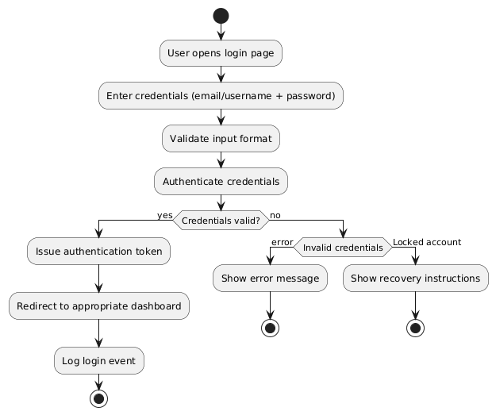

Figure 4.4 login activity diagram

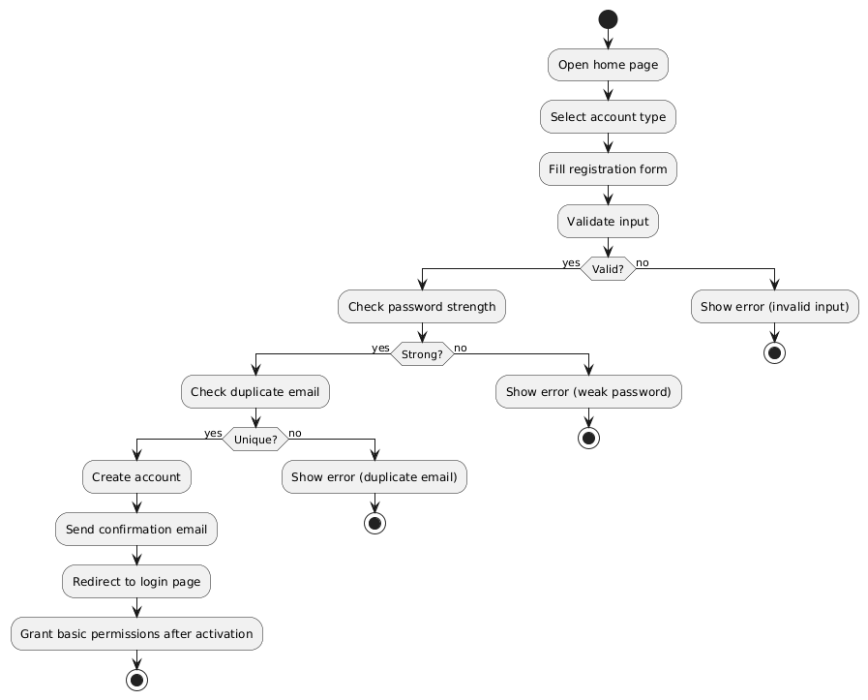

Figure 4.5 register (User Registration) activity diagram

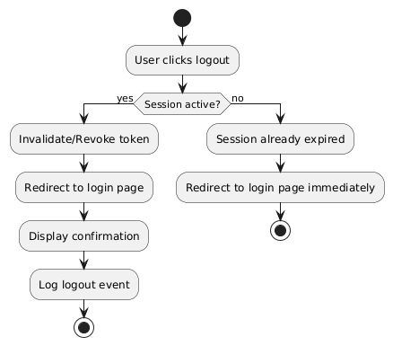

Figure 4.6 Register Logout activity diagram

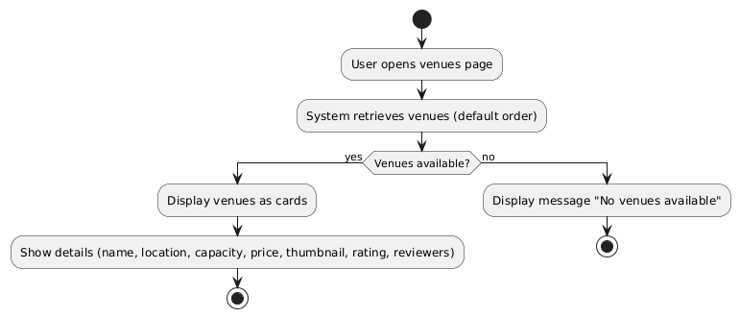

Figure 4.7 view venues activity diagram

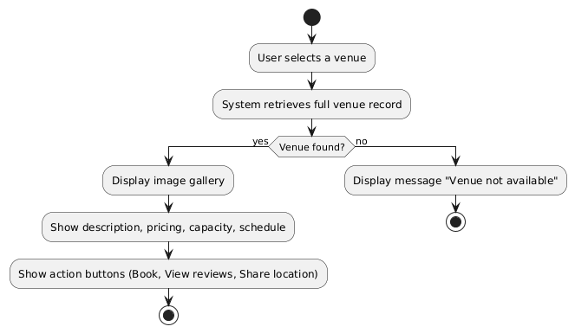

Figure 4.8 view venues details activity diagram

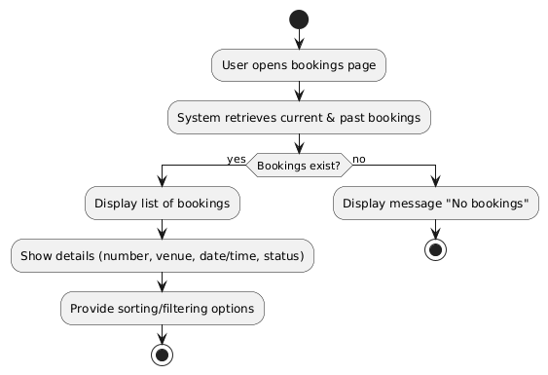

Figure 4.9 view bookings activity diagram

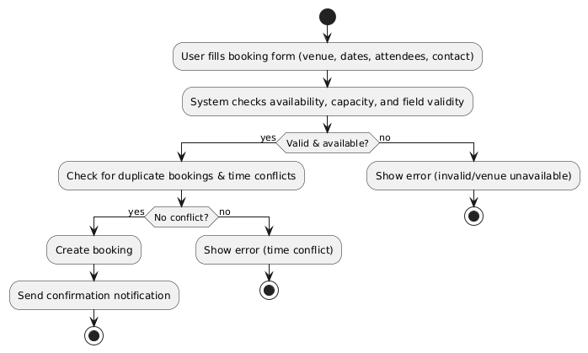

Figure 4.10 add booking activity diagram

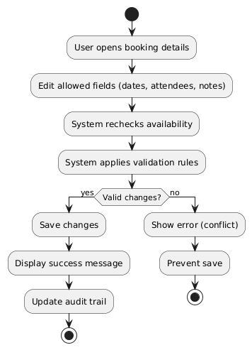

Figure 4.11 edit booking activity diagram

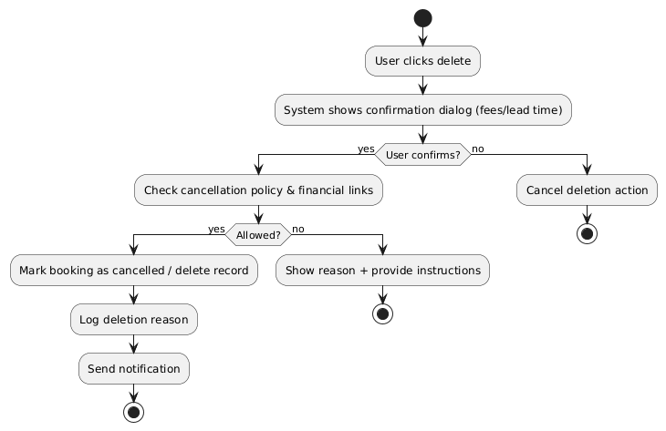

Figure 4.12 delete booking activity diagram

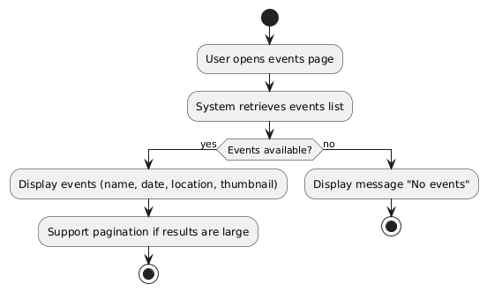

Figure 4.13 view events activity diagram

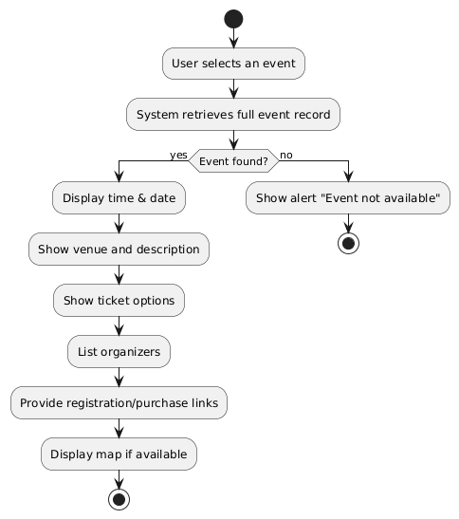

Figure 4.14 view events details activity diagram

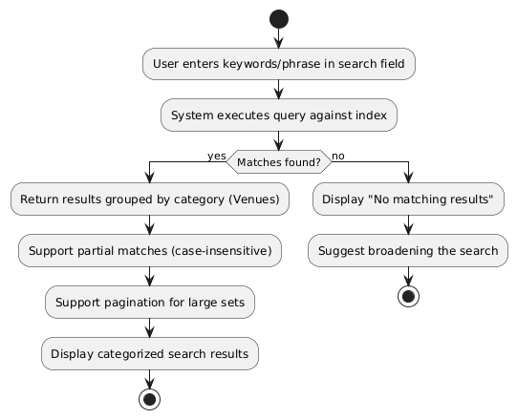

Figure 4.15 unified search for venues activity diagram

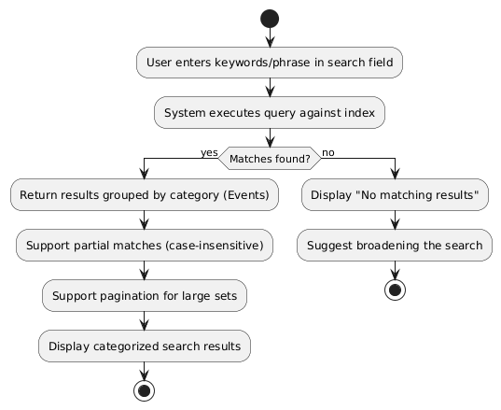

Figure 4.16 unified search for events activity diagram

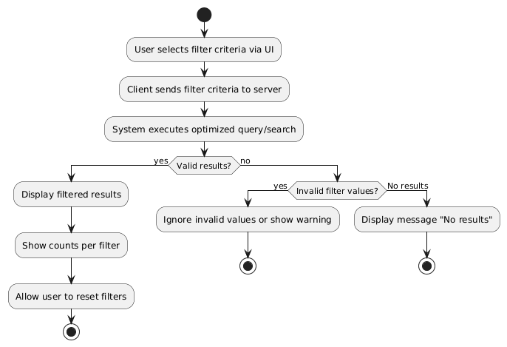

Figure 4.18 filter venues by specific criteria activity diagram

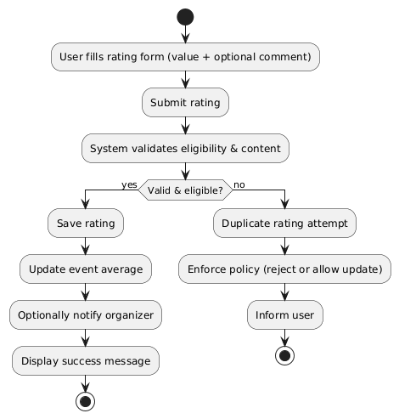

Figure 4.18 filter events by specific criteria activity diagram

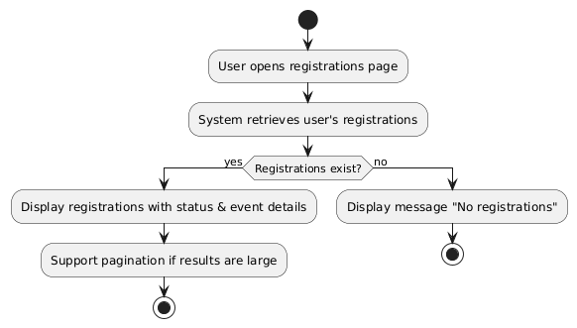

Figure 4.19 view registration activity diagram

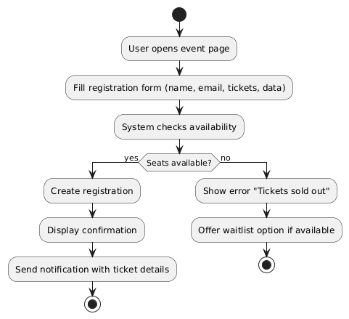

Figure 4.20 add registration activity diagram

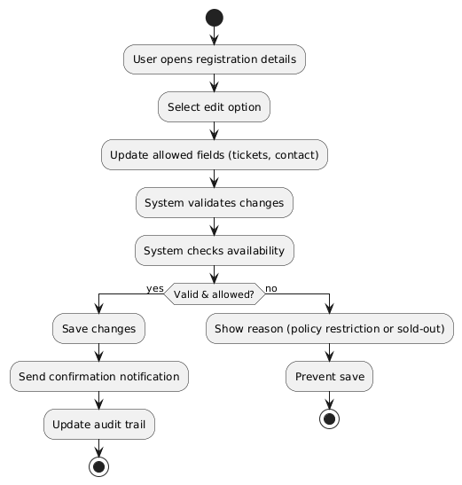

Figure 4.21 edit registration activity diagram

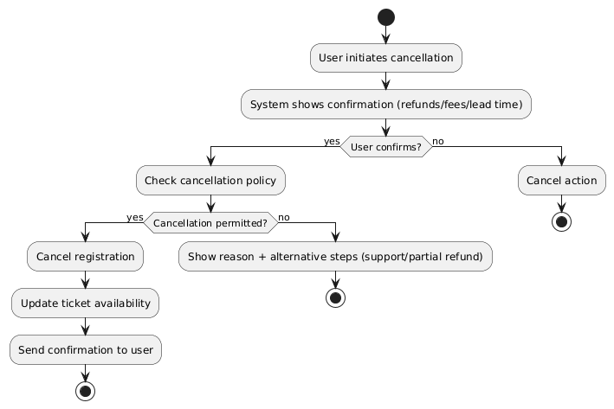

Figure 4.22 delete registration activity diagram

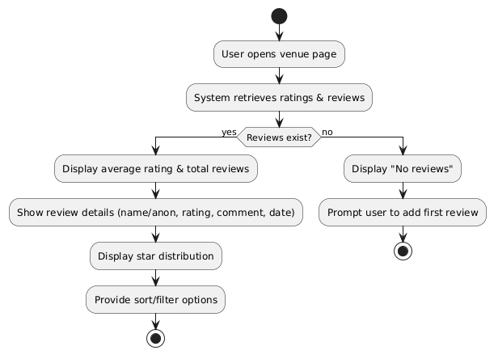

Figure 4.23 view venue ratings activity diagram

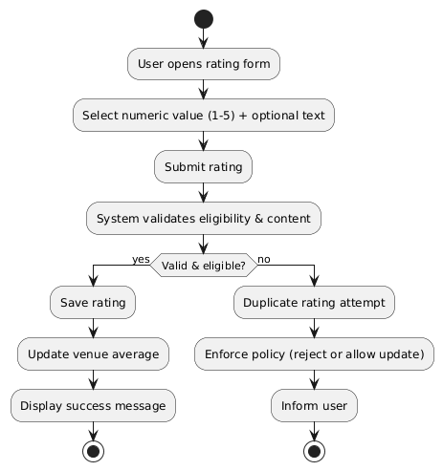

Figure 4.24 add venue rating activity diagram

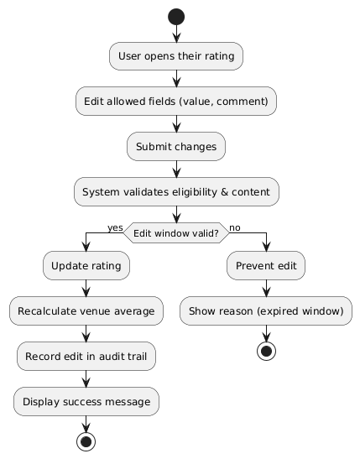

Figure 4.25 edit venue rating activity diagram

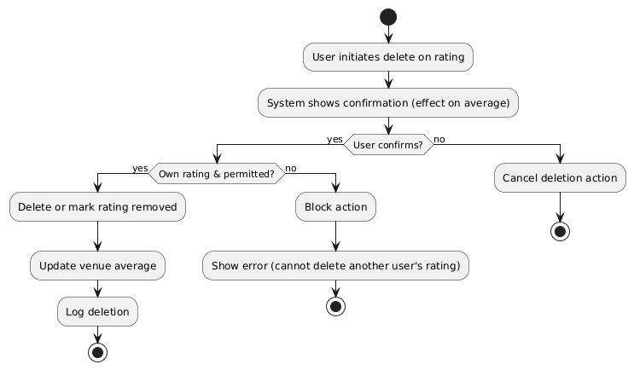

Figure 4.26 delete venue rating activity diagram

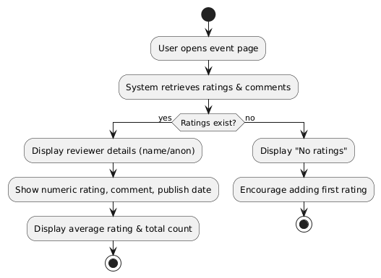

Figure 4.27 view event ratings activity diagram



Figure 4.28 add event rating activity diagram

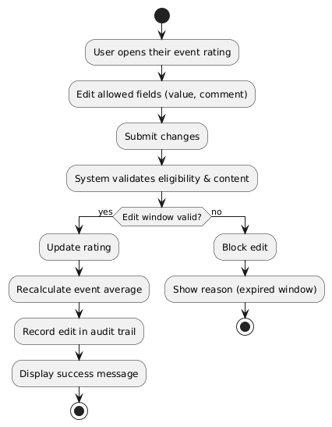

Figure 4.29 edit event rating activity diagram

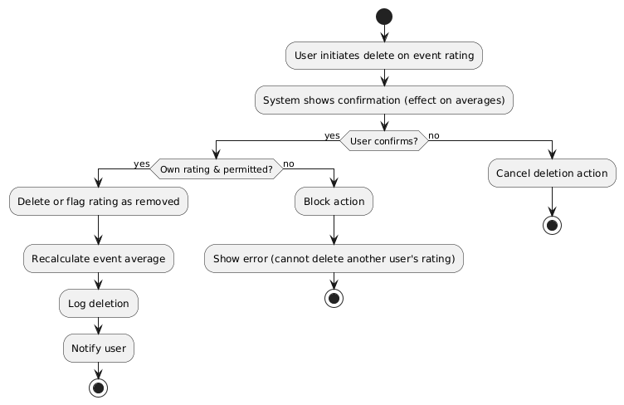

Figure 4.30 delete event rating activity diagram

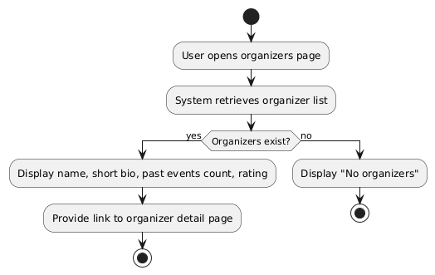

Figure 4.31 view organizers activity diagram

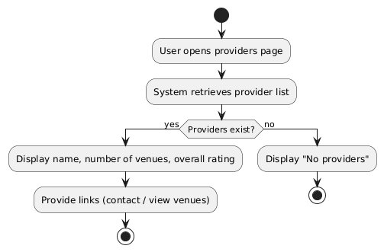

Figure 4.32 view providers activity diagram

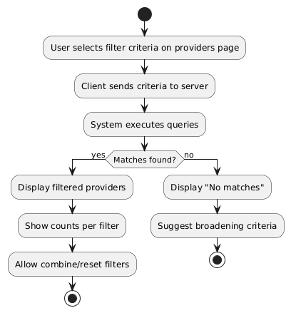

Figure 4.33 filter providers by specific criteria activity diagram

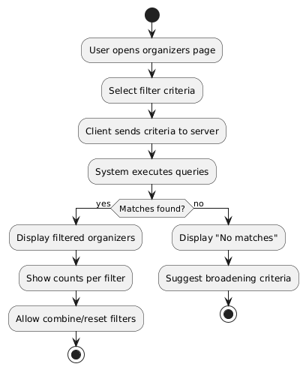

Figure 4.34 filter Organizers by specific criteria activity diagram

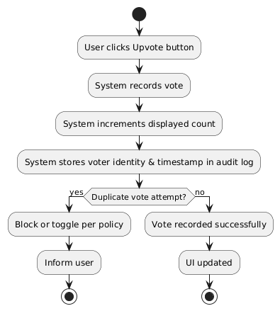

Figure 4.35 upvote activity diagram

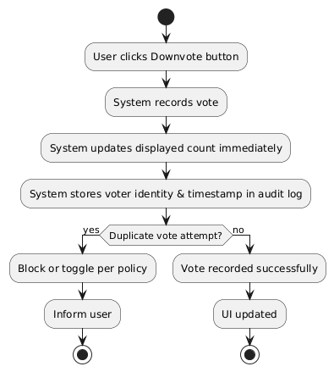

Figure 4.36 downvote activity diagram

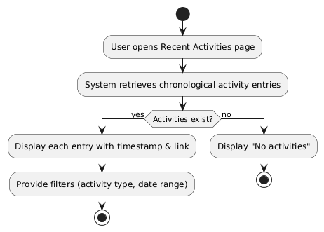

Figure 4.37 view recent activities activity diagram

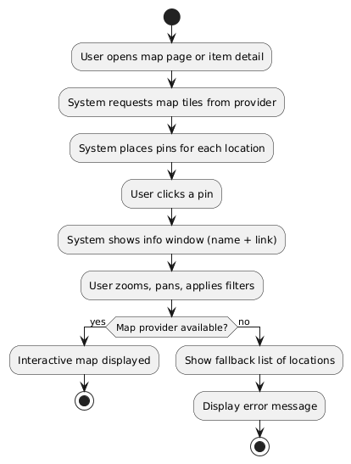

Figure 4.38 display map of event and venue locations activity diagram

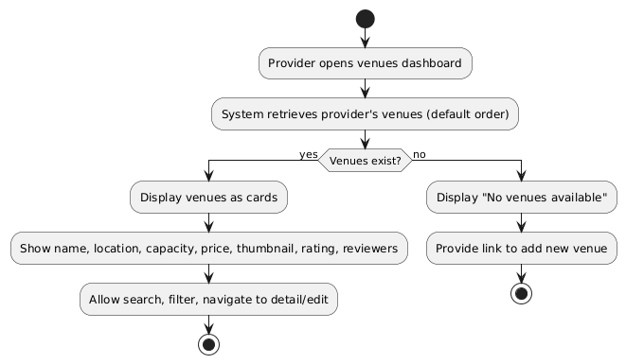

Figure 4.39 browse venues (provider) activity diagram

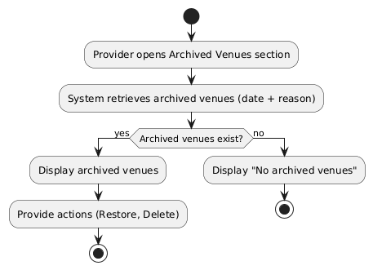

Figure 4.40 brows archived venues activity diagram

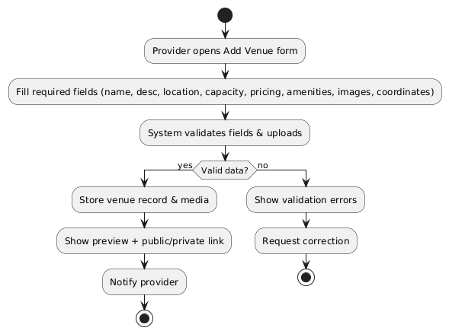

Figure 4.41 add venue activity diagram.

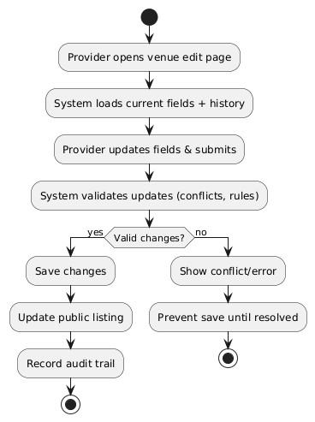

Figure 4.42 edit venue activity diagram

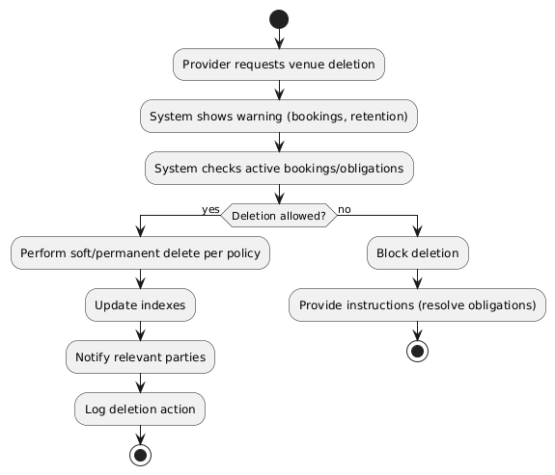

Figure 4.43 delete venue activity diagram

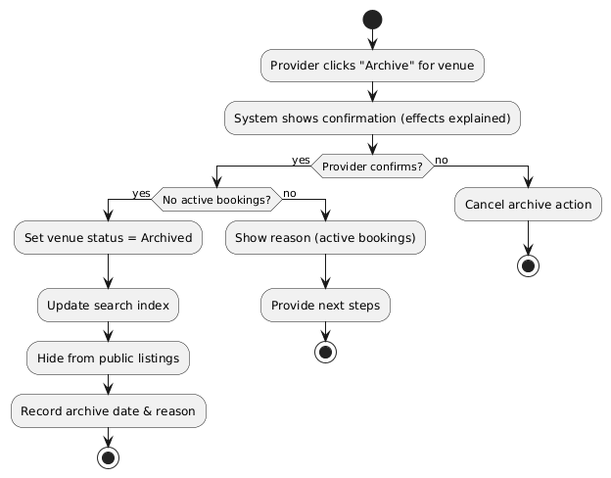

Figure 4.44 archive venue activity diagram

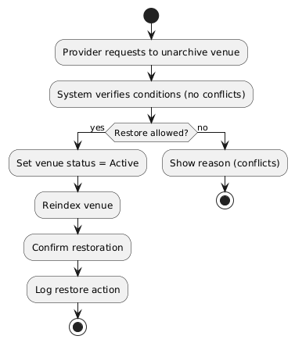

Figure 4.45 unarchive venue activity diagram

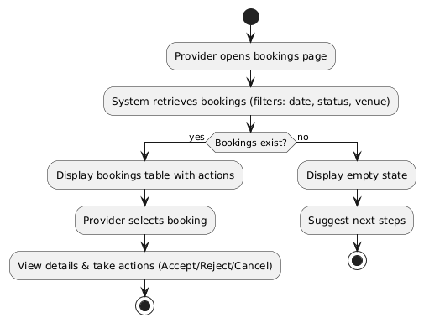

Figure 4.46 browse bookings activity diagram

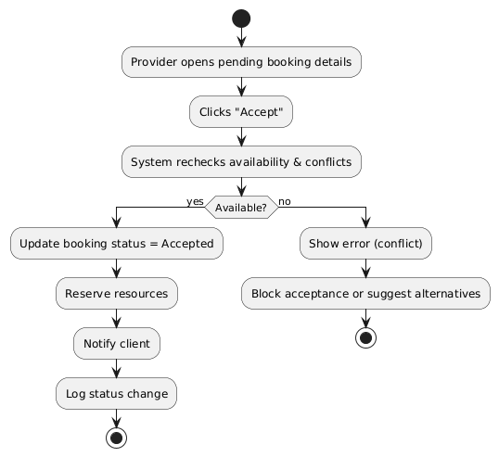

Figure 4.47 accept booking activity diagram

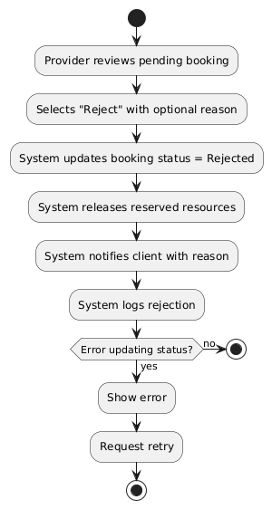

Figure 4.48 reject booking activity diagram

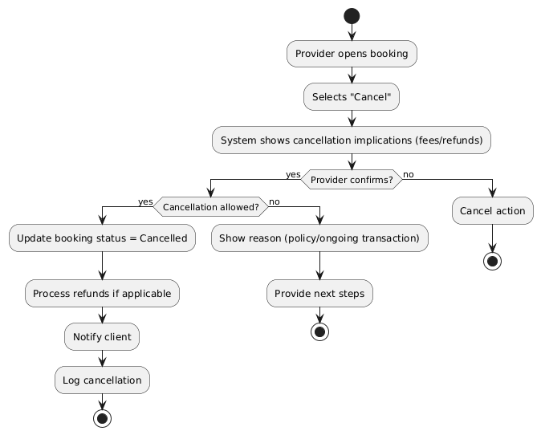

Figure 4.49 cancel booking activity diagram

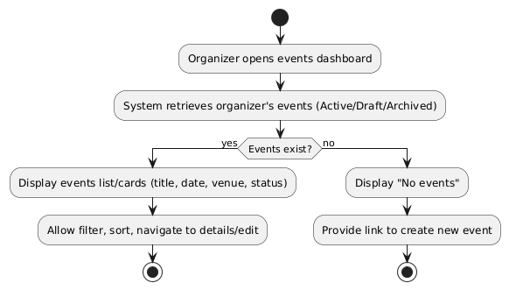

Figure 4.50 browse events (organizer) activity diagram

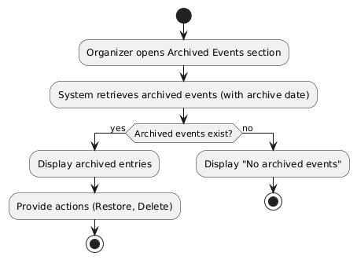

Figure 4.51 browse archived events activity diagram

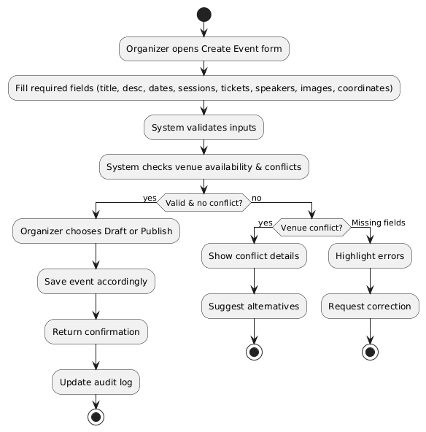

Figure 4.52 create event activity diagram

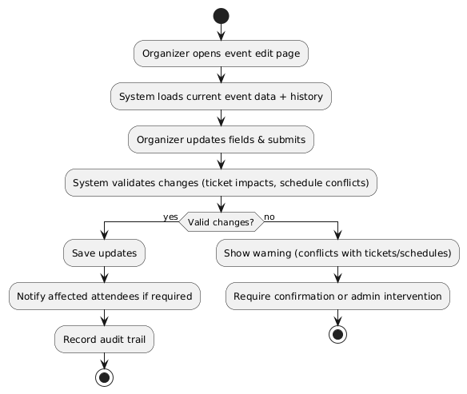

Figure 4.53 edit event activity diagram

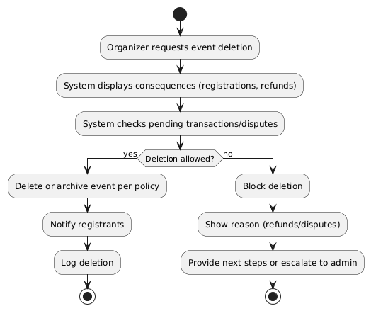

Figure 4.54 delete event activity diagram

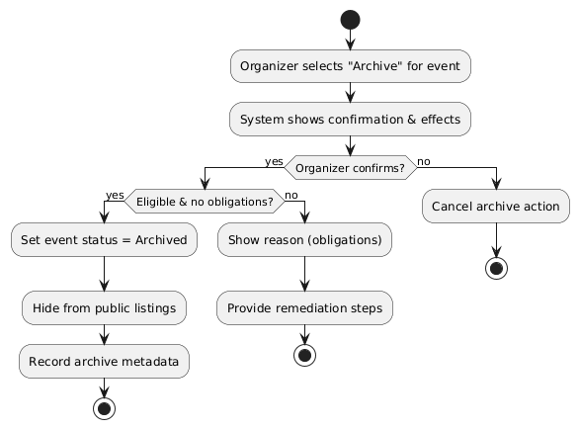

Figure 4.55 archive event activity diagram

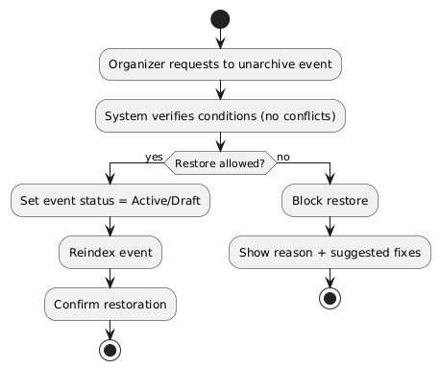

Figure 4.56 unarchive event activity diagram

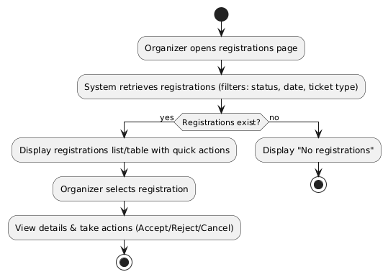

Figure 4.57 browse registrations activity diagram

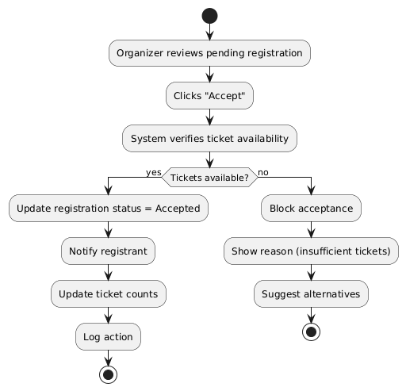

Figure 4.58 accept registration activity diagram

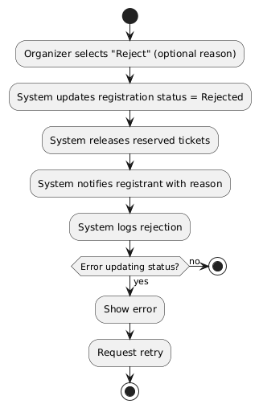

Figure 4.59 reject registration activity diagram

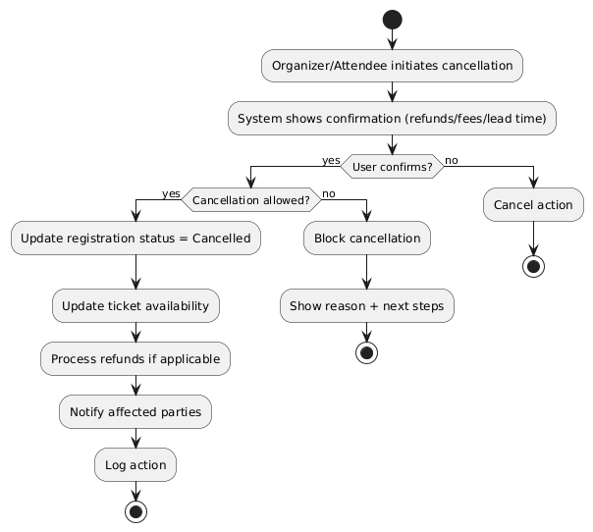

Figure 4.60 cancel registration activity diagram

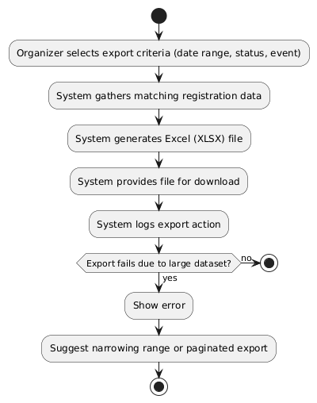

Figure 4.61 explore registration as excel file activity diagram

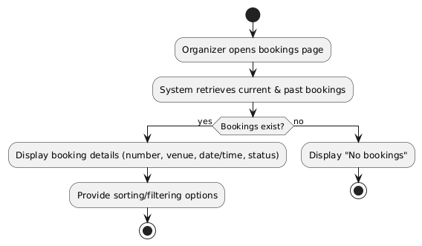

Figure 4.62 view booking (organizer) activity diagram

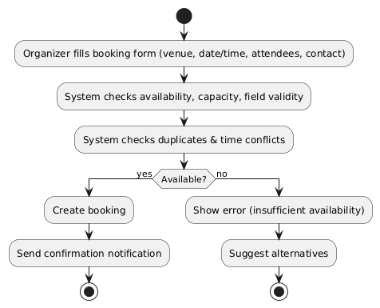

Figure 4.63 add booking (organizer) activity diagram

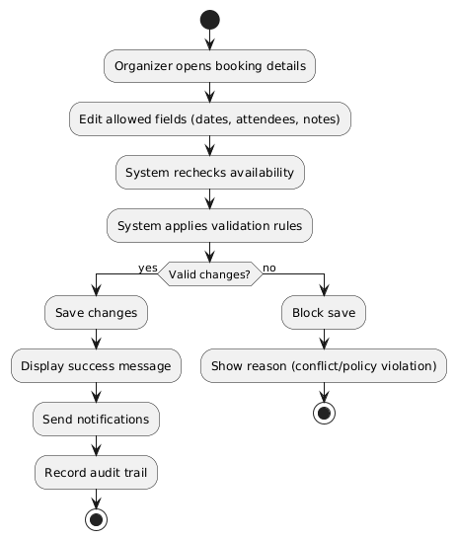

Figure 4.64 edit booking (organizer) activity diagram

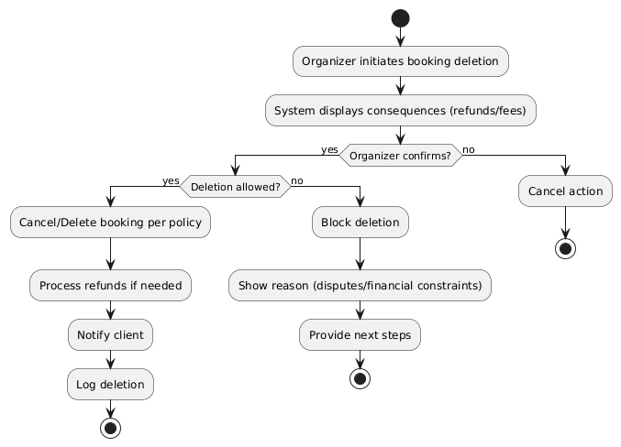

Figure 4.65 delete booking (organizer) activity diagram

**- sequence Diagram**

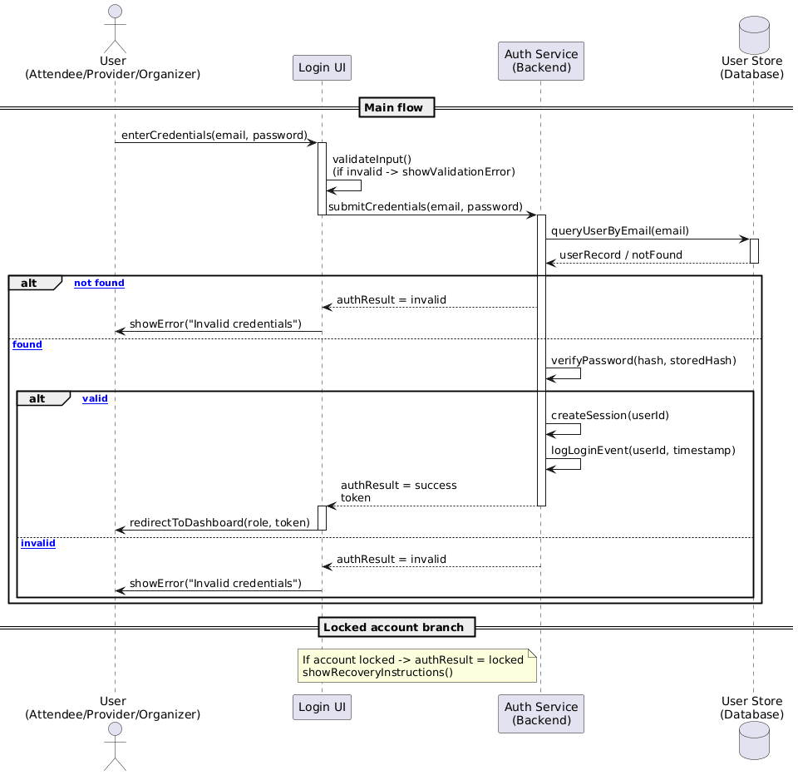

Figure 4.4 login sequence diagram

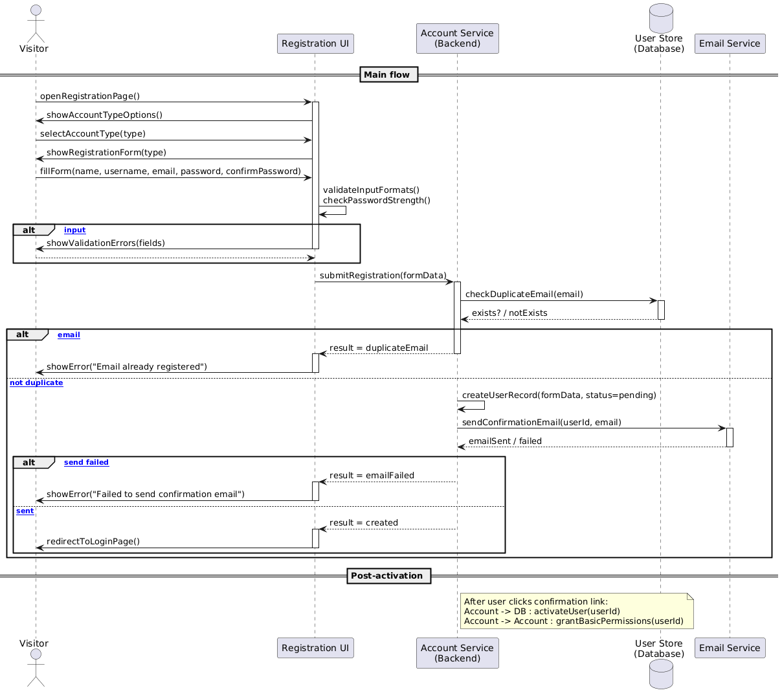

Figure 4.5 register (User Registration) sequence diagram

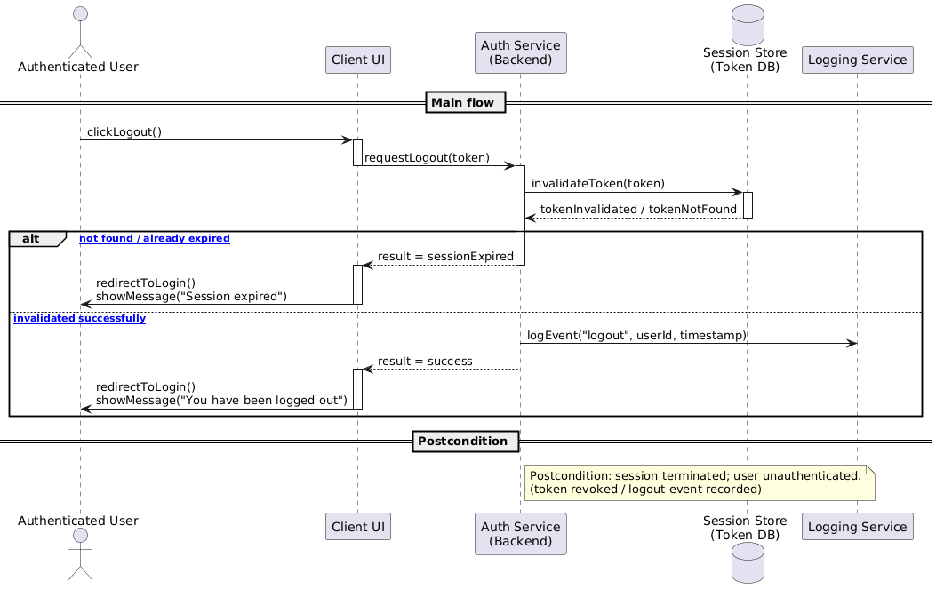

Figure 4.6 Register Logout sequence diagram

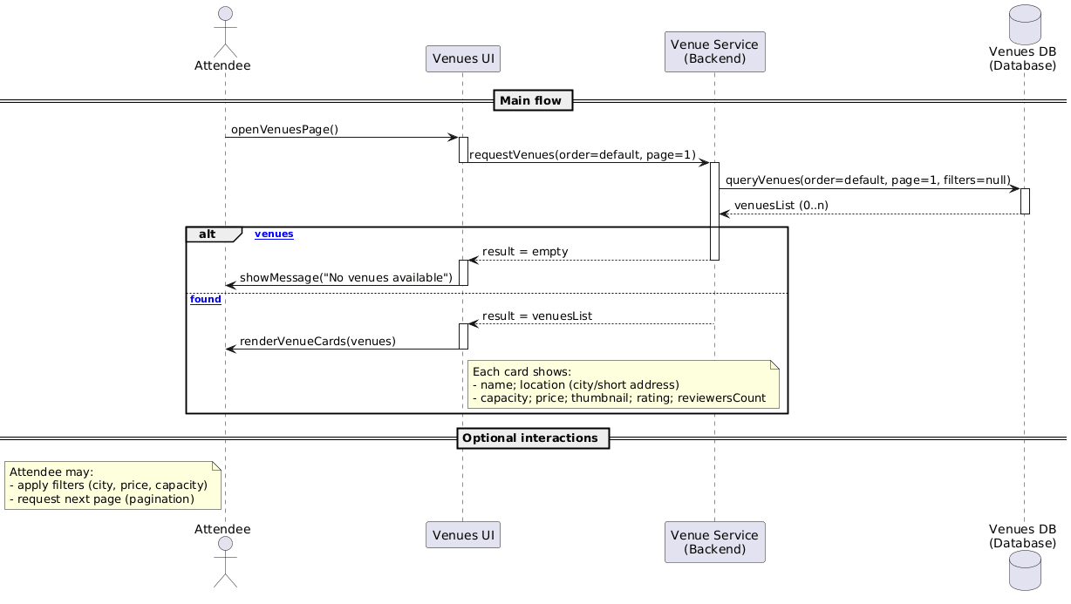

Figure 4.7 view venues sequence diagram

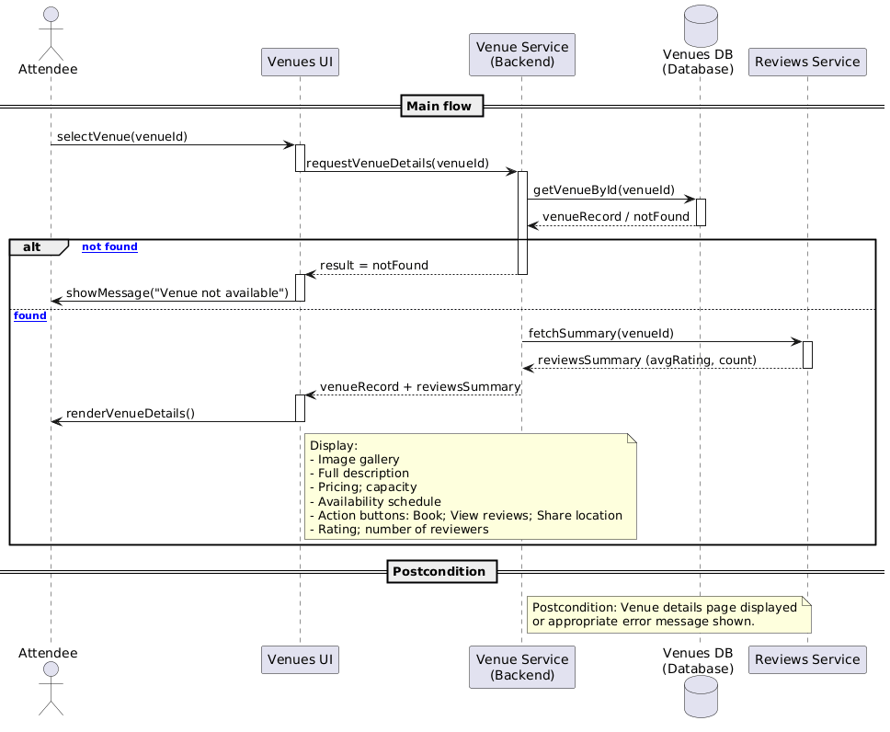

Figure 4.8 view venues details sequence diagram

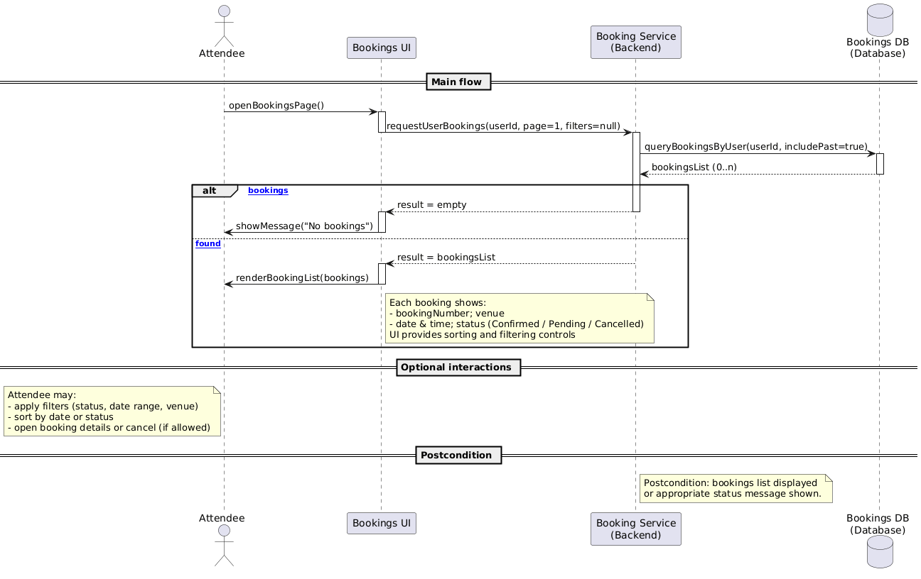

Figure 4.9 view bookings sequence diagram

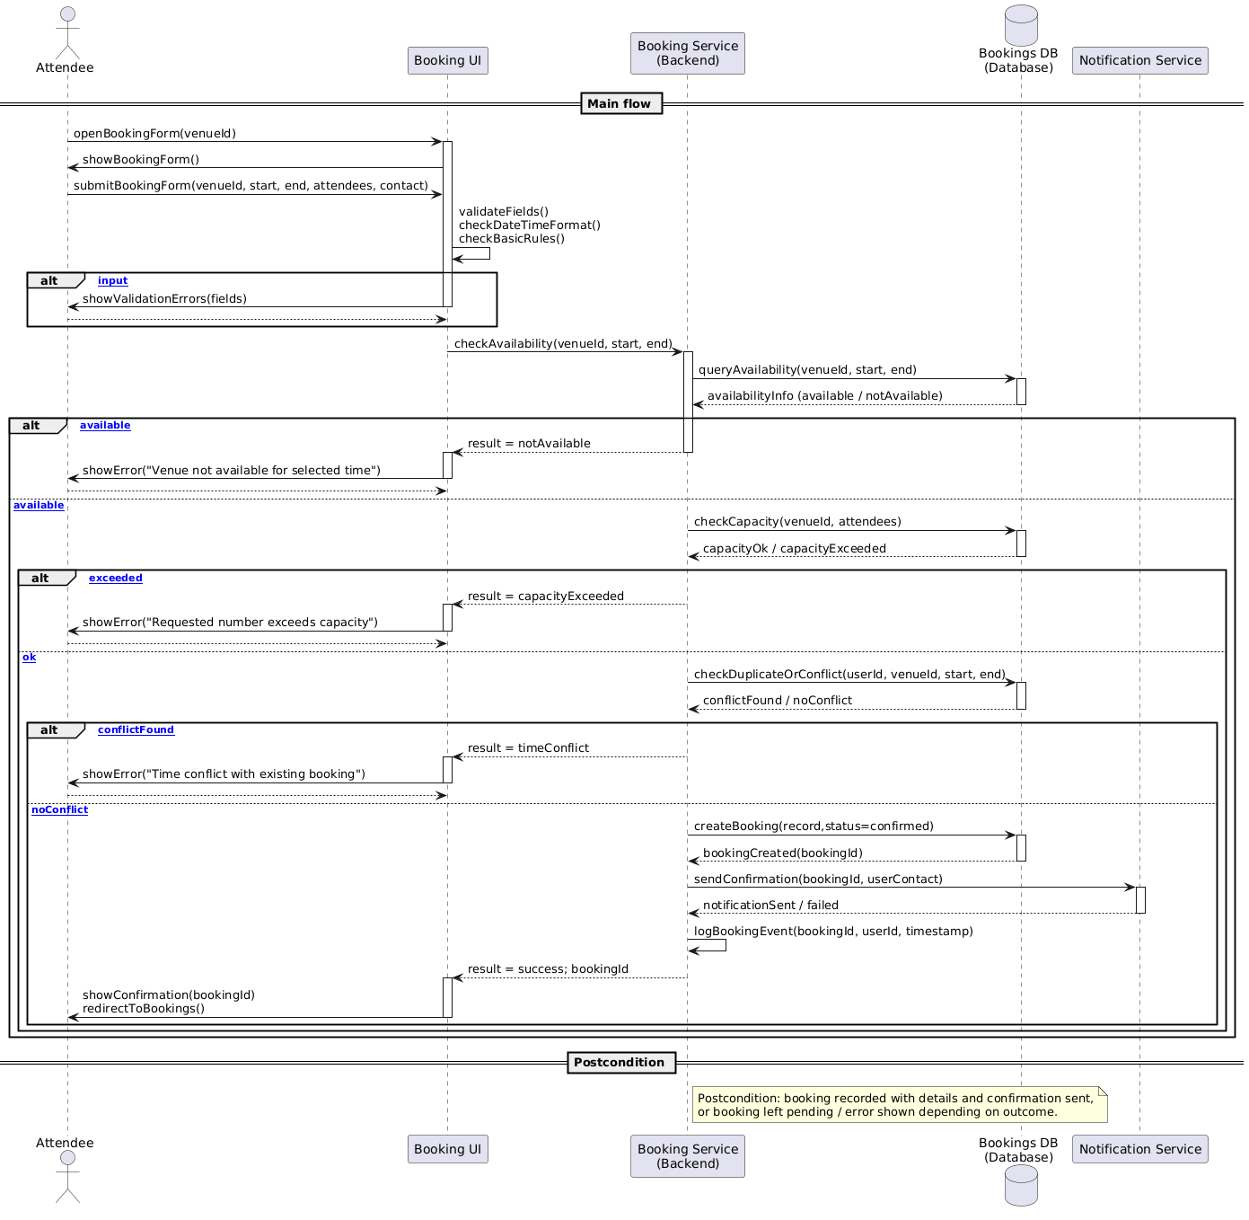

Figure 4.10 add booking sequence diagram

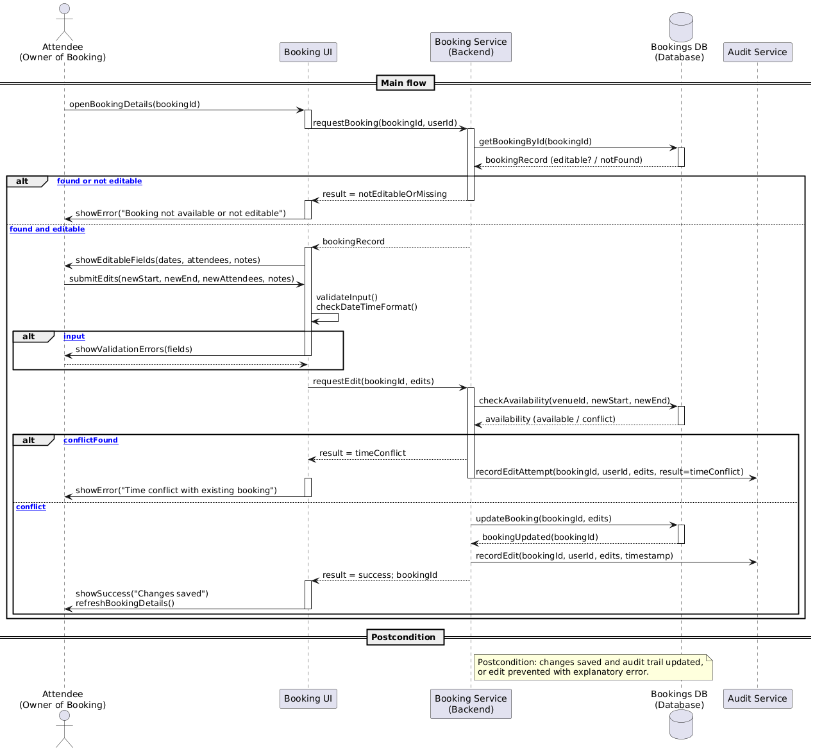

Figure 4.11 edit booking sequence diagram

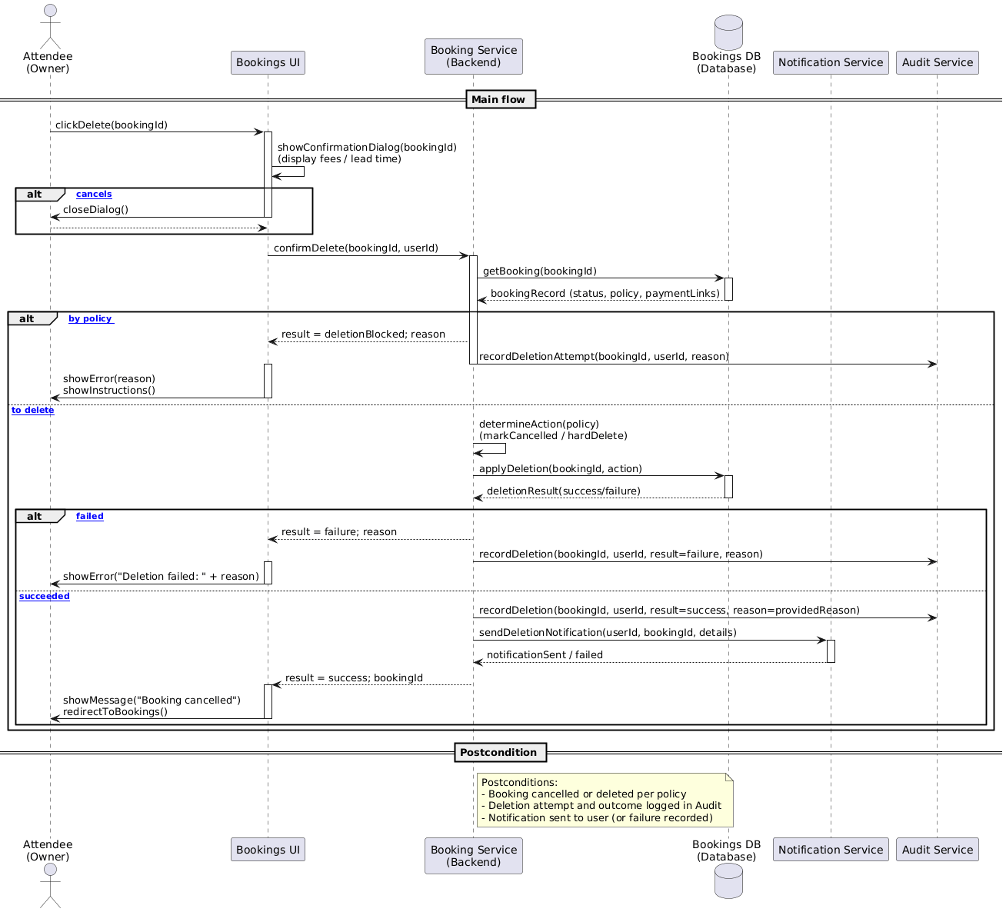

Figure 4.12 delete booking sequence diagram

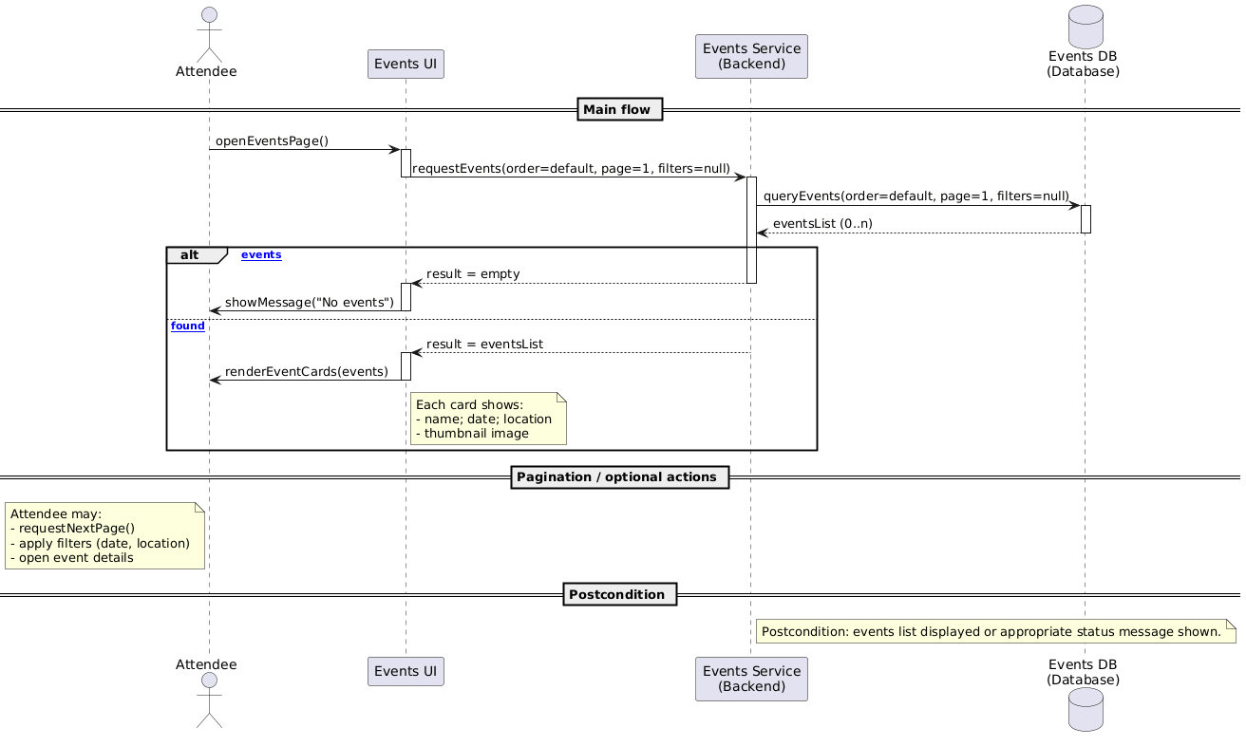

Figure 4.13 view events sequence diagram

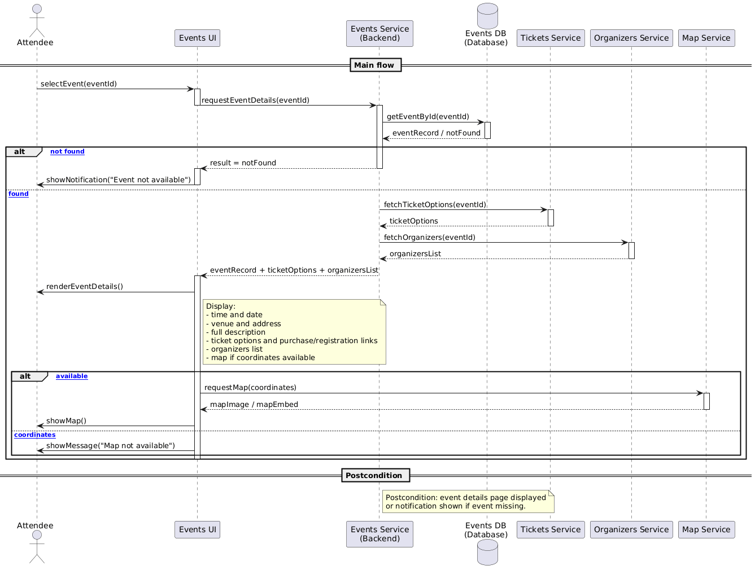

Figure 4.14 view events details sequence diagram

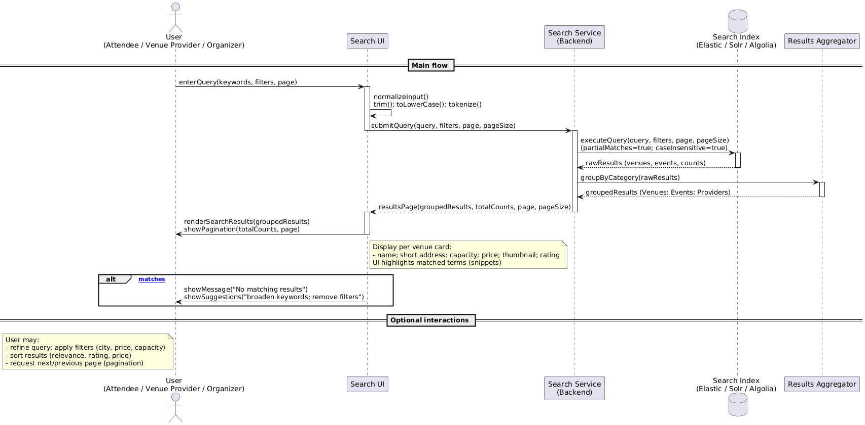

Figure 4.15 unified search for venues sequence diagram

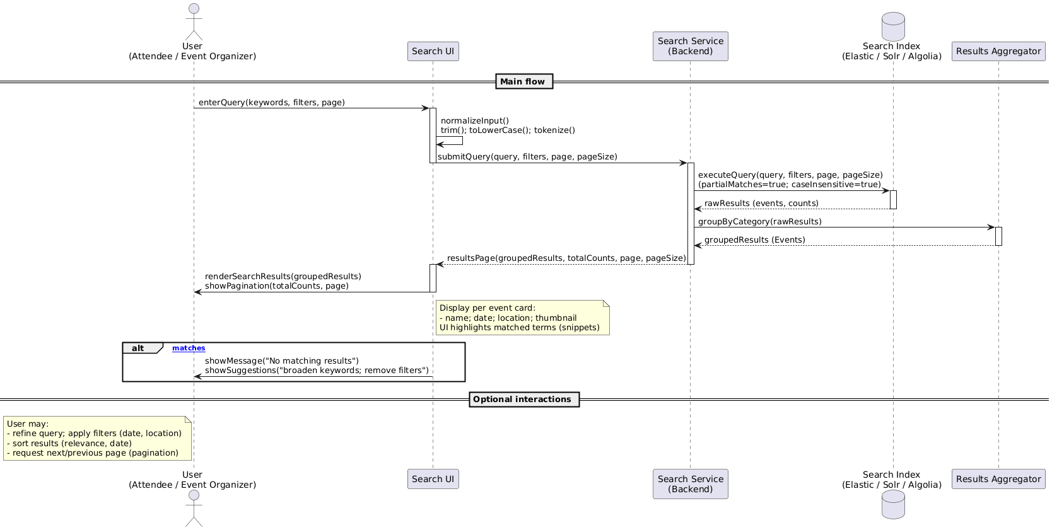

Figure 4.16 unified search for events sequence diagram

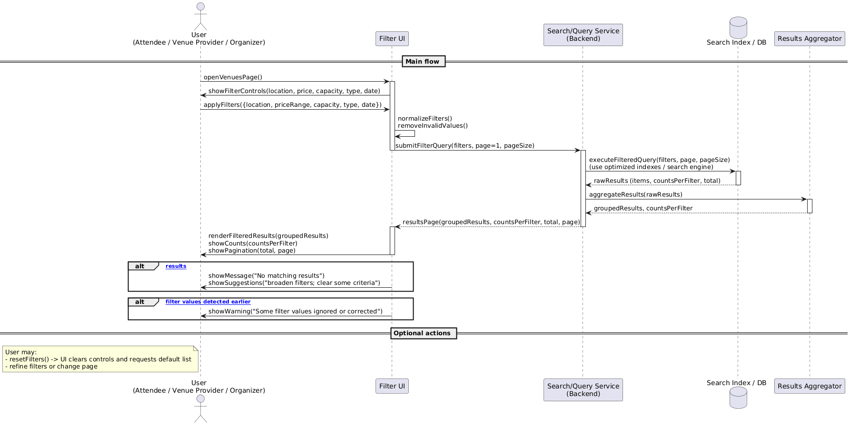

Figure 4.17 filter venues by specific criteria sequence diagram

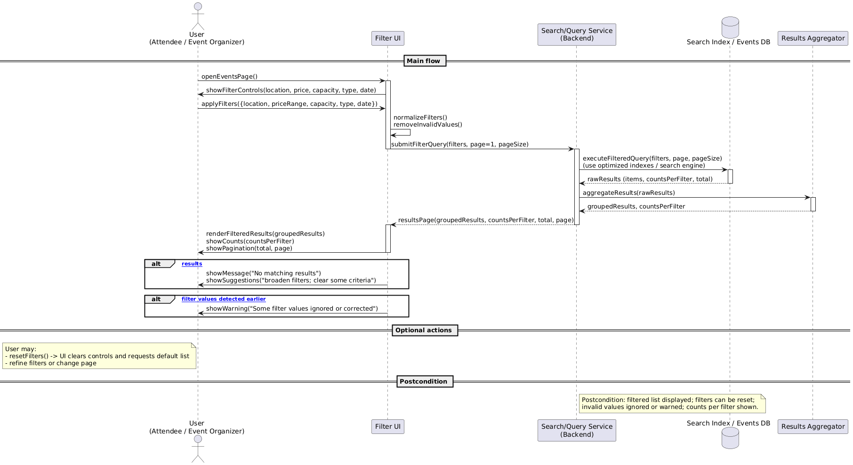

Figure 4.18 filter events by specific criteria sequence diagram

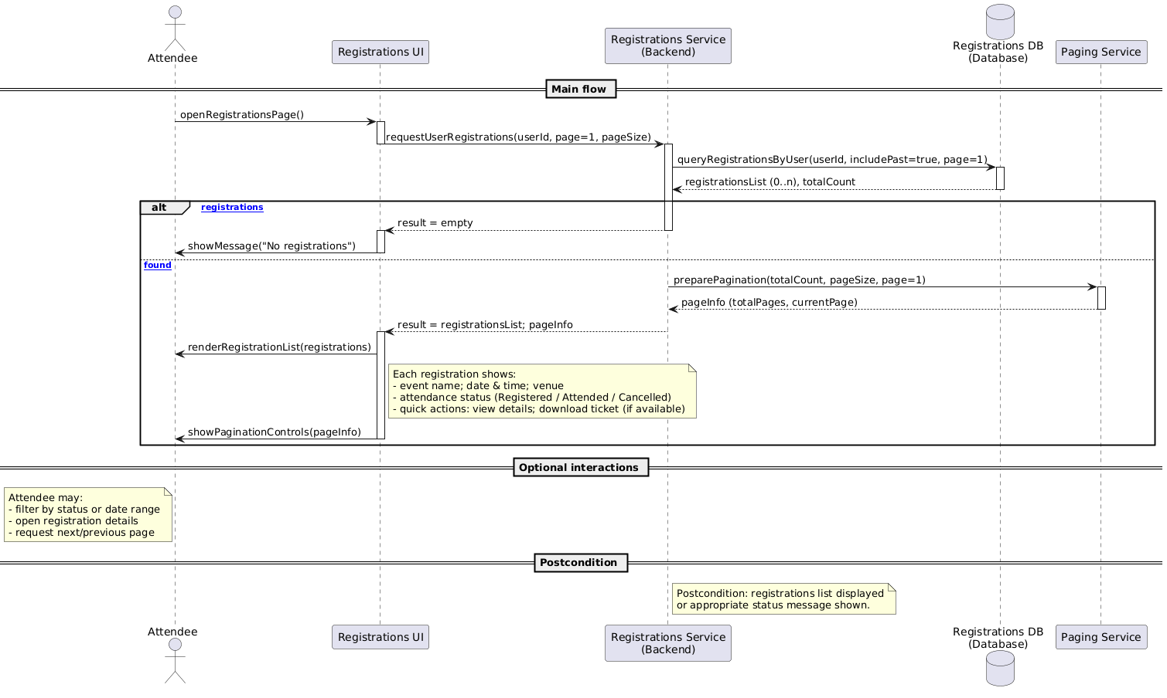

Figure 4.19 view registration sequence diagram

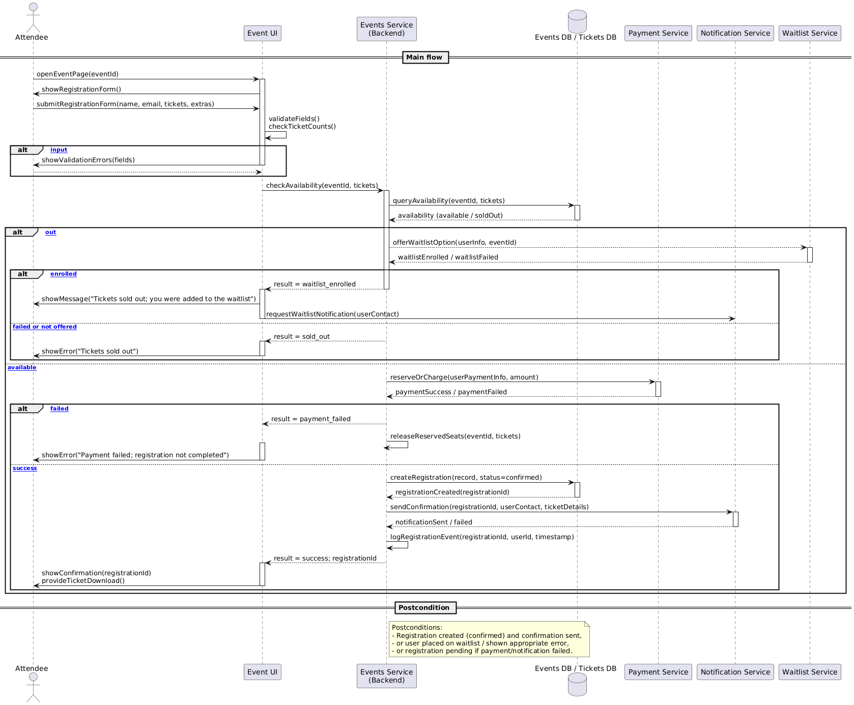

Figure 4.20 add registration sequence diagram

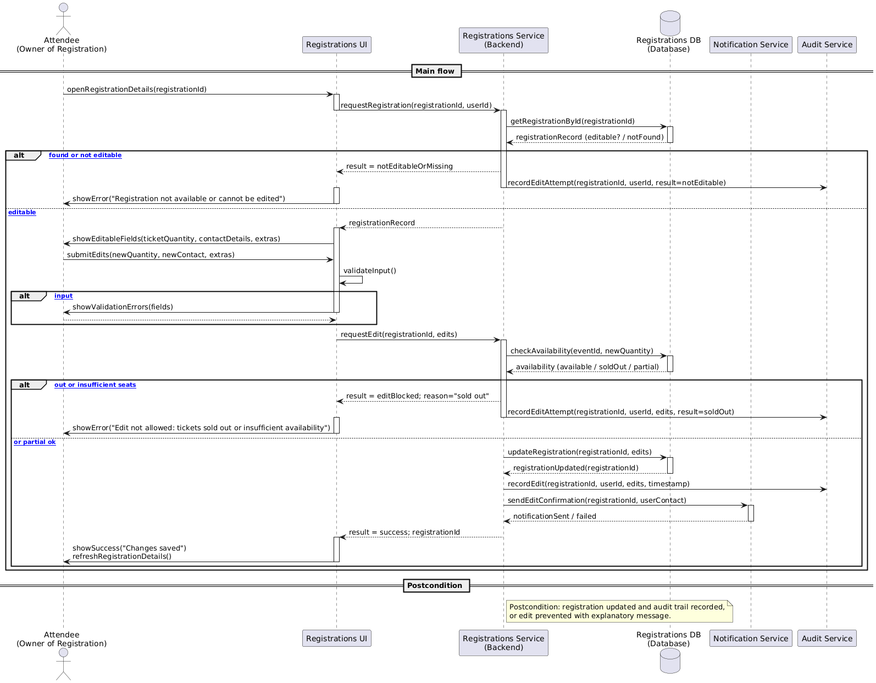

Figure 4.21 edit registration sequence diagram

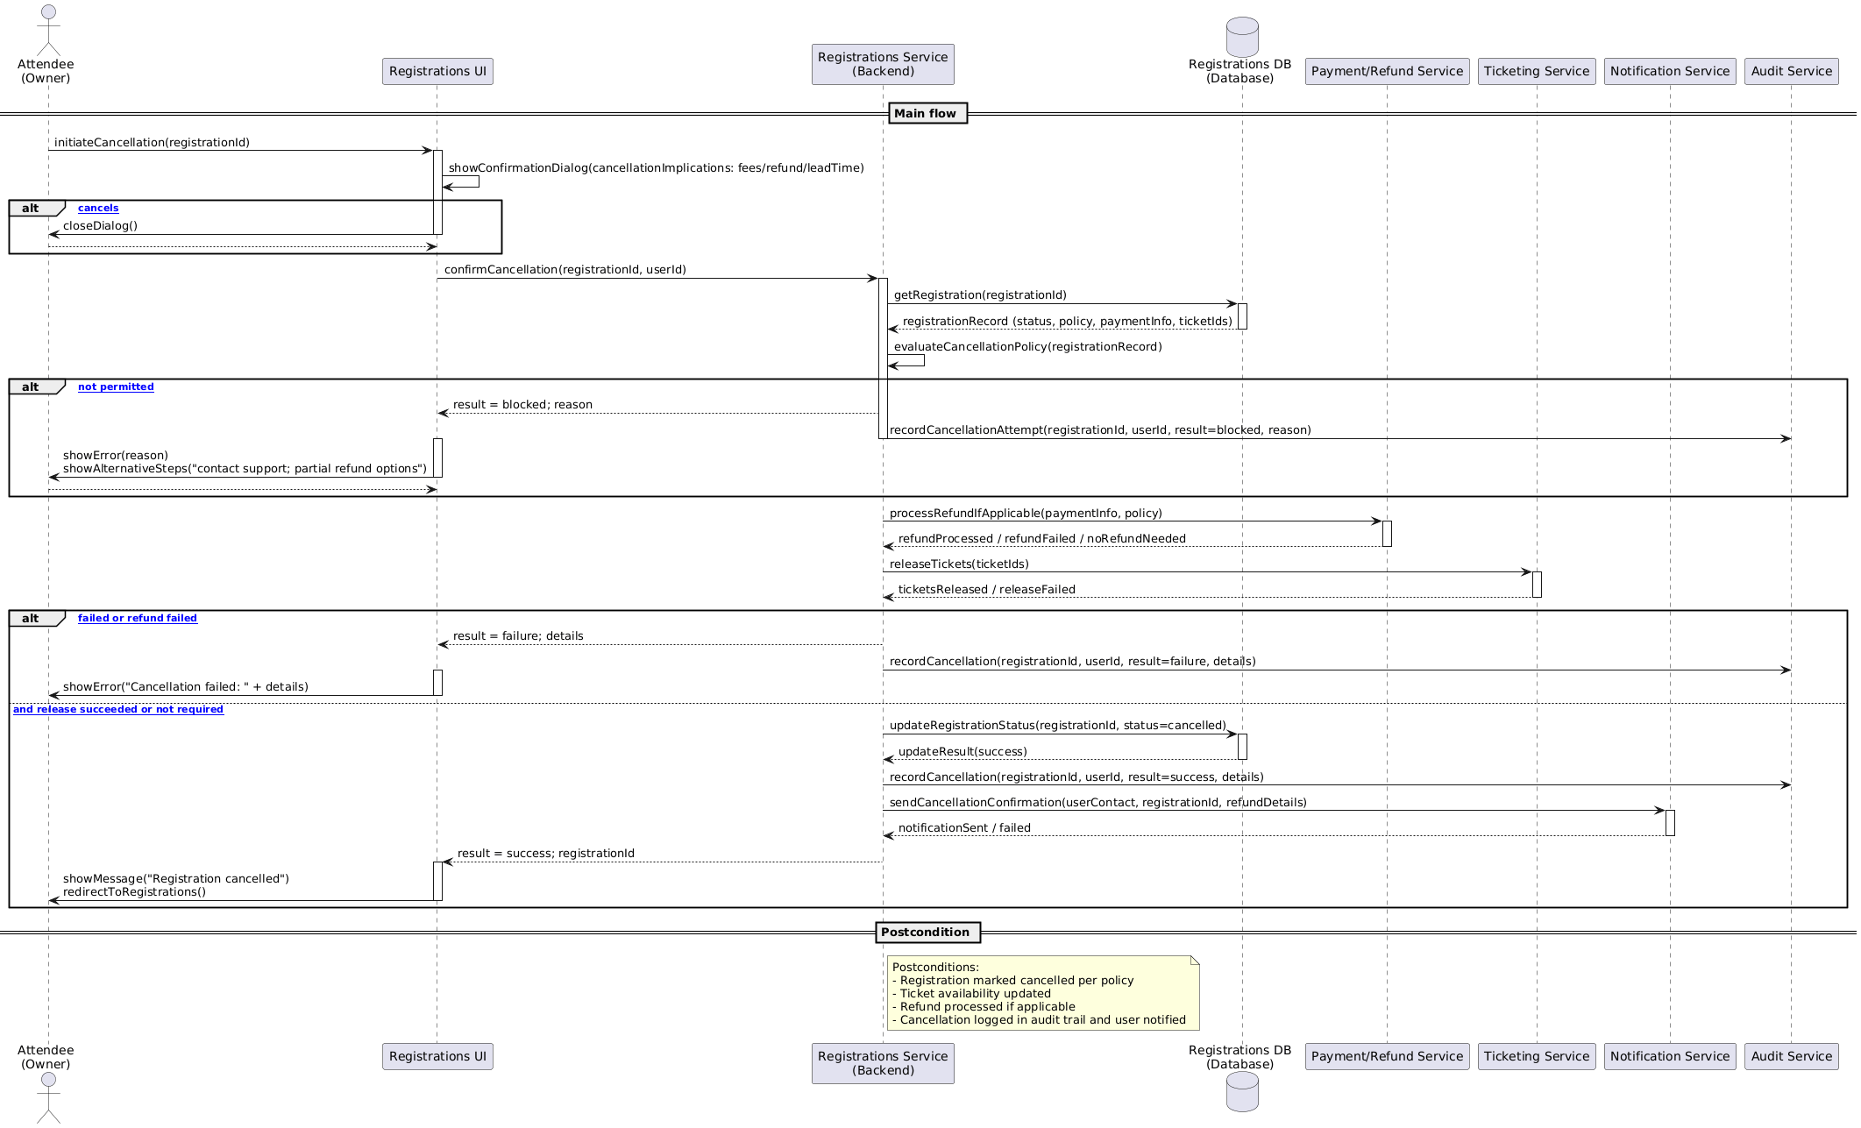

Figure 4.22 delete registration sequence diagram

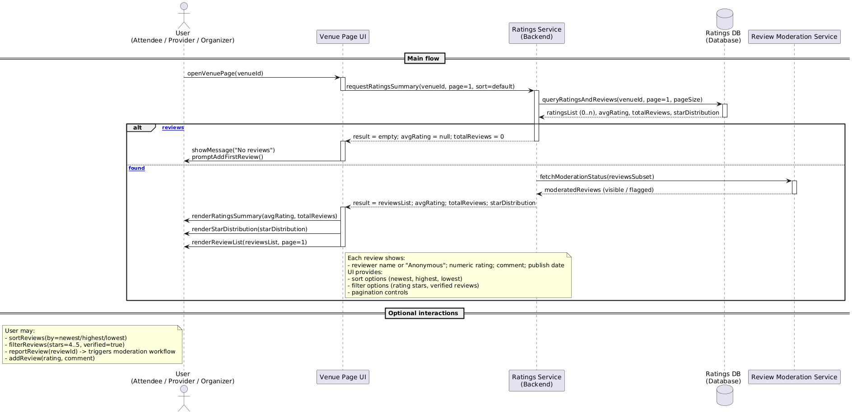

Figure 4.23 view venue ratings sequence diagram

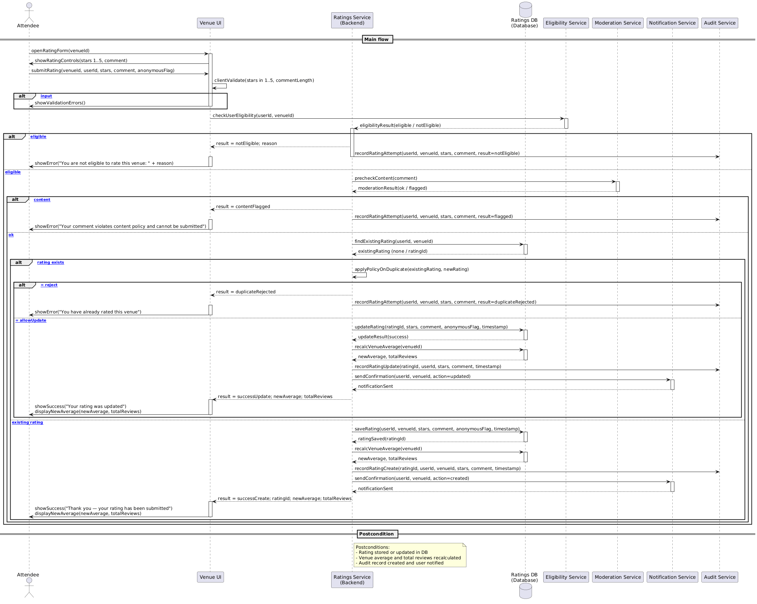

Figure 4.24 add venue rating sequence diagram

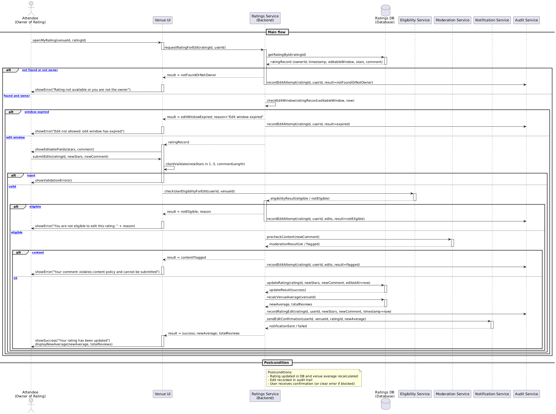

Figure 4.25 edit venue rating sequence diagram

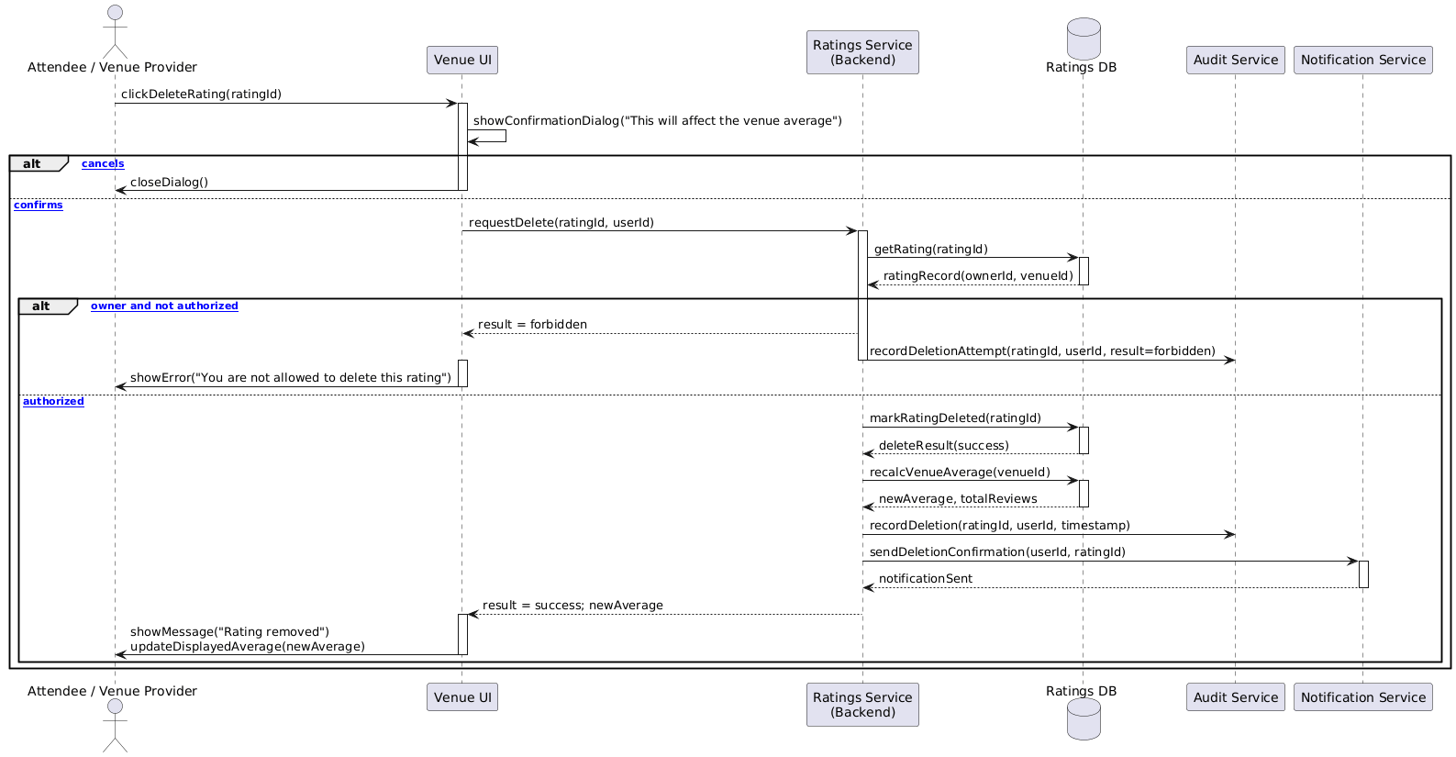

Figure 4.26 delete venue rating sequence diagram

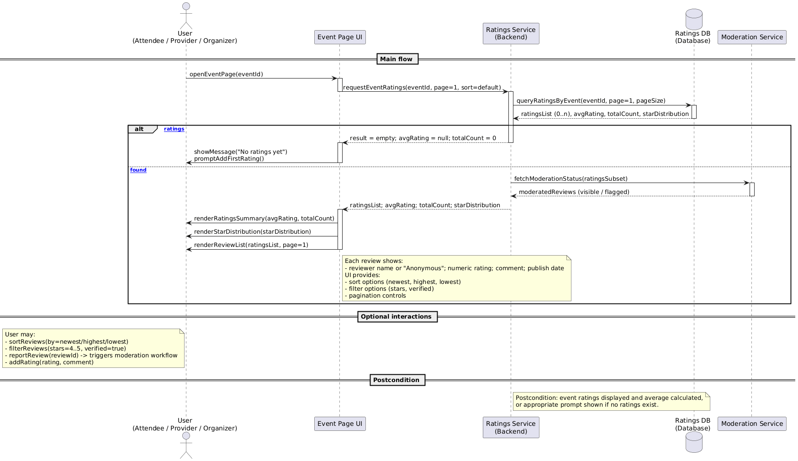

Figure 4.27 view event ratings sequence diagram

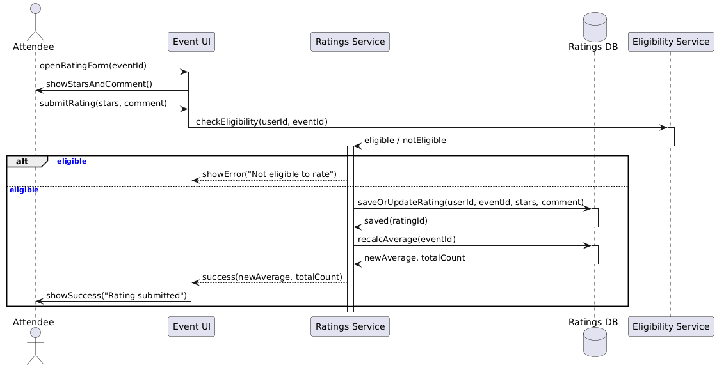

Figure 4.28 add event rating sequence diagram

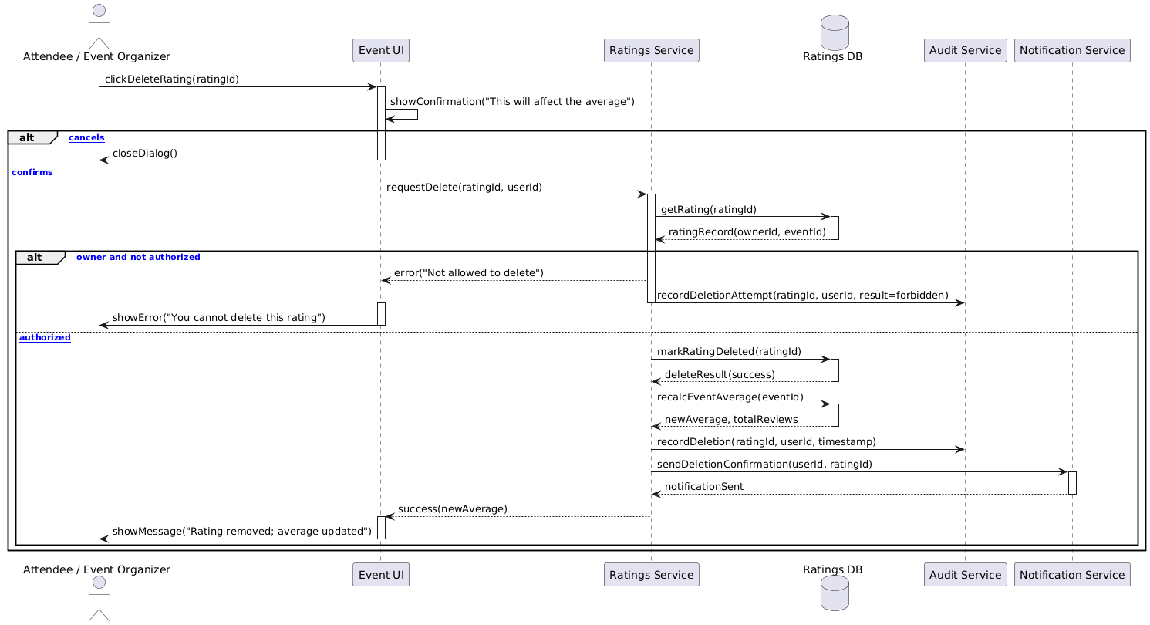

Figure 4.29 edit event rating sequence diagram

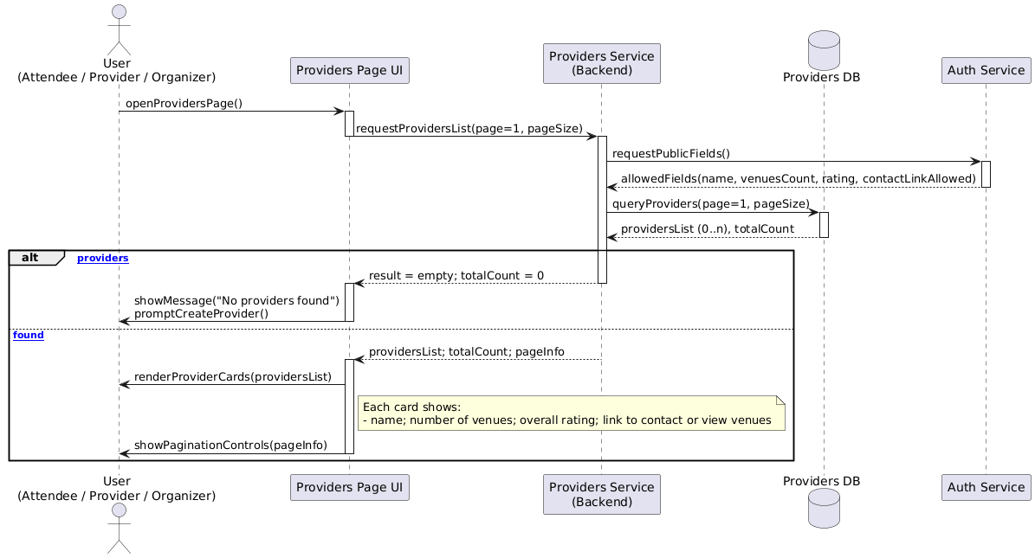

Figure 4.30 delete event rating sequence diagram

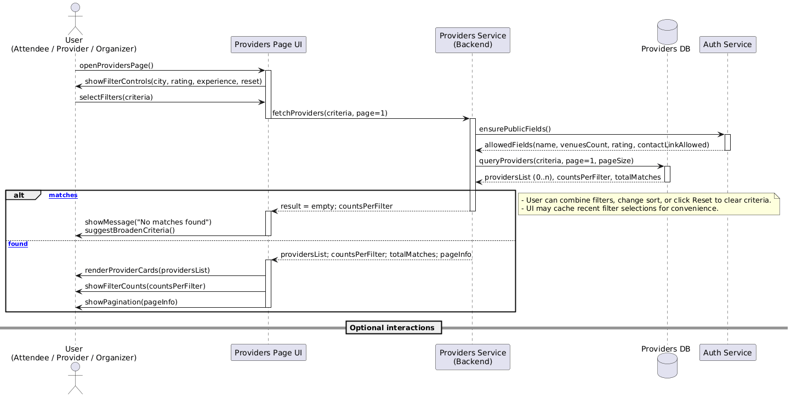

Figure 4.31 view organizers sequence diagram

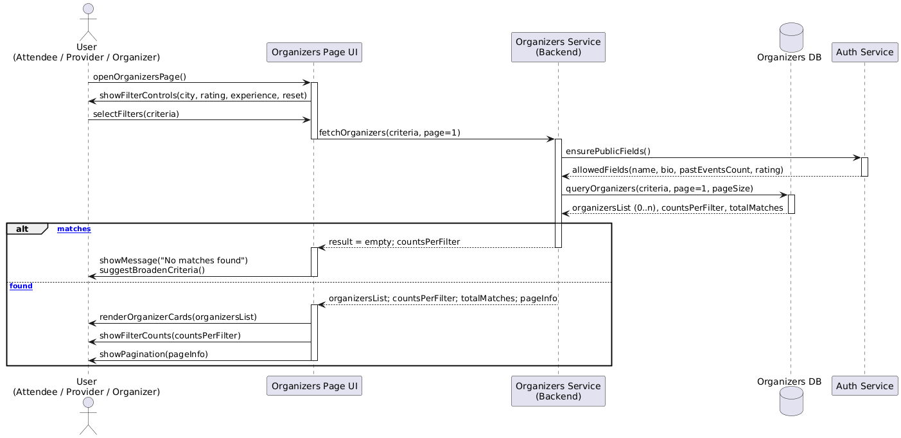

Figure 4.32 view providers sequence diagram



Figure 4.33 filter providers by specific criteria sequence diagram



Figure 4.34 filter Organizers by specific criteria sequence diagram

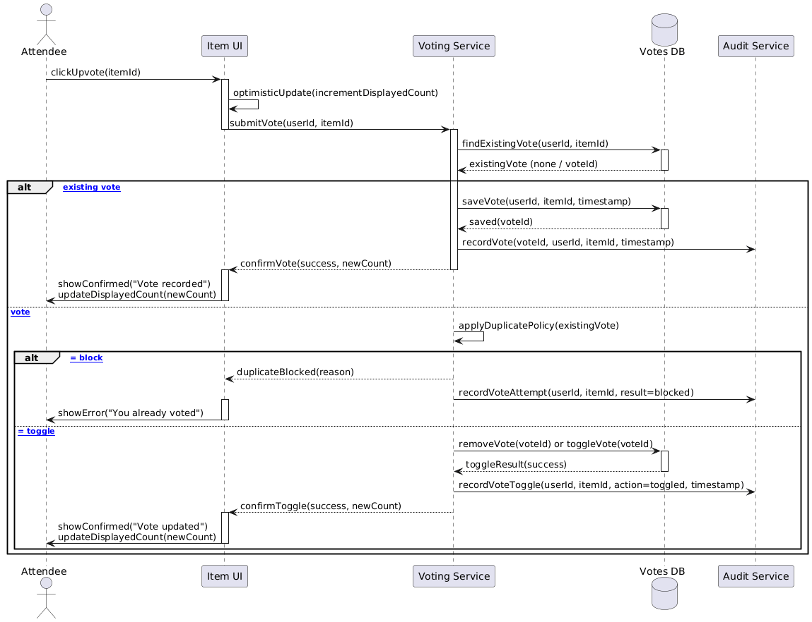

Figure 4.35 upvote sequence diagram

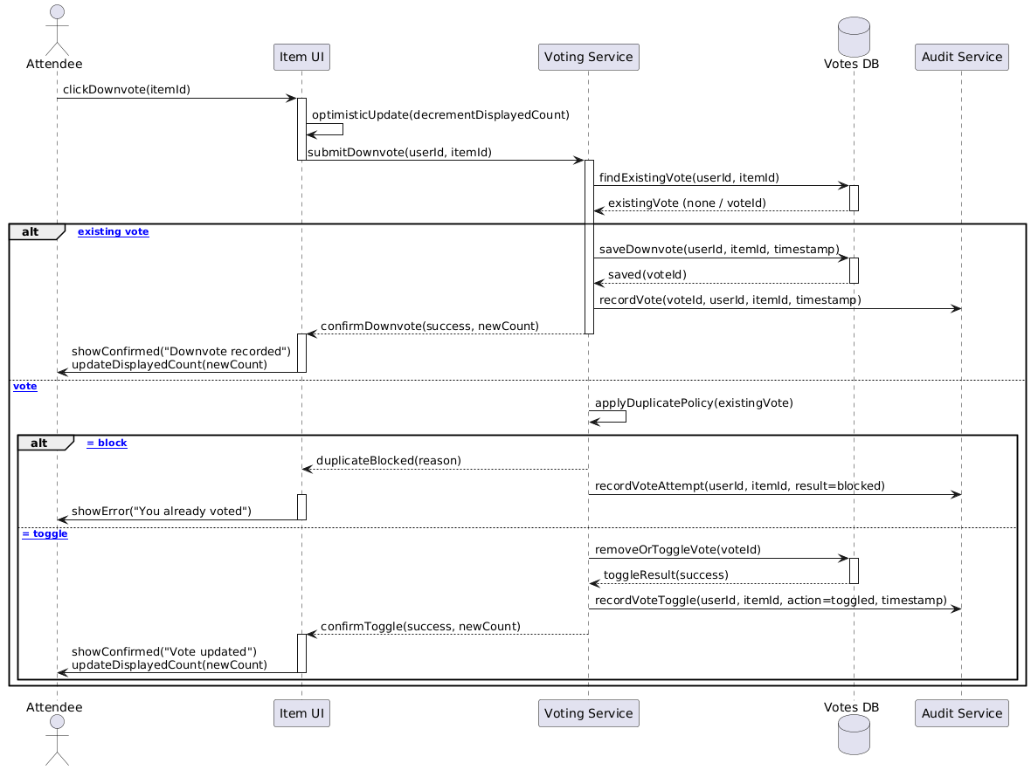

Figure 4.36 downvote sequence diagram

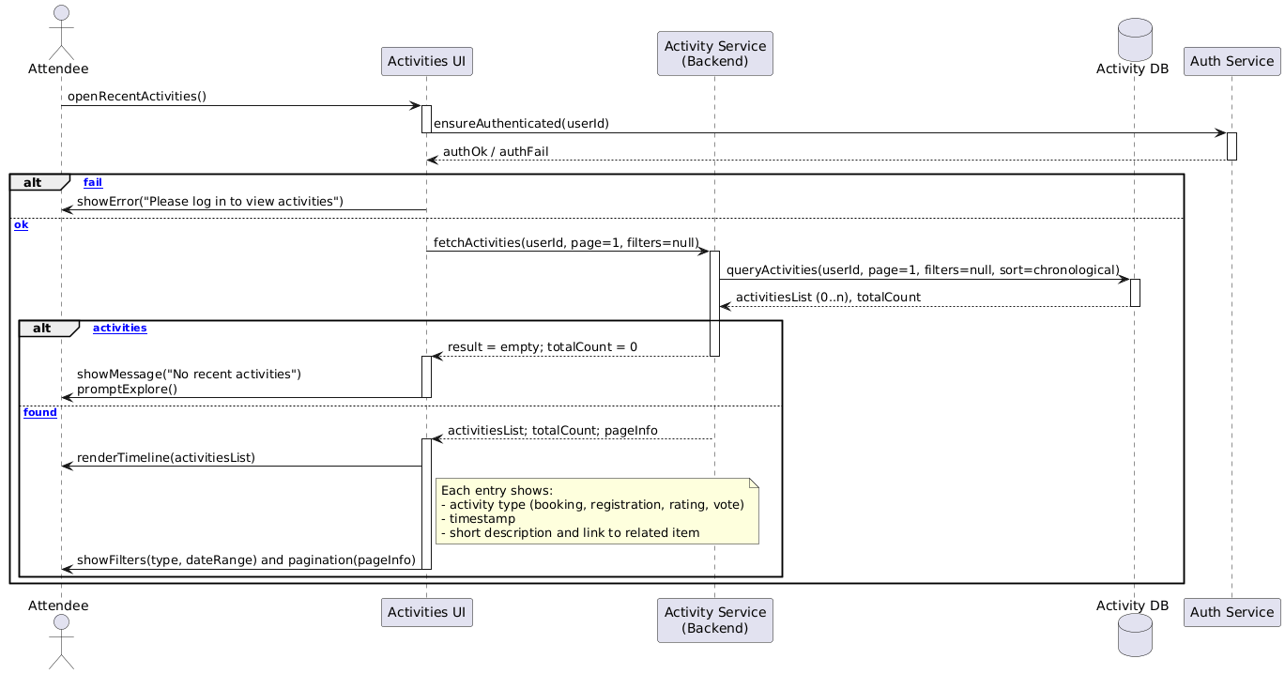

Figure 4.37 view recent activities sequence diagram

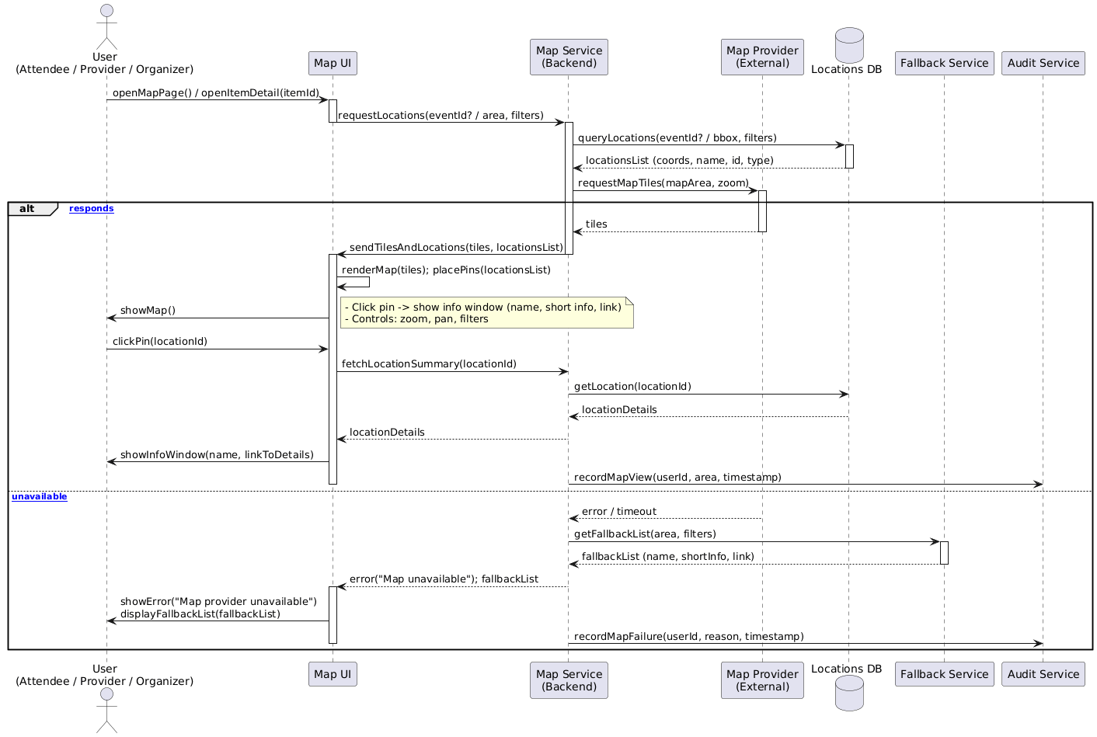

Figure 4.38 display map of event and venue locations sequence diagram

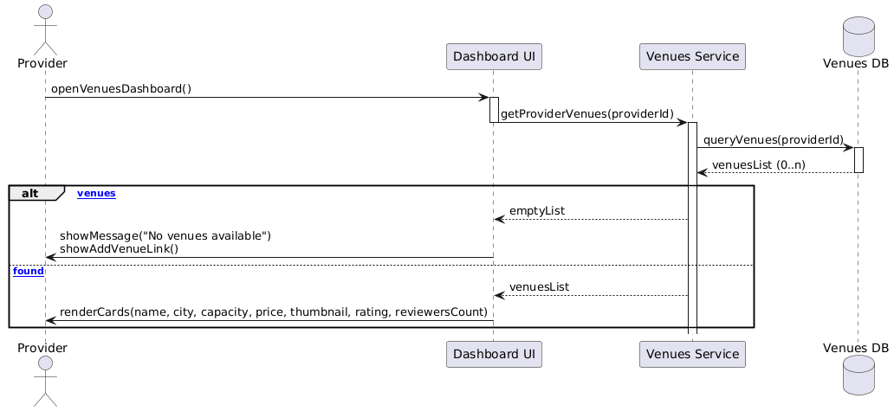

Figure 4.39 browse venues (provider) sequence diagram

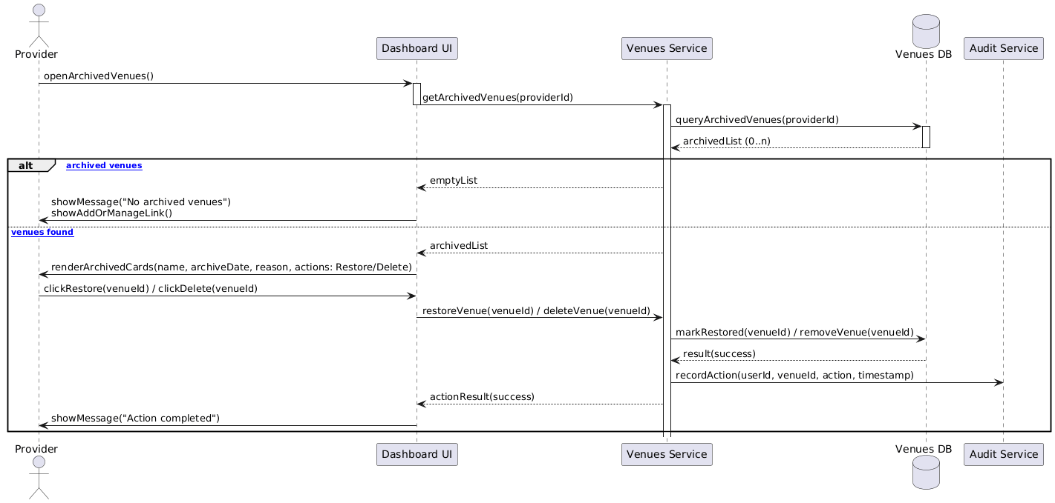

Figure 4.40 brows archived venues sequence diagram

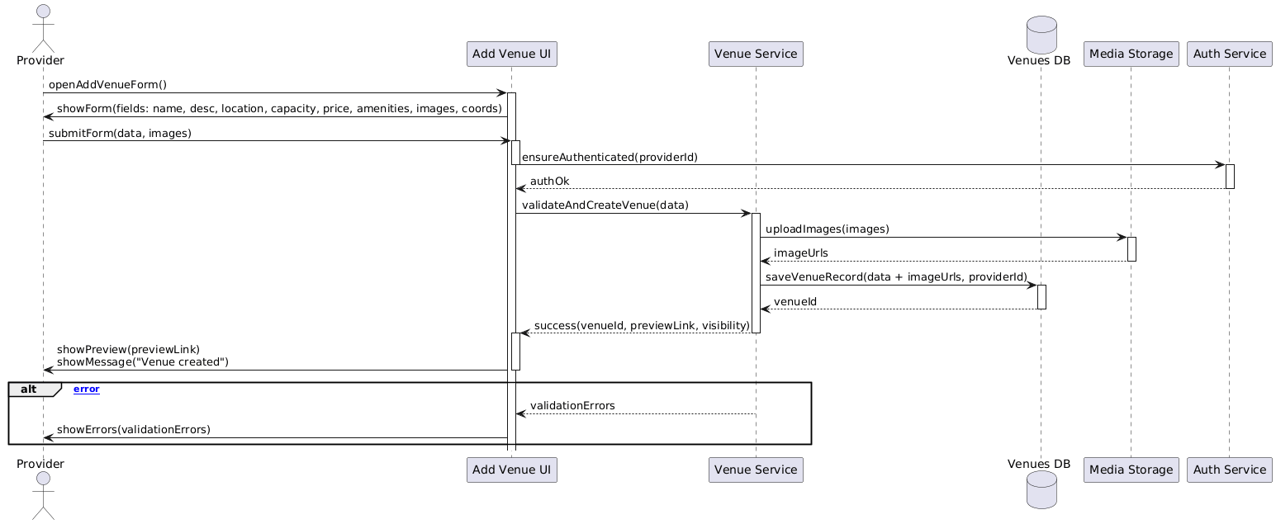

Figure 4.41 add venue sequence diagram

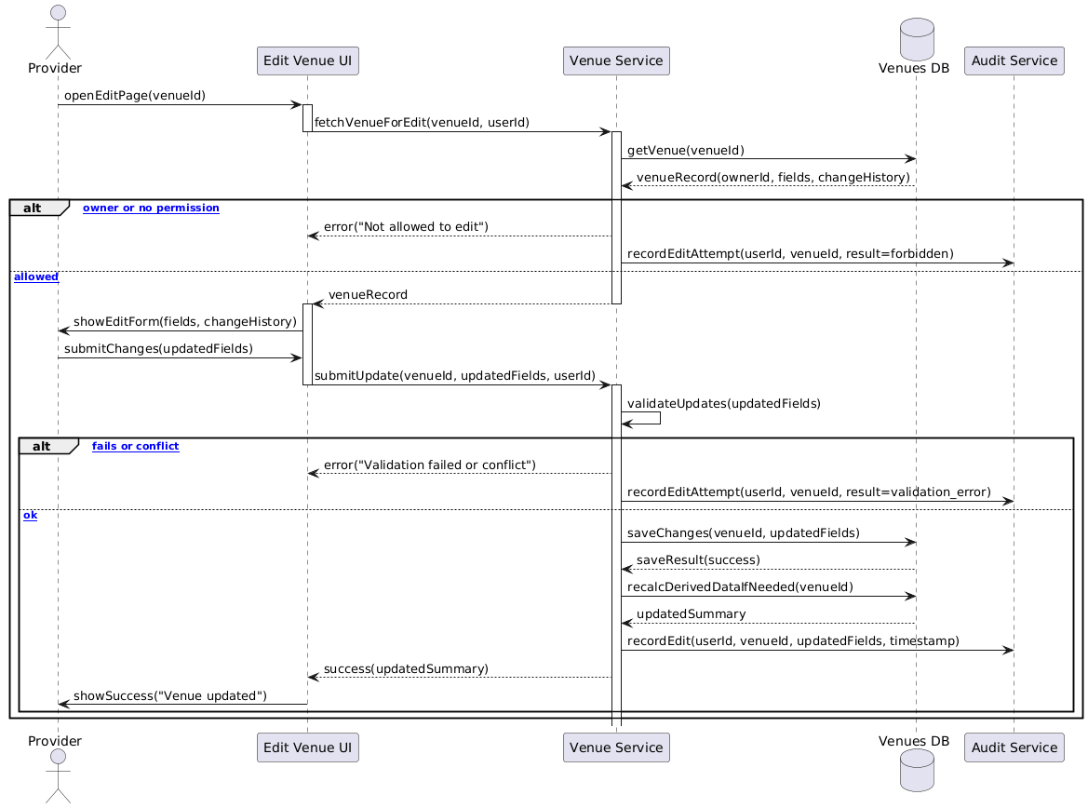

Figure 4.42 edit venue sequence diagram



Figure 4.43 delete venue sequence diagram

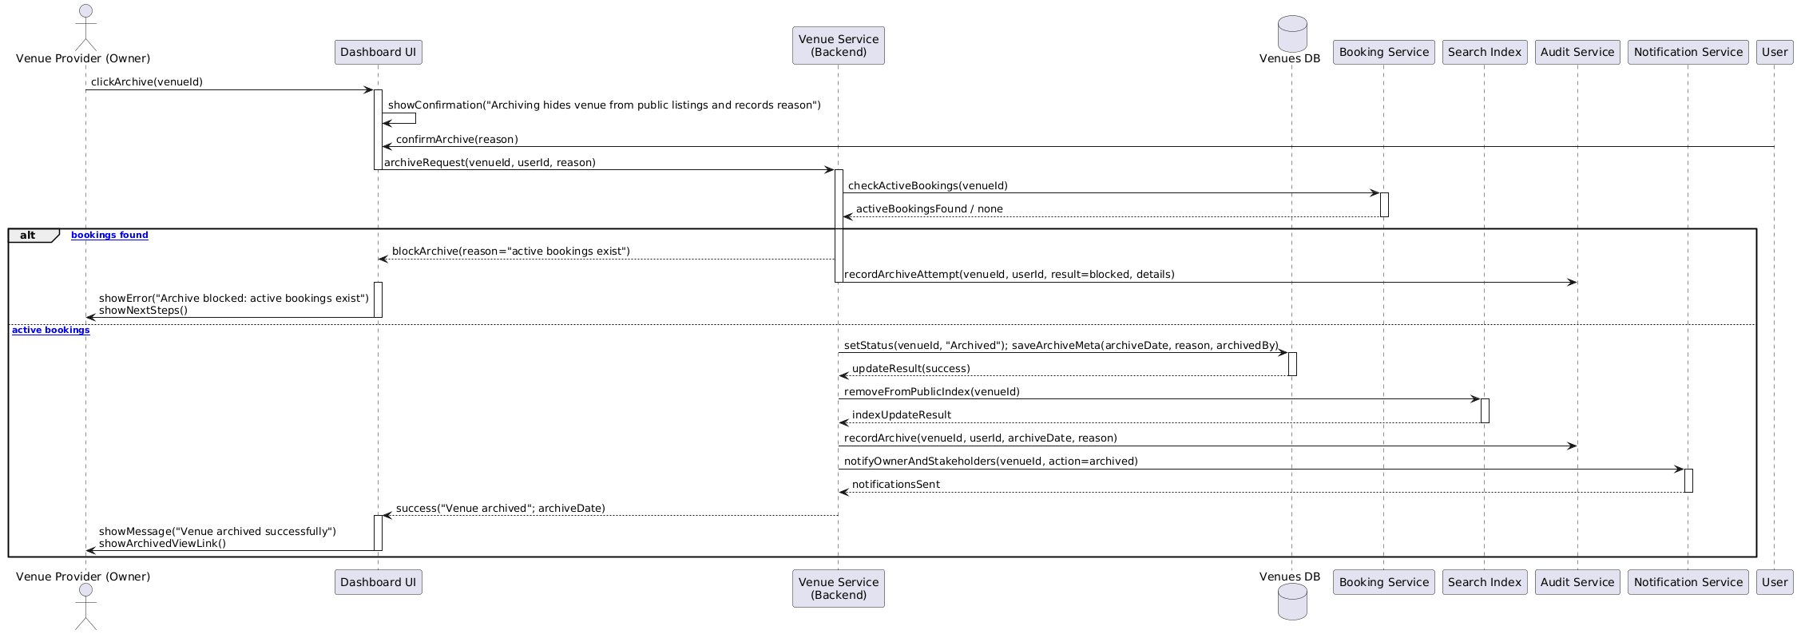

Figure 4.44 archive venue sequence diagram

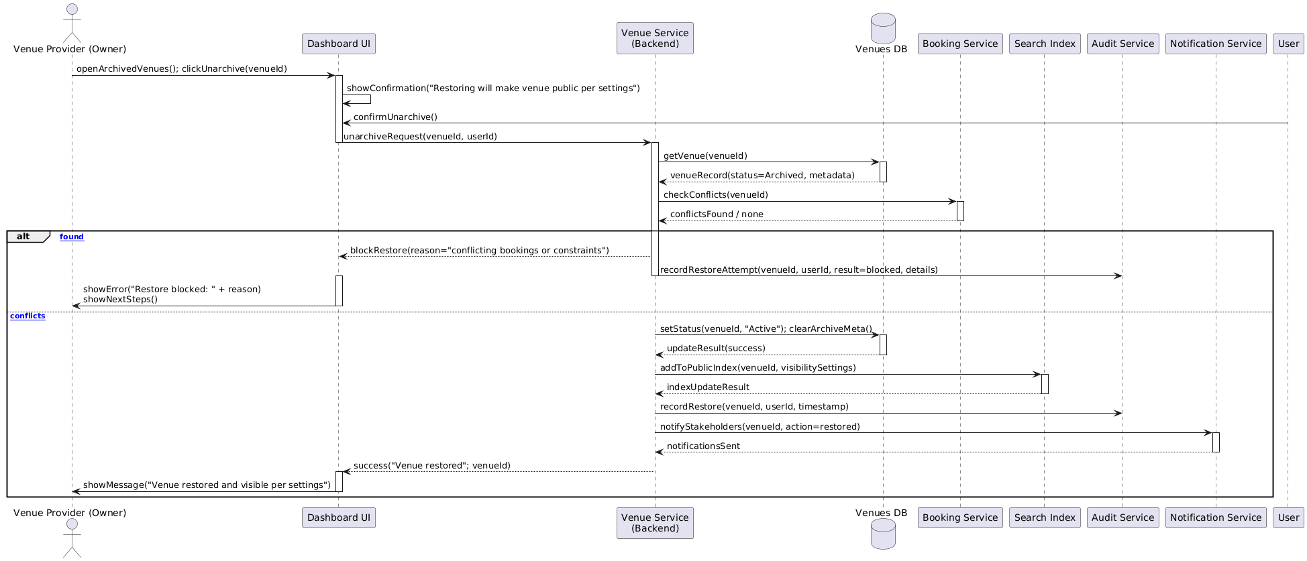

Figure 4.45 unarchive venue sequence diagram

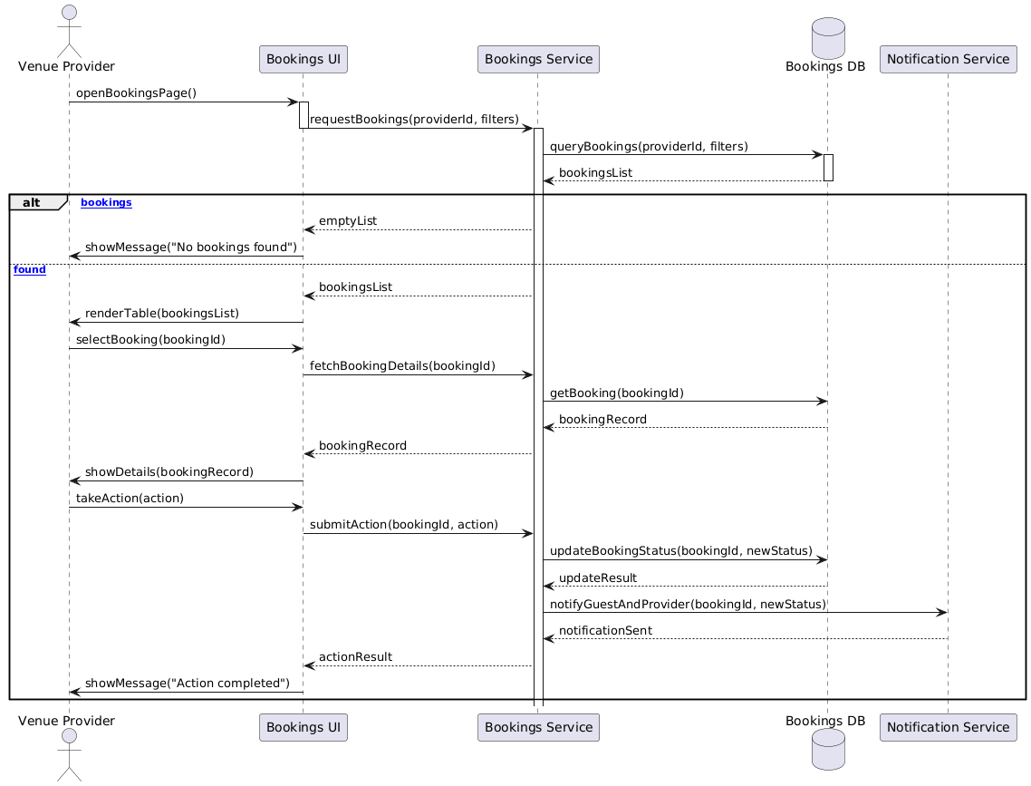

Figure 4.46 browse bookings sequence diagram



Figure 4.47 accept booking sequence diagram

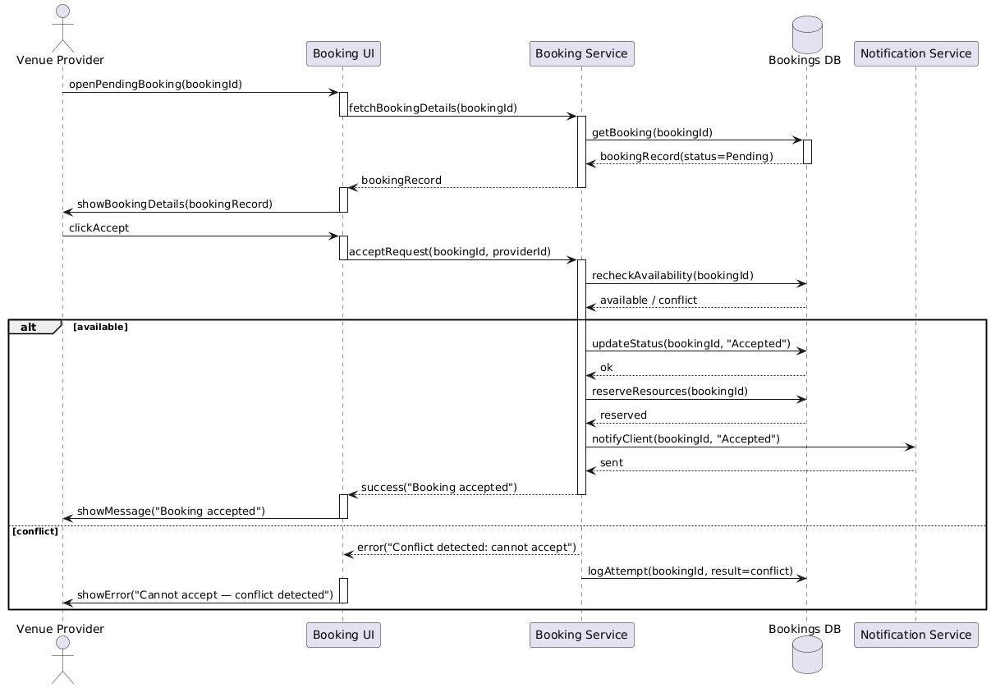

Figure 4.48 reject booking sequence diagram

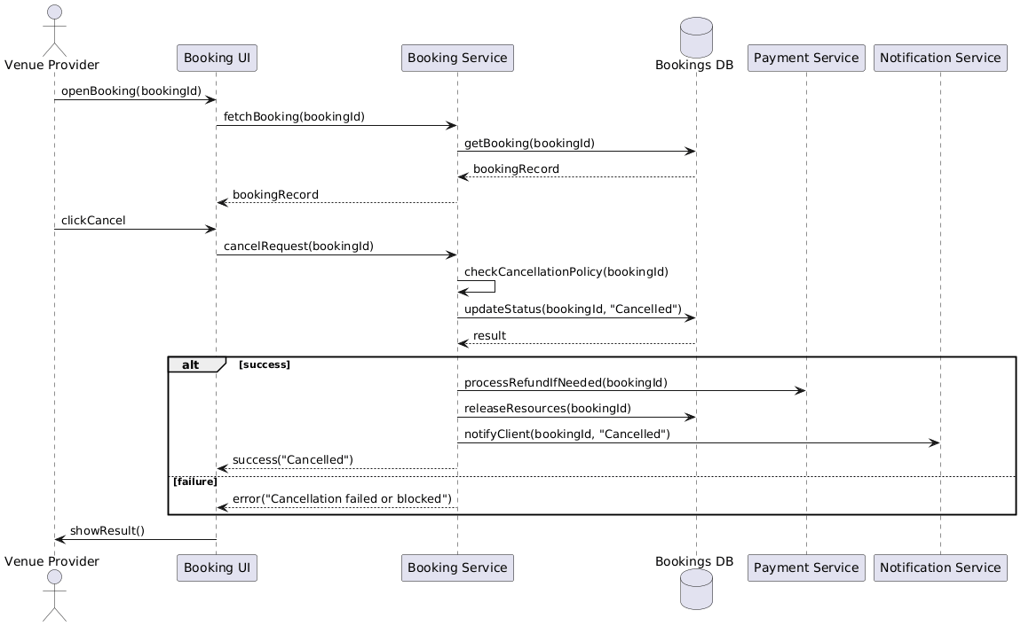

Figure 4.49 cancel booking sequence diagram

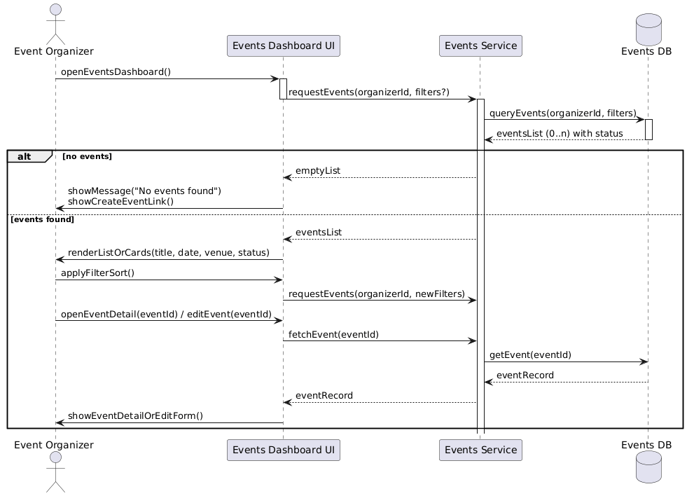

Figure 4.50 browse events (organizer) sequence diagram

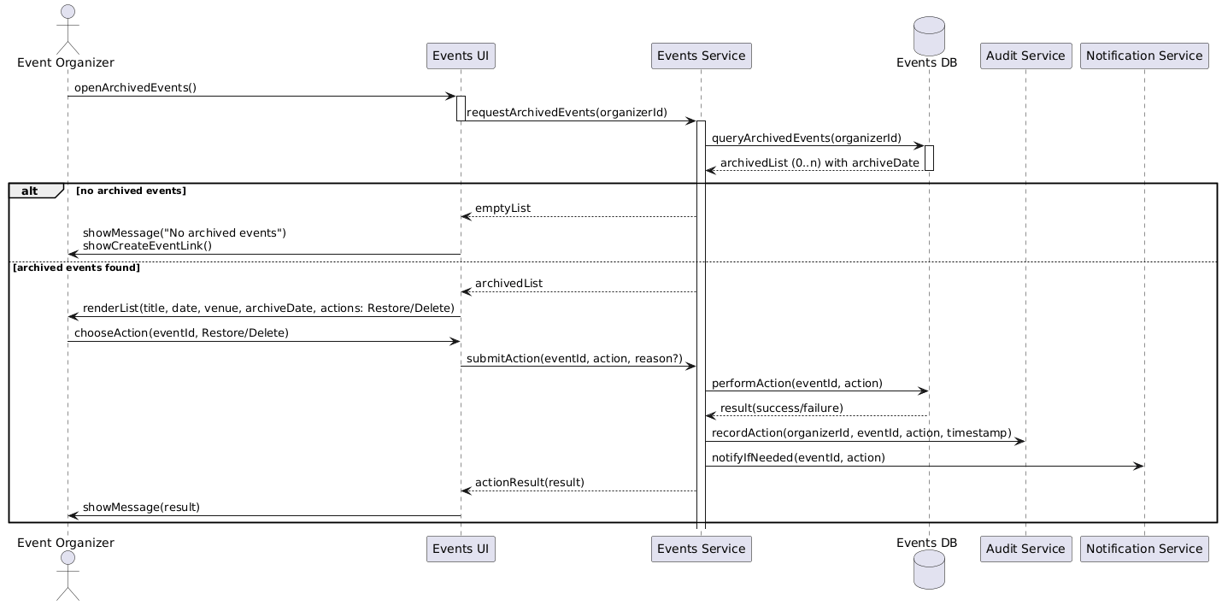

Figure 4.51 browse archived events sequence diagram

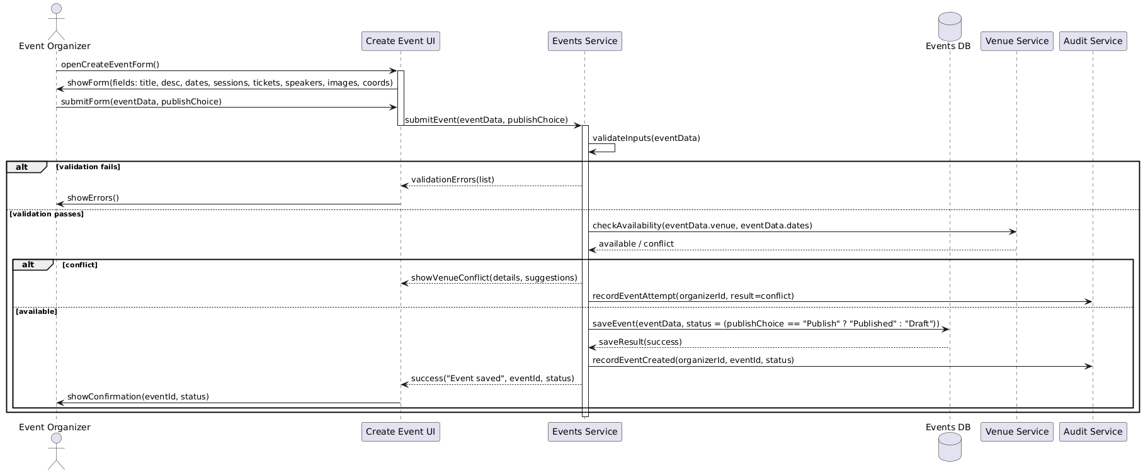

Figure 4.52 create event sequence diagram

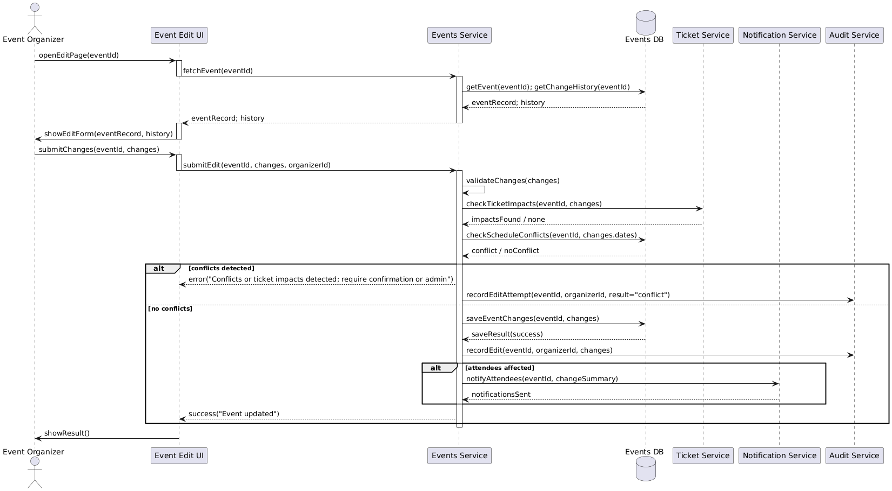

Figure 4.53 edit event sequence diagram

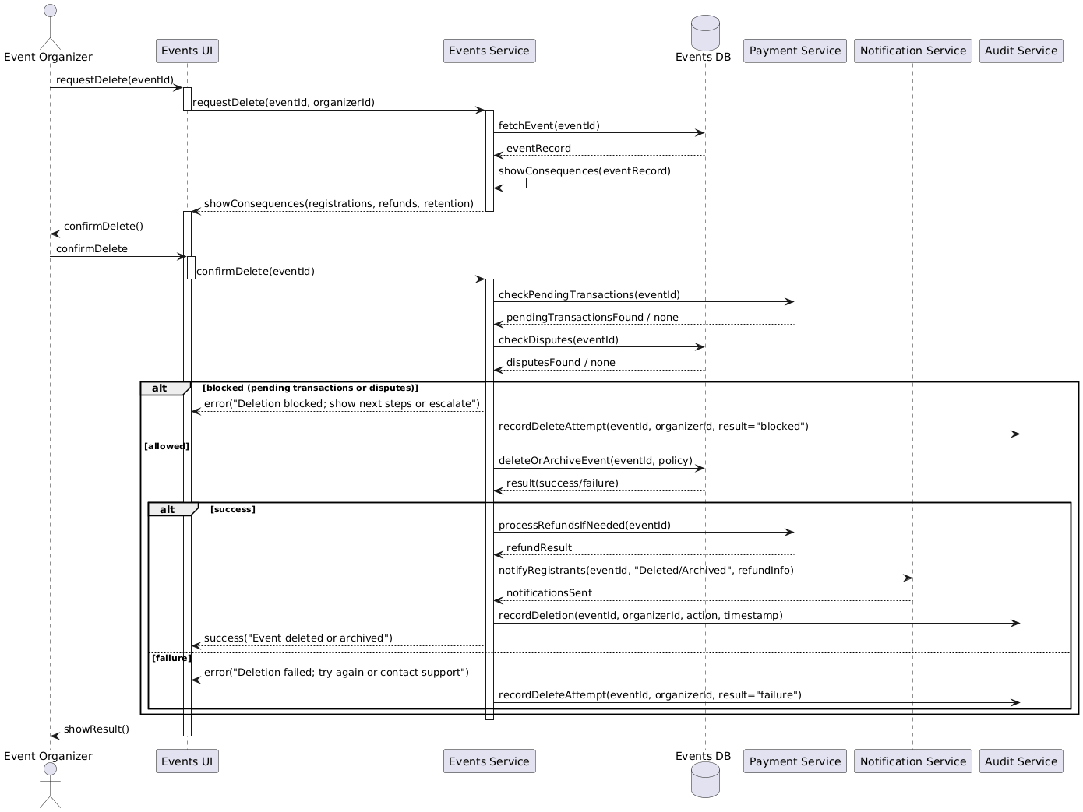

Figure 4.54 delete event sequence diagram

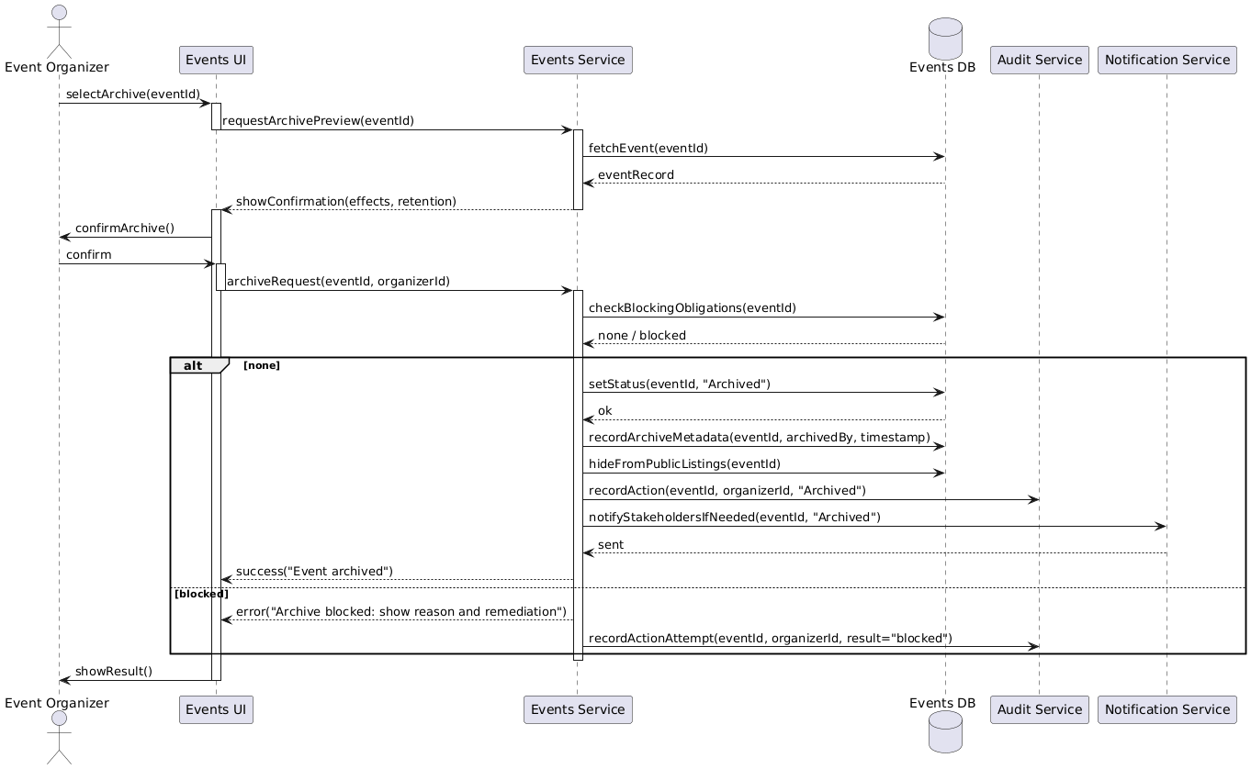

Figure 4.55 archive event sequence diagram

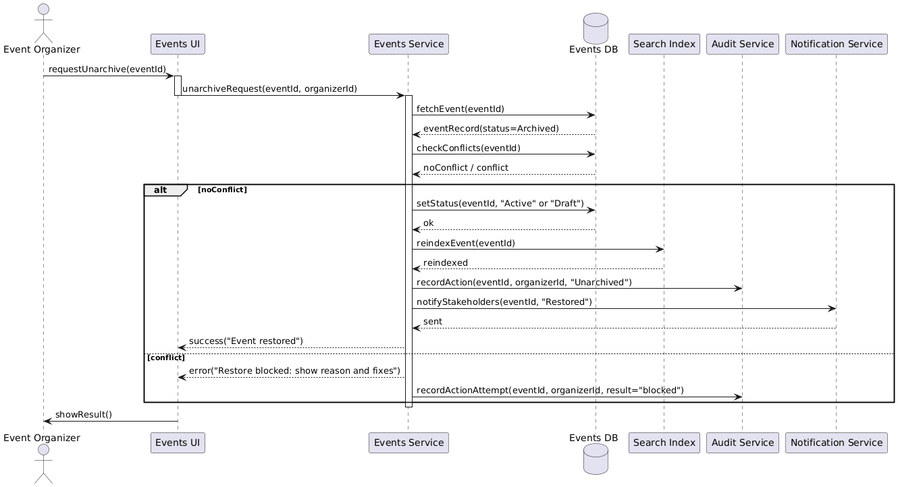

Figure 4.56 unarchive event sequence diagram

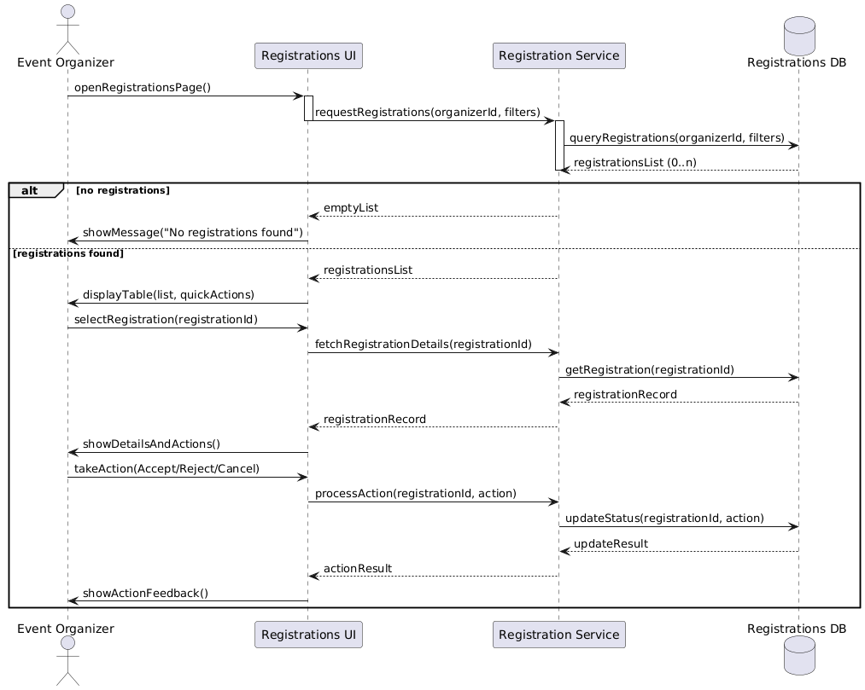

Figure 4.57 browse registrations sequence diagram

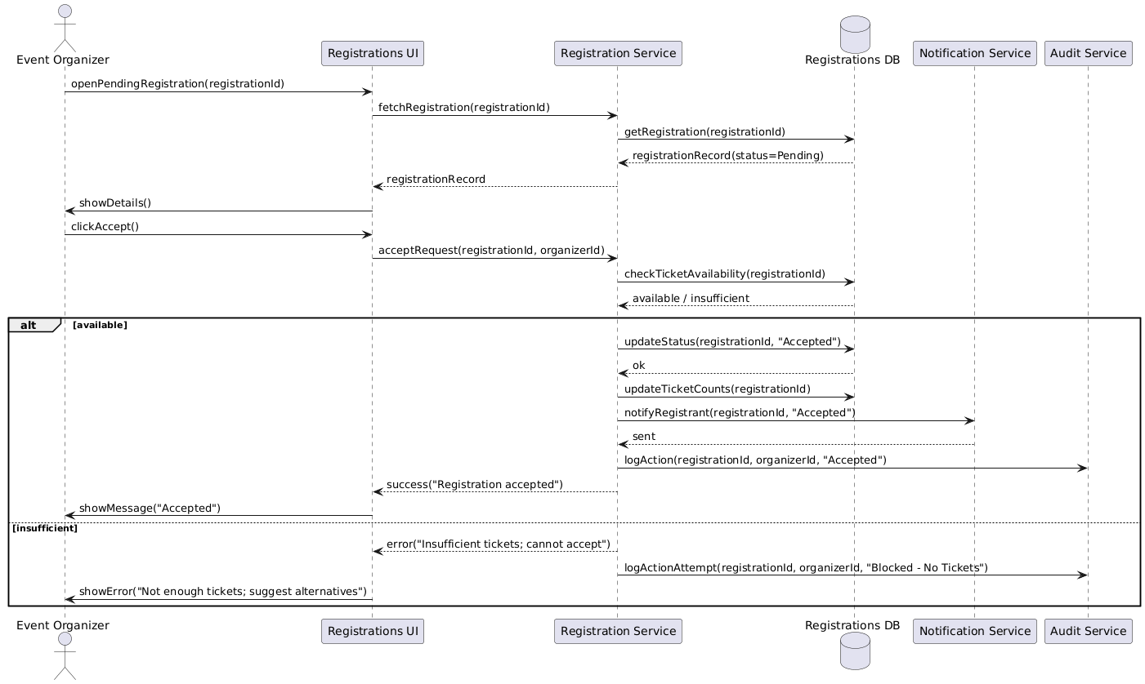

Figure 4.58 accept registration sequence diagram

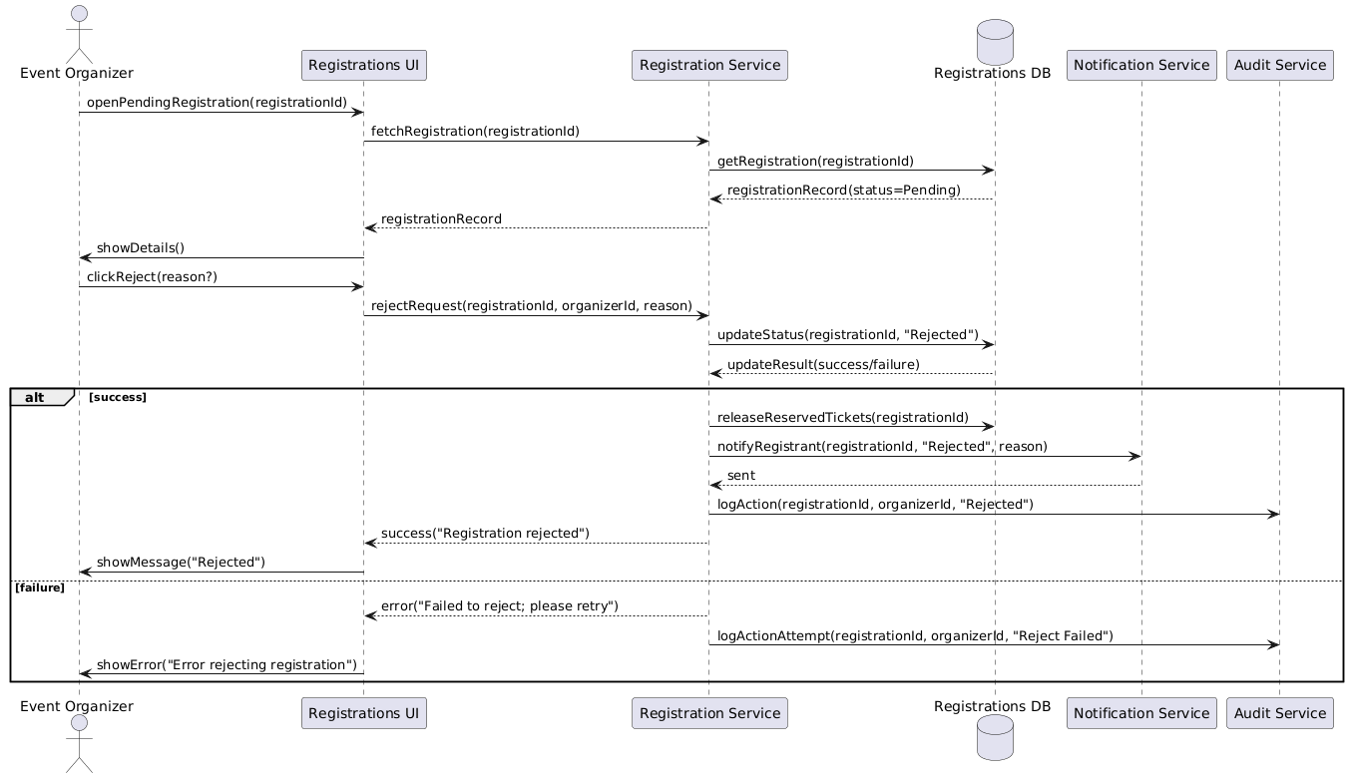

Figure 4.59 reject registration sequence diagram

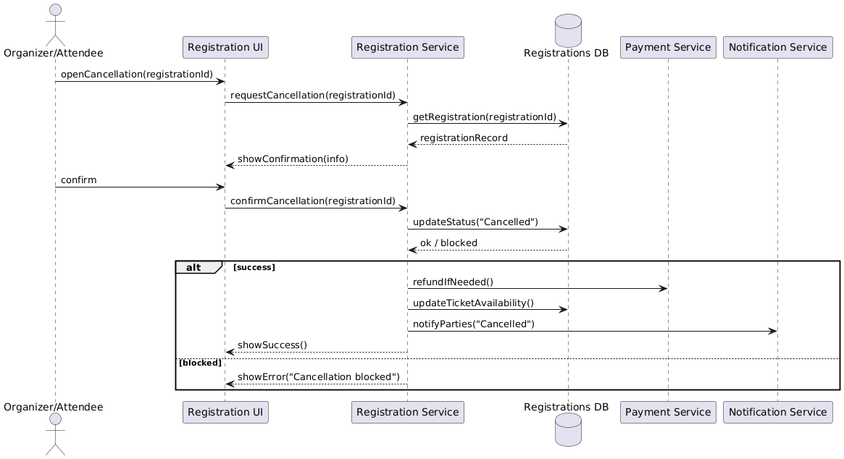

Figure 4.60 cancel registration sequence diagram

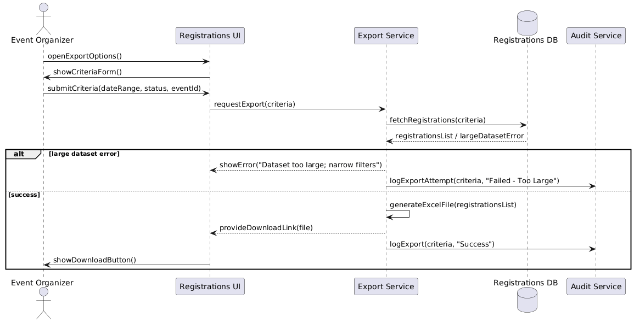

Figure 4.61 explore registration as excel file sequence diagram

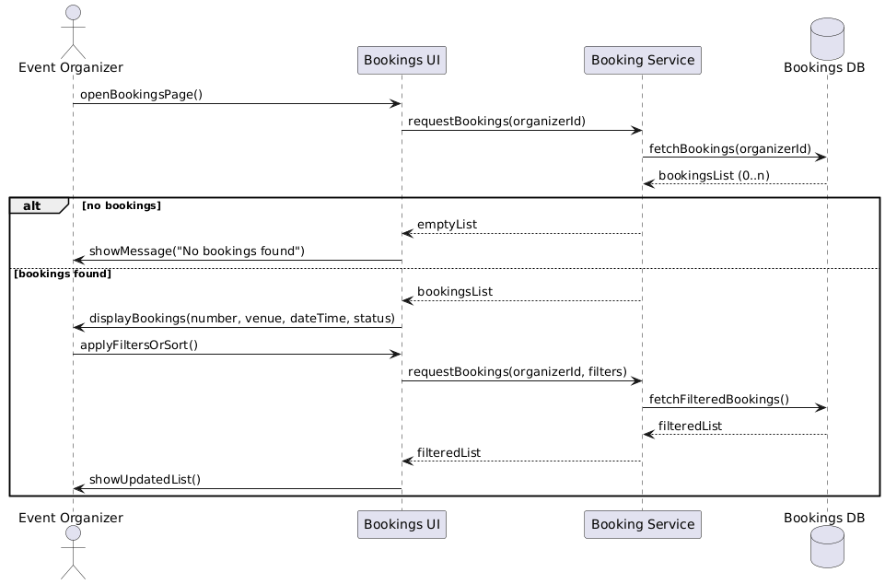

Figure 4.62 view booking (organizer) sequence diagram

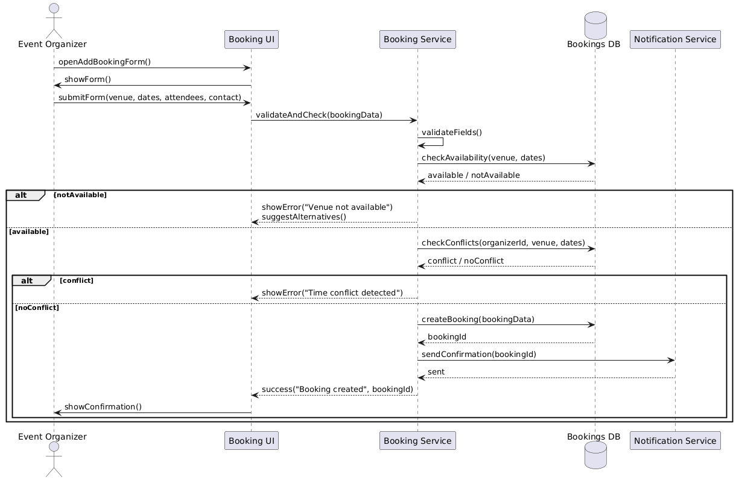

Figure 4.63 add booking (organizer) sequence diagram

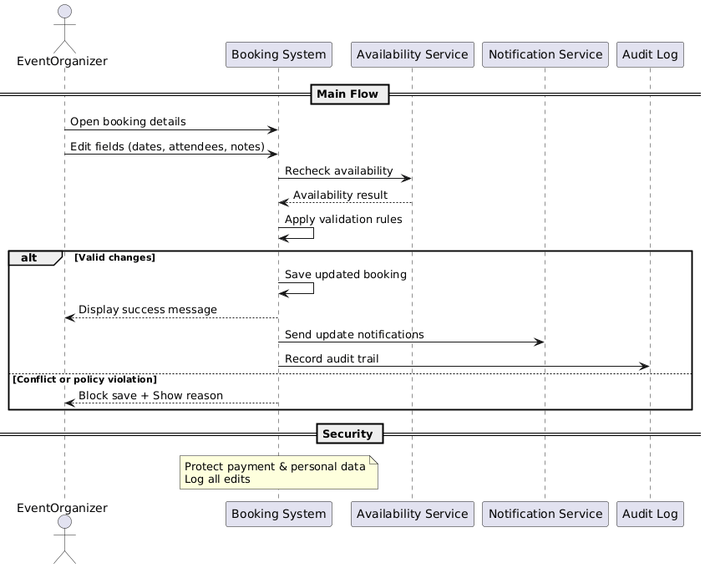Figure 4.64 edit booking (organizer) sequence diagram

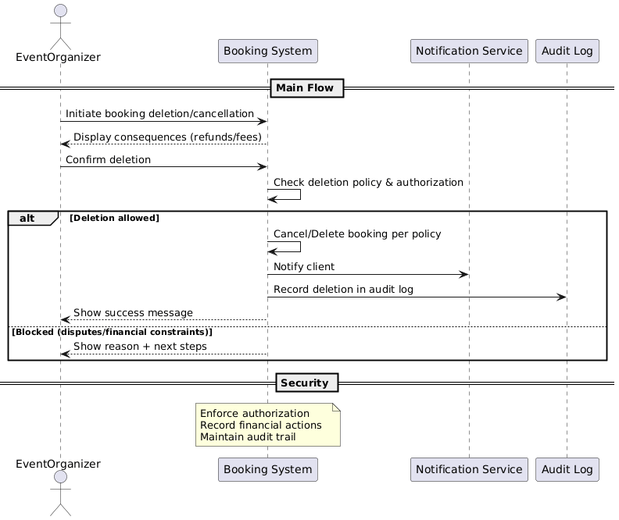

Figure 4.65 delete booking (organizer) sequence diagram

|  |  |  |  |  |
| --- | --- | --- | --- | --- |
| **Test ID** | **Use Case ID** | **Test Case Description** | **Inputs** | **Expected Results** |
| t-1 | Register (visitor) | It should display a success message and create a new guest account. | First name: bark, Last name: safe, Username: barfi, Email: bakrsafi@gmail.com, Password: barfi | A new guest account is created successfully. |
| t-2 | Sign up (visitor) | A success message should be displayed after the registration process is completed. | Username: "barksafe", Password: "barfi" | The visitor registers successfully. |
| t-3 | View event venues (client) | Must display all available event spaces to customers. | Customer presses the Venues button. | All available event venues are displayed. |
| T-4 | View client account (client) | Must display customer account details. | Customer presses the My Account button. | Customer’s account details are displayed. |
| t-5 | Reservation event venue (client) | It should display a success message and confirm the booking. | Reservation Date: 2025/03/15 10:00 PM | The event venue is successfully reserved. |
| t-6 | View event venues (service provider) | All event venues operated by the service provider must be displayed. | Service provider presses the My Venues button. | All venues owned by the service provider are displayed. |
| t-7 | Add venue (service provider) | It should display a success message and add the new location to the list. | Name: Rose, Description: details, Location: Bab-Touma | New venue is added successfully. |
| t-8 | Edit (service provider) | It should display a success message and update the venue details. | Name: Rose; Updated details for description and location | Venue details are updated successfully. |
| t-9 | Delete (service provider) | It should display a success message and remove the venue from the list. | Service provider presses the Delete Venue button | Venue is deleted and removed from the list. |
| t-10 | Log out | The user should log out and be redirected to the home page. | User presses the Log Out button (from My Venues or similar). | User is logged out and redirected to the home page. |
| t-11 | Filter Venues (client) | Must filter event venues based on criteria. | Filter criteria (e.g., price range, capacity). | Only venues matching the criteria are displayed. |
| t-12 | Cancel Reservation (client) | It should cancel the reservation and update its status. | Reservation ID and cancellation confirmation | Reservation is cancelled successfully. |
| t-13 | Share Venue Link (client) | A shareable link should be generated and a confirmation displayed. | Venue ID and selected sharing option (copy/email/social). | A shortened link is generated and displayed. |
| t-14 | Submit Feedback (client) | Client feedback should be recorded and a thank-you message should appear. | Venue ID, feedback text, and optional rating | Feedback is stored and a thank-you message is shown. |
| t-15 | Add Rating to Venue (client) | The rating should be recorded and the venue's average updated. | Venue ID, rating value (1–5), and optional comment | Rating is added and the overall average is updated. |
| t-16 | Receive Notifications (client) | Notifications must be displayed in real time to the client. | Automated trigger (e.g., booking update). | Notifications appear and the icon updates accordingly. |
| t-17 | Sign In (client) | The client must be able to log in successfully. | Username and password. | Client logs in and is redirected to the dashboard. |
| t-18 | Modify Client Account (client) | Client account details should be updated successfully. | Updated details (e.g., phone, address, profile photo). | Account is updated with a success message. |
| t-19 | Delete Account (client) | The client should be able to delete their account upon confirmation. | Deletion confirmation input. | Client account is deleted and the user is logged out. |
| t-20 | Sign In (service provider) | The service provider must be able to log in successfully. | Service provider credentials (Username, Password). | SP logs in and is redirected to its dashboard. |
| t-21 | Modify SP Account (service provider) | SP account details should be updated successfully. | Updated SP details (e.g., business info, contact). | SP account is updated with a success message. |
| t-22 | Delete Account (service provider) | The service provider should be able to delete their account upon confirmation. | Deletion confirmation input. | SP account is deleted successfully. |
| t-23 | View Single Venue (Owned) (SP) | Detailed information for the selected owned venue should be displayed. | Selection of a specific venue from the list. | Detailed venue page is displayed. |
| t-24 | View Archived Venues (SP) | Archived venues must be displayed in a list format. | SP accesses the Archived Venues section. | Archived venues list is displayed. |
| t-25 | View Venue Bookings (SP) | Booking records for a specific venue must be displayed. | Selection of a venue from My Venues. | Booking records with client details are shown. |
| t-26 | Accept / Reject Reservation (SP) | Reservation request should be processed with the appropriate status update. | Reservation ID with decision (Accept/Reject). | Reservation status is updated and the client is notified. |
| t-27 | View Client Feedback (SP) | The service provider should be able to view feedback submitted by clients. | Selection of a venue to view feedback. | List of feedback entries is displayed. |
| t-28 | Receive Notifications (SP) | Notifications relevant to the service provider should be displayed for review. | Automated trigger (e.g., booking update). | Notifications appear and the icon updates accordingly. |
| t-29 | Archive / Unarchive Venue (SP) | The venue's archive status should be toggled with a confirmation message. | Archive/Unarchive action input. | Venue status is updated and a confirmation message is displayed. |
| t-30 | View All Users (admin) | All user records must be displayed for administrative purposes. | Admin selects the "View All Users" option. | A grid of all user data is displayed. |
| t-31 | Manage Global Tags (admin) | Admin should be able to add, edit, or delete global tags with appropriate feedback. | Tag details input (name, category, etc.). | Global tags are updated successfully and a confirmation is shown. |

**Requirements Traceability Matrix:**

### Table 4.888 Requirements Traceability Matrix

|  |  |  |  |  |  |  |
| --- | --- | --- | --- | --- | --- | --- |
| **Requirement ID** | **Requirement Name** | **Function Type** | **Design** | **Application Interface** | **Code** | **Test Case ID** |
| REQ-A01 | Login | [function](https://copilot.microsoft.com/chats/SxHDmbtPHdwnuNhCwJQty#function-req-a01) | [Login - activity diagram](https://copilot.microsoft.com/chats/SxHDmbtPHdwnuNhCwJQty#activity-diagram-req-a01) ; [Login - sequence diagram](https://copilot.microsoft.com/chats/SxHDmbtPHdwnuNhCwJQty#sequence-diagram-req-a01) | [user interfaces](https://copilot.microsoft.com/chats/SxHDmbtPHdwnuNhCwJQty#ui-req-a01) | [c1](https://copilot.microsoft.com/chats/SxHDmbtPHdwnuNhCwJQty#code-req-a01) | [initial test cases](https://copilot.microsoft.com/chats/SxHDmbtPHdwnuNhCwJQty#testcases-req-a01) |
| REQ-A02 | Logout | [function](https://copilot.microsoft.com/chats/SxHDmbtPHdwnuNhCwJQty#function-req-a02) | [Logout - activity diagram](https://copilot.microsoft.com/chats/SxHDmbtPHdwnuNhCwJQty#activity-diagram-req-a02) ; [Logout - sequence diagram](https://copilot.microsoft.com/chats/SxHDmbtPHdwnuNhCwJQty#sequence-diagram-req-a02) | [user interfaces](https://copilot.microsoft.com/chats/SxHDmbtPHdwnuNhCwJQty#ui-req-a02) | [c2](https://copilot.microsoft.com/chats/SxHDmbtPHdwnuNhCwJQty#code-req-a02) | [initial test cases](https://copilot.microsoft.com/chats/SxHDmbtPHdwnuNhCwJQty#testcases-req-a02) |
| REQ-A03 | Register (User Registration) | [function](https://copilot.microsoft.com/chats/SxHDmbtPHdwnuNhCwJQty#function-req-a03) | [Register (User Registration) - activity diagram](https://copilot.microsoft.com/chats/SxHDmbtPHdwnuNhCwJQty#activity-diagram-req-a03) ; [Register (User Registration) - sequence diagram](https://copilot.microsoft.com/chats/SxHDmbtPHdwnuNhCwJQty#sequence-diagram-req-a03) | [user interfaces](https://copilot.microsoft.com/chats/SxHDmbtPHdwnuNhCwJQty#ui-req-a03) | [c3](https://copilot.microsoft.com/chats/SxHDmbtPHdwnuNhCwJQty#code-req-a03) | [initial test cases](https://copilot.microsoft.com/chats/SxHDmbtPHdwnuNhCwJQty#testcases-req-a03) |
| REQ-A04 | View Venues | [function](https://copilot.microsoft.com/chats/SxHDmbtPHdwnuNhCwJQty#function-req-a04) | [View Venues - activity diagram](https://copilot.microsoft.com/chats/SxHDmbtPHdwnuNhCwJQty#activity-diagram-req-a04) ; [View Venues - sequence diagram](https://copilot.microsoft.com/chats/SxHDmbtPHdwnuNhCwJQty#sequence-diagram-req-a04) | [user interfaces](https://copilot.microsoft.com/chats/SxHDmbtPHdwnuNhCwJQty#ui-req-a04) | [c4](https://copilot.microsoft.com/chats/SxHDmbtPHdwnuNhCwJQty#code-req-a04) | [initial test cases](https://copilot.microsoft.com/chats/SxHDmbtPHdwnuNhCwJQty#testcases-req-a04) |
| REQ-A05 | View Venue Details | [function](https://copilot.microsoft.com/chats/SxHDmbtPHdwnuNhCwJQty#function-req-a05) | [View Venue Details - activity diagram](https://copilot.microsoft.com/chats/SxHDmbtPHdwnuNhCwJQty#activity-diagram-req-a05) ; [View Venue Details - sequence diagram](https://copilot.microsoft.com/chats/SxHDmbtPHdwnuNhCwJQty#sequence-diagram-req-a05) | [user interfaces](https://copilot.microsoft.com/chats/SxHDmbtPHdwnuNhCwJQty#ui-req-a05) | [c5](https://copilot.microsoft.com/chats/SxHDmbtPHdwnuNhCwJQty#code-req-a05) | [initial test cases](https://copilot.microsoft.com/chats/SxHDmbtPHdwnuNhCwJQty#testcases-req-a05) |
| REQ-A06 | View Bookings | [function](https://copilot.microsoft.com/chats/SxHDmbtPHdwnuNhCwJQty#function-req-a06) | [View Bookings - activity diagram](https://copilot.microsoft.com/chats/SxHDmbtPHdwnuNhCwJQty#activity-diagram-req-a06) ; [View Bookings - sequence diagram](https://copilot.microsoft.com/chats/SxHDmbtPHdwnuNhCwJQty#sequence-diagram-req-a06) | [user interfaces](https://copilot.microsoft.com/chats/SxHDmbtPHdwnuNhCwJQty#ui-req-a06) | [c6](https://copilot.microsoft.com/chats/SxHDmbtPHdwnuNhCwJQty#code-req-a06) | [initial test cases](https://copilot.microsoft.com/chats/SxHDmbtPHdwnuNhCwJQty#testcases-req-a06) |
| REQ-A07 | Add Booking | [function](https://copilot.microsoft.com/chats/SxHDmbtPHdwnuNhCwJQty#function-req-a07) | [Add Booking - activity diagram](https://copilot.microsoft.com/chats/SxHDmbtPHdwnuNhCwJQty#activity-diagram-req-a07) ; [Add Booking - sequence diagram](https://copilot.microsoft.com/chats/SxHDmbtPHdwnuNhCwJQty#sequence-diagram-req-a07) | [user interfaces](https://copilot.microsoft.com/chats/SxHDmbtPHdwnuNhCwJQty#ui-req-a07) | [c7](https://copilot.microsoft.com/chats/SxHDmbtPHdwnuNhCwJQty#code-req-a07) | [initial test cases](https://copilot.microsoft.com/chats/SxHDmbtPHdwnuNhCwJQty#testcases-req-a07) |
| REQ-A08 | Edit Booking | [function](https://copilot.microsoft.com/chats/SxHDmbtPHdwnuNhCwJQty#function-req-a08) | [Edit Booking - activity diagram](https://copilot.microsoft.com/chats/SxHDmbtPHdwnuNhCwJQty#activity-diagram-req-a08) ; [Edit Booking - sequence diagram](https://copilot.microsoft.com/chats/SxHDmbtPHdwnuNhCwJQty#sequence-diagram-req-a08) | [user interfaces](https://copilot.microsoft.com/chats/SxHDmbtPHdwnuNhCwJQty#ui-req-a08) | [c8](https://copilot.microsoft.com/chats/SxHDmbtPHdwnuNhCwJQty#code-req-a08) | [initial test cases](https://copilot.microsoft.com/chats/SxHDmbtPHdwnuNhCwJQty#testcases-req-a08) |
| REQ-A09 | Delete Booking | [function](https://copilot.microsoft.com/chats/SxHDmbtPHdwnuNhCwJQty#function-req-a09) | [Delete Booking - activity diagram](https://copilot.microsoft.com/chats/SxHDmbtPHdwnuNhCwJQty#activity-diagram-req-a09) ; [Delete Booking - sequence diagram](https://copilot.microsoft.com/chats/SxHDmbtPHdwnuNhCwJQty#sequence-diagram-req-a09) | [user interfaces](https://copilot.microsoft.com/chats/SxHDmbtPHdwnuNhCwJQty#ui-req-a09) | [c9](https://copilot.microsoft.com/chats/SxHDmbtPHdwnuNhCwJQty#code-req-a09) | [initial test cases](https://copilot.microsoft.com/chats/SxHDmbtPHdwnuNhCwJQty#testcases-req-a09) |
| REQ-A10 | View Events | [function](https://copilot.microsoft.com/chats/SxHDmbtPHdwnuNhCwJQty#function-req-a10) | [View Events - activity diagram](https://copilot.microsoft.com/chats/SxHDmbtPHdwnuNhCwJQty#activity-diagram-req-a10) ; [View Events - sequence diagram](https://copilot.microsoft.com/chats/SxHDmbtPHdwnuNhCwJQty#sequence-diagram-req-a10) | [user interfaces](https://copilot.microsoft.com/chats/SxHDmbtPHdwnuNhCwJQty#ui-req-a10) | [c10](https://copilot.microsoft.com/chats/SxHDmbtPHdwnuNhCwJQty#code-req-a10) | [initial test cases](https://copilot.microsoft.com/chats/SxHDmbtPHdwnuNhCwJQty#testcases-req-a10) |
| REQ-A11 | View Event Details | [function](https://copilot.microsoft.com/chats/SxHDmbtPHdwnuNhCwJQty#function-req-a11) | [View Event Details - activity diagram](https://copilot.microsoft.com/chats/SxHDmbtPHdwnuNhCwJQty#activity-diagram-req-a11) ; [View Event Details - sequence diagram](https://copilot.microsoft.com/chats/SxHDmbtPHdwnuNhCwJQty#sequence-diagram-req-a11) | [user interfaces](https://copilot.microsoft.com/chats/SxHDmbtPHdwnuNhCwJQty#ui-req-a11) | [c11](https://copilot.microsoft.com/chats/SxHDmbtPHdwnuNhCwJQty#code-req-a11) | [initial test cases](https://copilot.microsoft.com/chats/SxHDmbtPHdwnuNhCwJQty#testcases-req-a11) |
| REQ-A12 | Unified Search for Venues | [function](https://copilot.microsoft.com/chats/SxHDmbtPHdwnuNhCwJQty#function-req-a12) | [Unified Search for Venues - activity diagram](https://copilot.microsoft.com/chats/SxHDmbtPHdwnuNhCwJQty#activity-diagram-req-a12) ; [Unified Search for Venues - sequence diagram](https://copilot.microsoft.com/chats/SxHDmbtPHdwnuNhCwJQty#sequence-diagram-req-a12) | [user interfaces](https://copilot.microsoft.com/chats/SxHDmbtPHdwnuNhCwJQty#ui-req-a12) | [c12](https://copilot.microsoft.com/chats/SxHDmbtPHdwnuNhCwJQty#code-req-a12) | [initial test cases](https://copilot.microsoft.com/chats/SxHDmbtPHdwnuNhCwJQty#testcases-req-a12) |
| REQ-A13 | Unified Search for Events | [function](https://copilot.microsoft.com/chats/SxHDmbtPHdwnuNhCwJQty#function-req-a13) | [Unified Search for Events - activity diagram](https://copilot.microsoft.com/chats/SxHDmbtPHdwnuNhCwJQty#activity-diagram-req-a13) ; [Unified Search for Events - sequence diagram](https://copilot.microsoft.com/chats/SxHDmbtPHdwnuNhCwJQty#sequence-diagram-req-a13) | [user interfaces](https://copilot.microsoft.com/chats/SxHDmbtPHdwnuNhCwJQty#ui-req-a13) | [c13](https://copilot.microsoft.com/chats/SxHDmbtPHdwnuNhCwJQty#code-req-a13) | [initial test cases](https://copilot.microsoft.com/chats/SxHDmbtPHdwnuNhCwJQty#testcases-req-a13) |
| REQ-A14 | Filter Venues by Specific Criteria | [function](https://copilot.microsoft.com/chats/SxHDmbtPHdwnuNhCwJQty#function-req-a14) | [Filter Venues by Specific Criteria - activity diagram](https://copilot.microsoft.com/chats/SxHDmbtPHdwnuNhCwJQty#activity-diagram-req-a14) ; [Filter Venues by Specific Criteria - sequence diagram](https://copilot.microsoft.com/chats/SxHDmbtPHdwnuNhCwJQty#sequence-diagram-req-a14) | [user interfaces](https://copilot.microsoft.com/chats/SxHDmbtPHdwnuNhCwJQty#ui-req-a14) | [c14](https://copilot.microsoft.com/chats/SxHDmbtPHdwnuNhCwJQty#code-req-a14) | [initial test cases](https://copilot.microsoft.com/chats/SxHDmbtPHdwnuNhCwJQty#testcases-req-a14) |
| REQ-A15 | Filter Events by Specific Criteria | [function](https://copilot.microsoft.com/chats/SxHDmbtPHdwnuNhCwJQty#function-req-a15) | [Filter Events by Specific Criteria - activity diagram](https://copilot.microsoft.com/chats/SxHDmbtPHdwnuNhCwJQty#activity-diagram-req-a15) ; [Filter Events by Specific Criteria - sequence diagram](https://copilot.microsoft.com/chats/SxHDmbtPHdwnuNhCwJQty#sequence-diagram-req-a15) | [user interfaces](https://copilot.microsoft.com/chats/SxHDmbtPHdwnuNhCwJQty#ui-req-a15) | [c15](https://copilot.microsoft.com/chats/SxHDmbtPHdwnuNhCwJQty#code-req-a15) | [initial test cases](https://copilot.microsoft.com/chats/SxHDmbtPHdwnuNhCwJQty#testcases-req-a15) |
| REQ-A16 | View Registrations | [function](https://copilot.microsoft.com/chats/SxHDmbtPHdwnuNhCwJQty#function-req-a16) | [View Registrations - activity diagram](https://copilot.microsoft.com/chats/SxHDmbtPHdwnuNhCwJQty#activity-diagram-req-a16) ; [View Registrations - sequence diagram](https://copilot.microsoft.com/chats/SxHDmbtPHdwnuNhCwJQty#sequence-diagram-req-a16) | [user interfaces](https://copilot.microsoft.com/chats/SxHDmbtPHdwnuNhCwJQty#ui-req-a16) | [c16](https://copilot.microsoft.com/chats/SxHDmbtPHdwnuNhCwJQty#code-req-a16) | [initial test cases](https://copilot.microsoft.com/chats/SxHDmbtPHdwnuNhCwJQty#testcases-req-a16) |
| REQ-A17 | Add Registration | [function](https://copilot.microsoft.com/chats/SxHDmbtPHdwnuNhCwJQty#function-req-a17) | [Add Registration - activity diagram](https://copilot.microsoft.com/chats/SxHDmbtPHdwnuNhCwJQty#activity-diagram-req-a17) ; [Add Registration - sequence diagram](https://copilot.microsoft.com/chats/SxHDmbtPHdwnuNhCwJQty#sequence-diagram-req-a17) | [user interfaces](https://copilot.microsoft.com/chats/SxHDmbtPHdwnuNhCwJQty#ui-req-a17) | [c17](https://copilot.microsoft.com/chats/SxHDmbtPHdwnuNhCwJQty#code-req-a17) | [initial test cases](https://copilot.microsoft.com/chats/SxHDmbtPHdwnuNhCwJQty#testcases-req-a17) |
| REQ-A18 | Edit Registration | [function](https://copilot.microsoft.com/chats/SxHDmbtPHdwnuNhCwJQty#function-req-a18) | [Edit Registration - activity diagram](https://copilot.microsoft.com/chats/SxHDmbtPHdwnuNhCwJQty#activity-diagram-req-a18) ; [Edit Registration - sequence diagram](https://copilot.microsoft.com/chats/SxHDmbtPHdwnuNhCwJQty#sequence-diagram-req-a18) | [user interfaces](https://copilot.microsoft.com/chats/SxHDmbtPHdwnuNhCwJQty#ui-req-a18) | [c18](https://copilot.microsoft.com/chats/SxHDmbtPHdwnuNhCwJQty#code-req-a18) | [initial test cases](https://copilot.microsoft.com/chats/SxHDmbtPHdwnuNhCwJQty#testcases-req-a18) |
| REQ-A19 | Delete Registration | [function](https://copilot.microsoft.com/chats/SxHDmbtPHdwnuNhCwJQty#function-req-a19) | [Delete Registration - activity diagram](https://copilot.microsoft.com/chats/SxHDmbtPHdwnuNhCwJQty#activity-diagram-req-a19) ; [Delete Registration - sequence diagram](https://copilot.microsoft.com/chats/SxHDmbtPHdwnuNhCwJQty#sequence-diagram-req-a19) | [user interfaces](https://copilot.microsoft.com/chats/SxHDmbtPHdwnuNhCwJQty#ui-req-a19) | [c19](https://copilot.microsoft.com/chats/SxHDmbtPHdwnuNhCwJQty#code-req-a19) | [initial test cases](https://copilot.microsoft.com/chats/SxHDmbtPHdwnuNhCwJQty#testcases-req-a19) |
| REQ-A20 | View Venue Ratings | [function](https://copilot.microsoft.com/chats/SxHDmbtPHdwnuNhCwJQty#function-req-a20) | [View Venue Ratings - activity diagram](https://copilot.microsoft.com/chats/SxHDmbtPHdwnuNhCwJQty#activity-diagram-req-a20) ; [View Venue Ratings - sequence diagram](https://copilot.microsoft.com/chats/SxHDmbtPHdwnuNhCwJQty#sequence-diagram-req-a20) | [user interfaces](https://copilot.microsoft.com/chats/SxHDmbtPHdwnuNhCwJQty#ui-req-a20) | [c20](https://copilot.microsoft.com/chats/SxHDmbtPHdwnuNhCwJQty#code-req-a20) | [initial test cases](https://copilot.microsoft.com/chats/SxHDmbtPHdwnuNhCwJQty#testcases-req-a20) |
| REQ-A21 | Add Venue Rating | [function](https://copilot.microsoft.com/chats/SxHDmbtPHdwnuNhCwJQty#function-req-a21) | [Add Venue Rating - activity diagram](https://copilot.microsoft.com/chats/SxHDmbtPHdwnuNhCwJQty#activity-diagram-req-a21) ; [Add Venue Rating - sequence diagram](https://copilot.microsoft.com/chats/SxHDmbtPHdwnuNhCwJQty#sequence-diagram-req-a21) | [user interfaces](https://copilot.microsoft.com/chats/SxHDmbtPHdwnuNhCwJQty#ui-req-a21) | [c21](https://copilot.microsoft.com/chats/SxHDmbtPHdwnuNhCwJQty#code-req-a21) | [initial test cases](https://copilot.microsoft.com/chats/SxHDmbtPHdwnuNhCwJQty#testcases-req-a21) |
| REQ-A22 | Edit Venue Rating | [function](https://copilot.microsoft.com/chats/SxHDmbtPHdwnuNhCwJQty#function-req-a22) | [Edit Venue Rating - activity diagram](https://copilot.microsoft.com/chats/SxHDmbtPHdwnuNhCwJQty#activity-diagram-req-a22) ; [Edit Venue Rating - sequence diagram](https://copilot.microsoft.com/chats/SxHDmbtPHdwnuNhCwJQty#sequence-diagram-req-a22) | [user interfaces](https://copilot.microsoft.com/chats/SxHDmbtPHdwnuNhCwJQty#ui-req-a22) | [c22](https://copilot.microsoft.com/chats/SxHDmbtPHdwnuNhCwJQty#code-req-a22) | [initial test cases](https://copilot.microsoft.com/chats/SxHDmbtPHdwnuNhCwJQty#testcases-req-a22) |
| REQ-A23 | Delete Venue Rating | [function](https://copilot.microsoft.com/chats/SxHDmbtPHdwnuNhCwJQty#function-req-a23) | [Delete Venue Rating - activity diagram](https://copilot.microsoft.com/chats/SxHDmbtPHdwnuNhCwJQty#activity-diagram-req-a23) ; [Delete Venue Rating - sequence diagram](https://copilot.microsoft.com/chats/SxHDmbtPHdwnuNhCwJQty#sequence-diagram-req-a23) | [user interfaces](https://copilot.microsoft.com/chats/SxHDmbtPHdwnuNhCwJQty#ui-req-a23) | [c23](https://copilot.microsoft.com/chats/SxHDmbtPHdwnuNhCwJQty#code-req-a23) | [initial test cases](https://copilot.microsoft.com/chats/SxHDmbtPHdwnuNhCwJQty#testcases-req-a23) |
| REQ-A24 | View Event Ratings | [function](https://copilot.microsoft.com/chats/SxHDmbtPHdwnuNhCwJQty#function-req-a24) | [View Event Ratings - activity diagram](https://copilot.microsoft.com/chats/SxHDmbtPHdwnuNhCwJQty#activity-diagram-req-a24) ; [View Event Ratings - sequence diagram](https://copilot.microsoft.com/chats/SxHDmbtPHdwnuNhCwJQty#sequence-diagram-req-a24) | [user interfaces](https://copilot.microsoft.com/chats/SxHDmbtPHdwnuNhCwJQty#ui-req-a24) | [c24](https://copilot.microsoft.com/chats/SxHDmbtPHdwnuNhCwJQty#code-req-a24) | [initial test cases](https://copilot.microsoft.com/chats/SxHDmbtPHdwnuNhCwJQty#testcases-req-a24) |
| REQ-A25 | Add Event Rating | [function](https://copilot.microsoft.com/chats/SxHDmbtPHdwnuNhCwJQty#function-req-a25) | [Add Event Rating - activity diagram](https://copilot.microsoft.com/chats/SxHDmbtPHdwnuNhCwJQty#activity-diagram-req-a25) ; [Add Event Rating - sequence diagram](https://copilot.microsoft.com/chats/SxHDmbtPHdwnuNhCwJQty#sequence-diagram-req-a25) | [user interfaces](https://copilot.microsoft.com/chats/SxHDmbtPHdwnuNhCwJQty#ui-req-a25) | [c25](https://copilot.microsoft.com/chats/SxHDmbtPHdwnuNhCwJQty#code-req-a25) | [initial test cases](https://copilot.microsoft.com/chats/SxHDmbtPHdwnuNhCwJQty#testcases-req-a25) |
| REQ-A26 | Edit Event Rating | [function](https://copilot.microsoft.com/chats/SxHDmbtPHdwnuNhCwJQty#function-req-a26) | [Edit Event Rating - activity diagram](https://copilot.microsoft.com/chats/SxHDmbtPHdwnuNhCwJQty#activity-diagram-req-a26) ; [Edit Event Rating - sequence diagram](https://copilot.microsoft.com/chats/SxHDmbtPHdwnuNhCwJQty#sequence-diagram-req-a26) | [user interfaces](https://copilot.microsoft.com/chats/SxHDmbtPHdwnuNhCwJQty#ui-req-a26) | [c26](https://copilot.microsoft.com/chats/SxHDmbtPHdwnuNhCwJQty#code-req-a26) | [initial test cases](https://copilot.microsoft.com/chats/SxHDmbtPHdwnuNhCwJQty#testcases-req-a26) |
| REQ-A27 | Delete Event Rating | [function](https://copilot.microsoft.com/chats/SxHDmbtPHdwnuNhCwJQty#function-req-a27) | [Delete Event Rating - activity diagram](https://copilot.microsoft.com/chats/SxHDmbtPHdwnuNhCwJQty#activity-diagram-req-a27) ; [Delete Event Rating - sequence diagram](https://copilot.microsoft.com/chats/SxHDmbtPHdwnuNhCwJQty#sequence-diagram-req-a27) | [user interfaces](https://copilot.microsoft.com/chats/SxHDmbtPHdwnuNhCwJQty#ui-req-a27) | [c27](https://copilot.microsoft.com/chats/SxHDmbtPHdwnuNhCwJQty#code-req-a27) | [initial test cases](https://copilot.microsoft.com/chats/SxHDmbtPHdwnuNhCwJQty#testcases-req-a27) |
| REQ-A28 | View Organizers | [function](https://copilot.microsoft.com/chats/SxHDmbtPHdwnuNhCwJQty#function-req-a28) | [View Organizers - activity diagram](https://copilot.microsoft.com/chats/SxHDmbtPHdwnuNhCwJQty#activity-diagram-req-a28) ; [View Organizers - sequence diagram](https://copilot.microsoft.com/chats/SxHDmbtPHdwnuNhCwJQty#sequence-diagram-req-a28) | [user interfaces](https://copilot.microsoft.com/chats/SxHDmbtPHdwnuNhCwJQty#ui-req-a28) | [c28](https://copilot.microsoft.com/chats/SxHDmbtPHdwnuNhCwJQty#code-req-a28) | [initial test cases](https://copilot.microsoft.com/chats/SxHDmbtPHdwnuNhCwJQty#testcases-req-a28) |
| REQ-A29 | View Providers | [function](https://copilot.microsoft.com/chats/SxHDmbtPHdwnuNhCwJQty#function-req-a29) | [View Providers - activity diagram](https://copilot.microsoft.com/chats/SxHDmbtPHdwnuNhCwJQty#activity-diagram-req-a29) ; [View Providers - sequence diagram](https://copilot.microsoft.com/chats/SxHDmbtPHdwnuNhCwJQty#sequence-diagram-req-a29) | [user interfaces](https://copilot.microsoft.com/chats/SxHDmbtPHdwnuNhCwJQty#ui-req-a29) | [c29](https://copilot.microsoft.com/chats/SxHDmbtPHdwnuNhCwJQty#code-req-a29) | [initial test cases](https://copilot.microsoft.com/chats/SxHDmbtPHdwnuNhCwJQty#testcases-req-a29) |
| REQ-A30 | Filter Organizers by Specific Criteria | [function](https://copilot.microsoft.com/chats/SxHDmbtPHdwnuNhCwJQty#function-req-a30) | [Filter Organizers by Specific Criteria - activity diagram](https://copilot.microsoft.com/chats/SxHDmbtPHdwnuNhCwJQty#activity-diagram-req-a30) ; [Filter Organizers by Specific Criteria - sequence diagram](https://copilot.microsoft.com/chats/SxHDmbtPHdwnuNhCwJQty#sequence-diagram-req-a30) | [user interfaces](https://copilot.microsoft.com/chats/SxHDmbtPHdwnuNhCwJQty#ui-req-a30) | [c30](https://copilot.microsoft.com/chats/SxHDmbtPHdwnuNhCwJQty#code-req-a30) | [initial test cases](https://copilot.microsoft.com/chats/SxHDmbtPHdwnuNhCwJQty#testcases-req-a30) |
| REQ-A31 | Filter Providers by Specific Criteria | [function](https://copilot.microsoft.com/chats/SxHDmbtPHdwnuNhCwJQty#function-req-a31) | [Filter Providers by Specific Criteria - activity diagram](https://copilot.microsoft.com/chats/SxHDmbtPHdwnuNhCwJQty#activity-diagram-req-a31) ; [Filter Providers by Specific Criteria - sequence diagram](https://copilot.microsoft.com/chats/SxHDmbtPHdwnuNhCwJQty#sequence-diagram-req-a31) | [user interfaces](https://copilot.microsoft.com/chats/SxHDmbtPHdwnuNhCwJQty#ui-req-a31) | [c31](https://copilot.microsoft.com/chats/SxHDmbtPHdwnuNhCwJQty#code-req-a31) | [initial test cases](https://copilot.microsoft.com/chats/SxHDmbtPHdwnuNhCwJQty#testcases-req-a31) |
| REQ-A32 | Upvote | [function](https://copilot.microsoft.com/chats/SxHDmbtPHdwnuNhCwJQty#function-req-a32) | [Upvote - activity diagram](https://copilot.microsoft.com/chats/SxHDmbtPHdwnuNhCwJQty#activity-diagram-req-a32) ; [Upvote - sequence diagram](https://copilot.microsoft.com/chats/SxHDmbtPHdwnuNhCwJQty#sequence-diagram-req-a32) | [user interfaces](https://copilot.microsoft.com/chats/SxHDmbtPHdwnuNhCwJQty#ui-req-a32) | [c32](https://copilot.microsoft.com/chats/SxHDmbtPHdwnuNhCwJQty#code-req-a32) | [initial test cases](https://copilot.microsoft.com/chats/SxHDmbtPHdwnuNhCwJQty#testcases-req-a32) |
| REQ-A33 | Downvote | [function](https://copilot.microsoft.com/chats/SxHDmbtPHdwnuNhCwJQty#function-req-a33) | [Downvote - activity diagram](https://copilot.microsoft.com/chats/SxHDmbtPHdwnuNhCwJQty#activity-diagram-req-a33) ; [Downvote - sequence diagram](https://copilot.microsoft.com/chats/SxHDmbtPHdwnuNhCwJQty#sequence-diagram-req-a33) | [user interfaces](https://copilot.microsoft.com/chats/SxHDmbtPHdwnuNhCwJQty#ui-req-a33) | [c33](https://copilot.microsoft.com/chats/SxHDmbtPHdwnuNhCwJQty#code-req-a33) | [initial test cases](https://copilot.microsoft.com/chats/SxHDmbtPHdwnuNhCwJQty#testcases-req-a33) |
| REQ-A34 | View Recent Activities | [function](https://copilot.microsoft.com/chats/SxHDmbtPHdwnuNhCwJQty#function-req-a34) | [View Recent Activities - activity diagram](https://copilot.microsoft.com/chats/SxHDmbtPHdwnuNhCwJQty#activity-diagram-req-a34) ; [View Recent Activities - sequence diagram](https://copilot.microsoft.com/chats/SxHDmbtPHdwnuNhCwJQty#sequence-diagram-req-a34) | [user interfaces](https://copilot.microsoft.com/chats/SxHDmbtPHdwnuNhCwJQty#ui-req-a34) | [c34](https://copilot.microsoft.com/chats/SxHDmbtPHdwnuNhCwJQty#code-req-a34) | [initial test cases](https://copilot.microsoft.com/chats/SxHDmbtPHdwnuNhCwJQty#testcases-req-a34) |
| REQ-A35 | Display Map of Event and Venue Locations | [function](https://copilot.microsoft.com/chats/SxHDmbtPHdwnuNhCwJQty#function-req-a35) | [Display Map of Event and Venue Locations - activity diagram](https://copilot.microsoft.com/chats/SxHDmbtPHdwnuNhCwJQty#activity-diagram-req-a35) ; [Display Map of Event and Venue Locations - sequence diagram](https://copilot.microsoft.com/chats/SxHDmbtPHdwnuNhCwJQty#sequence-diagram-req-a35) | [user interfaces](https://copilot.microsoft.com/chats/SxHDmbtPHdwnuNhCwJQty#ui-req-a35) | [c35](https://copilot.microsoft.com/chats/SxHDmbtPHdwnuNhCwJQty#code-req-a35) | [initial test cases](https://copilot.microsoft.com/chats/SxHDmbtPHdwnuNhCwJQty#testcases-req-a35) |
| REQ-A36 | Browse Venues (Provider) | [function](https://copilot.microsoft.com/chats/SxHDmbtPHdwnuNhCwJQty#function-req-a36) | [Browse Venues (Provider) - activity diagram](https://copilot.microsoft.com/chats/SxHDmbtPHdwnuNhCwJQty#activity-diagram-req-a36) ; [Browse Venues (Provider) - sequence diagram](https://copilot.microsoft.com/chats/SxHDmbtPHdwnuNhCwJQty#sequence-diagram-req-a36) | [user interfaces](https://copilot.microsoft.com/chats/SxHDmbtPHdwnuNhCwJQty#ui-req-a36) | [c36](https://copilot.microsoft.com/chats/SxHDmbtPHdwnuNhCwJQty#code-req-a36) | [initial test cases](https://copilot.microsoft.com/chats/SxHDmbtPHdwnuNhCwJQty#testcases-req-a36) |
| REQ-A37 | Browse Archived Venues | [function](https://copilot.microsoft.com/chats/SxHDmbtPHdwnuNhCwJQty#function-req-a37) | [Browse Archived Venues - activity diagram](https://copilot.microsoft.com/chats/SxHDmbtPHdwnuNhCwJQty#activity-diagram-req-a37) ; [Browse Archived Venues - sequence diagram](https://copilot.microsoft.com/chats/SxHDmbtPHdwnuNhCwJQty#sequence-diagram-req-a37) | [user interfaces](https://copilot.microsoft.com/chats/SxHDmbtPHdwnuNhCwJQty#ui-req-a37) | [c37](https://copilot.microsoft.com/chats/SxHDmbtPHdwnuNhCwJQty#code-req-a37) | [initial test cases](https://copilot.microsoft.com/chats/SxHDmbtPHdwnuNhCwJQty#testcases-req-a37) |
| REQ-A38 | Add Venue | [function](https://copilot.microsoft.com/chats/SxHDmbtPHdwnuNhCwJQty#function-req-a38) | [Add Venue - activity diagram](https://copilot.microsoft.com/chats/SxHDmbtPHdwnuNhCwJQty#activity-diagram-req-a38) ; [Add Venue - sequence diagram](https://copilot.microsoft.com/chats/SxHDmbtPHdwnuNhCwJQty#sequence-diagram-req-a38) | [user interfaces](https://copilot.microsoft.com/chats/SxHDmbtPHdwnuNhCwJQty#ui-req-a38) | [c38](https://copilot.microsoft.com/chats/SxHDmbtPHdwnuNhCwJQty#code-req-a38) | [initial test cases](https://copilot.microsoft.com/chats/SxHDmbtPHdwnuNhCwJQty#testcases-req-a38) |
| REQ-A39 | Edit Venue | [function](https://copilot.microsoft.com/chats/SxHDmbtPHdwnuNhCwJQty#function-req-a39) | [Edit Venue - activity diagram](https://copilot.microsoft.com/chats/SxHDmbtPHdwnuNhCwJQty#activity-diagram-req-a39) ; [Edit Venue - sequence diagram](https://copilot.microsoft.com/chats/SxHDmbtPHdwnuNhCwJQty#sequence-diagram-req-a39) | [user interfaces](https://copilot.microsoft.com/chats/SxHDmbtPHdwnuNhCwJQty#ui-req-a39) | [c39](https://copilot.microsoft.com/chats/SxHDmbtPHdwnuNhCwJQty#code-req-a39) | [initial test cases](https://copilot.microsoft.com/chats/SxHDmbtPHdwnuNhCwJQty#testcases-req-a39) |
| REQ-A40 | Delete Venue | [function](https://copilot.microsoft.com/chats/SxHDmbtPHdwnuNhCwJQty#function-req-a40) | [Delete Venue - activity diagram](https://copilot.microsoft.com/chats/SxHDmbtPHdwnuNhCwJQty#activity-diagram-req-a40) ; [Delete Venue - sequence diagram](https://copilot.microsoft.com/chats/SxHDmbtPHdwnuNhCwJQty#sequence-diagram-req-a40) | [user interfaces](https://copilot.microsoft.com/chats/SxHDmbtPHdwnuNhCwJQty#ui-req-a40) | [c40](https://copilot.microsoft.com/chats/SxHDmbtPHdwnuNhCwJQty#code-req-a40) | [initial test cases](https://copilot.microsoft.com/chats/SxHDmbtPHdwnuNhCwJQty#testcases-req-a40) |
| REQ-A41 | Archive Venue | [function](https://copilot.microsoft.com/chats/SxHDmbtPHdwnuNhCwJQty#function-req-a41) | [Archive Venue - activity diagram](https://copilot.microsoft.com/chats/SxHDmbtPHdwnuNhCwJQty#activity-diagram-req-a41) ; [Archive Venue - sequence diagram](https://copilot.microsoft.com/chats/SxHDmbtPHdwnuNhCwJQty#sequence-diagram-req-a41) | [user interfaces](https://copilot.microsoft.com/chats/SxHDmbtPHdwnuNhCwJQty#ui-req-a41) | [c41](https://copilot.microsoft.com/chats/SxHDmbtPHdwnuNhCwJQty#code-req-a41) | [initial test cases](https://copilot.microsoft.com/chats/SxHDmbtPHdwnuNhCwJQty#testcases-req-a41) |
| REQ-A42 | Unarchive Venue | [function](https://copilot.microsoft.com/chats/SxHDmbtPHdwnuNhCwJQty#function-req-a42) | [Unarchive Venue - activity diagram](https://copilot.microsoft.com/chats/SxHDmbtPHdwnuNhCwJQty#activity-diagram-req-a42) ; [Unarchive Venue - sequence diagram](https://copilot.microsoft.com/chats/SxHDmbtPHdwnuNhCwJQty#sequence-diagram-req-a42) | [user interfaces](https://copilot.microsoft.com/chats/SxHDmbtPHdwnuNhCwJQty#ui-req-a42) | [c42](https://copilot.microsoft.com/chats/SxHDmbtPHdwnuNhCwJQty#code-req-a42) | [initial test cases](https://copilot.microsoft.com/chats/SxHDmbtPHdwnuNhCwJQty#testcases-req-a42) |
| REQ-A43 | Browse Bookings (Provider) | [function](https://copilot.microsoft.com/chats/SxHDmbtPHdwnuNhCwJQty#function-req-a43) | [Browse Bookings (Provider) - activity diagram](https://copilot.microsoft.com/chats/SxHDmbtPHdwnuNhCwJQty#activity-diagram-req-a43) ; [Browse Bookings (Provider) - sequence diagram](https://copilot.microsoft.com/chats/SxHDmbtPHdwnuNhCwJQty#sequence-diagram-req-a43) | [user interfaces](https://copilot.microsoft.com/chats/SxHDmbtPHdwnuNhCwJQty#ui-req-a43) | [c43](https://copilot.microsoft.com/chats/SxHDmbtPHdwnuNhCwJQty#code-req-a43) | [initial test cases](https://copilot.microsoft.com/chats/SxHDmbtPHdwnuNhCwJQty#testcases-req-a43) |
| REQ-A44 | Accept Booking (Provider) | [function](https://copilot.microsoft.com/chats/SxHDmbtPHdwnuNhCwJQty#function-req-a44) | [Accept Booking (Provider) - activity diagram](https://copilot.microsoft.com/chats/SxHDmbtPHdwnuNhCwJQty#activity-diagram-req-a44) ; [Accept Booking (Provider) - sequence diagram](https://copilot.microsoft.com/chats/SxHDmbtPHdwnuNhCwJQty#sequence-diagram-req-a44) | [user interfaces](https://copilot.microsoft.com/chats/SxHDmbtPHdwnuNhCwJQty#ui-req-a44) | [c44](https://copilot.microsoft.com/chats/SxHDmbtPHdwnuNhCwJQty#code-req-a44) | [initial test cases](https://copilot.microsoft.com/chats/SxHDmbtPHdwnuNhCwJQty#testcases-req-a44) |
| REQ-A45 | Reject Booking (Provider) | [function](https://copilot.microsoft.com/chats/SxHDmbtPHdwnuNhCwJQty#function-req-a45) | [Reject Booking (Provider) - activity diagram](https://copilot.microsoft.com/chats/SxHDmbtPHdwnuNhCwJQty#activity-diagram-req-a45) ; [Reject Booking (Provider) - sequence diagram](https://copilot.microsoft.com/chats/SxHDmbtPHdwnuNhCwJQty#sequence-diagram-req-a45) | [user interfaces](https://copilot.microsoft.com/chats/SxHDmbtPHdwnuNhCwJQty#ui-req-a45) | [c45](https://copilot.microsoft.com/chats/SxHDmbtPHdwnuNhCwJQty#code-req-a45) | [initial test cases](https://copilot.microsoft.com/chats/SxHDmbtPHdwnuNhCwJQty#testcases-req-a45) |
| REQ-A46 | Cancel Booking (Provider) | [function](https://copilot.microsoft.com/chats/SxHDmbtPHdwnuNhCwJQty#function-req-a46) | [Cancel Booking (Provider) - activity diagram](https://copilot.microsoft.com/chats/SxHDmbtPHdwnuNhCwJQty#activity-diagram-req-a46) ; [Cancel Booking (Provider) - sequence diagram](https://copilot.microsoft.com/chats/SxHDmbtPHdwnuNhCwJQty#sequence-diagram-req-a46) | [user interfaces](https://copilot.microsoft.com/chats/SxHDmbtPHdwnuNhCwJQty#ui-req-a46) | [c46](https://copilot.microsoft.com/chats/SxHDmbtPHdwnuNhCwJQty#code-req-a46) | [initial test cases](https://copilot.microsoft.com/chats/SxHDmbtPHdwnuNhCwJQty#testcases-req-a46) |
| REQ-A47 | Browse Events (Organizer) | [function](https://copilot.microsoft.com/chats/SxHDmbtPHdwnuNhCwJQty#function-req-a47) | [Browse Events (Organizer) - activity diagram](https://copilot.microsoft.com/chats/SxHDmbtPHdwnuNhCwJQty#activity-diagram-req-a47) ; [Browse Events (Organizer) - sequence diagram](https://copilot.microsoft.com/chats/SxHDmbtPHdwnuNhCwJQty#sequence-diagram-req-a47) | [user interfaces](https://copilot.microsoft.com/chats/SxHDmbtPHdwnuNhCwJQty#ui-req-a47) | [c47](https://copilot.microsoft.com/chats/SxHDmbtPHdwnuNhCwJQty#code-req-a47) | [initial test cases](https://copilot.microsoft.com/chats/SxHDmbtPHdwnuNhCwJQty#testcases-req-a47) |
| REQ-A48 | Browse Archived Events | [function](https://copilot.microsoft.com/chats/SxHDmbtPHdwnuNhCwJQty#function-req-a48) | [Browse Archived Events - activity diagram](https://copilot.microsoft.com/chats/SxHDmbtPHdwnuNhCwJQty#activity-diagram-req-a48) ; [Browse Archived Events - sequence diagram](https://copilot.microsoft.com/chats/SxHDmbtPHdwnuNhCwJQty#sequence-diagram-req-a48) | [user interfaces](https://copilot.microsoft.com/chats/SxHDmbtPHdwnuNhCwJQty#ui-req-a48) | [c48](https://copilot.microsoft.com/chats/SxHDmbtPHdwnuNhCwJQty#code-req-a48) | [initial test cases](https://copilot.microsoft.com/chats/SxHDmbtPHdwnuNhCwJQty#testcases-req-a48) |
| REQ-A49 | Create Event | [function](https://copilot.microsoft.com/chats/SxHDmbtPHdwnuNhCwJQty#function-req-a49) | [Create Event - activity diagram](https://copilot.microsoft.com/chats/SxHDmbtPHdwnuNhCwJQty#activity-diagram-req-a49) ; [Create Event - sequence diagram](https://copilot.microsoft.com/chats/SxHDmbtPHdwnuNhCwJQty#sequence-diagram-req-a49) | [user interfaces](https://copilot.microsoft.com/chats/SxHDmbtPHdwnuNhCwJQty#ui-req-a49) | [c49](https://copilot.microsoft.com/chats/SxHDmbtPHdwnuNhCwJQty#code-req-a49) | [initial test cases](https://copilot.microsoft.com/chats/SxHDmbtPHdwnuNhCwJQty#testcases-req-a49) |
| REQ-A50 | Edit Event | [function](https://copilot.microsoft.com/chats/SxHDmbtPHdwnuNhCwJQty#function-req-a50) | [Edit Event - activity diagram](https://copilot.microsoft.com/chats/SxHDmbtPHdwnuNhCwJQty#activity-diagram-req-a50) ; [Edit Event - sequence diagram](https://copilot.microsoft.com/chats/SxHDmbtPHdwnuNhCwJQty#sequence-diagram-req-a50) | [user interfaces](https://copilot.microsoft.com/chats/SxHDmbtPHdwnuNhCwJQty#ui-req-a50) | [c50](https://copilot.microsoft.com/chats/SxHDmbtPHdwnuNhCwJQty#code-req-a50) | [initial test cases](https://copilot.microsoft.com/chats/SxHDmbtPHdwnuNhCwJQty#testcases-req-a50) |
| REQ-A51 | Delete Event | [function](https://copilot.microsoft.com/chats/SxHDmbtPHdwnuNhCwJQty#function-req-a51) | [Delete Event - activity diagram](https://copilot.microsoft.com/chats/SxHDmbtPHdwnuNhCwJQty#activity-diagram-req-a51) ; [Delete Event - sequence diagram](https://copilot.microsoft.com/chats/SxHDmbtPHdwnuNhCwJQty#sequence-diagram-req-a51) | [user interfaces](https://copilot.microsoft.com/chats/SxHDmbtPHdwnuNhCwJQty#ui-req-a51) | [c51](https://copilot.microsoft.com/chats/SxHDmbtPHdwnuNhCwJQty#code-req-a51) | [initial test cases](https://copilot.microsoft.com/chats/SxHDmbtPHdwnuNhCwJQty#testcases-req-a51) |
| REQ-A52 | Archive Event | [function](https://copilot.microsoft.com/chats/SxHDmbtPHdwnuNhCwJQty#function-req-a52) | [Archive Event - activity diagram](https://copilot.microsoft.com/chats/SxHDmbtPHdwnuNhCwJQty#activity-diagram-req-a52) ; [Archive Event - sequence diagram](https://copilot.microsoft.com/chats/SxHDmbtPHdwnuNhCwJQty#sequence-diagram-req-a52) | [user interfaces](https://copilot.microsoft.com/chats/SxHDmbtPHdwnuNhCwJQty#ui-req-a52) | [c52](https://copilot.microsoft.com/chats/SxHDmbtPHdwnuNhCwJQty#code-req-a52) | [initial test cases](https://copilot.microsoft.com/chats/SxHDmbtPHdwnuNhCwJQty#testcases-req-a52) |
| REQ-A53 | Unarchive Event | [function](https://copilot.microsoft.com/chats/SxHDmbtPHdwnuNhCwJQty#function-req-a53) | [Unarchive Event - activity diagram](https://copilot.microsoft.com/chats/SxHDmbtPHdwnuNhCwJQty#activity-diagram-req-a53) ; [Unarchive Event - sequence diagram](https://copilot.microsoft.com/chats/SxHDmbtPHdwnuNhCwJQty#sequence-diagram-req-a53) | [user interfaces](https://copilot.microsoft.com/chats/SxHDmbtPHdwnuNhCwJQty#ui-req-a53) | [c53](https://copilot.microsoft.com/chats/SxHDmbtPHdwnuNhCwJQty#code-req-a53) | [initial test cases](https://copilot.microsoft.com/chats/SxHDmbtPHdwnuNhCwJQty#testcases-req-a53) |
| REQ-A54 | Browse Registrations (Organizer) | [function](https://copilot.microsoft.com/chats/SxHDmbtPHdwnuNhCwJQty#function-req-a54) | [Browse Registrations (Organizer) - activity diagram](https://copilot.microsoft.com/chats/SxHDmbtPHdwnuNhCwJQty#activity-diagram-req-a54) ; [Browse Registrations (Organizer) - sequence diagram](https://copilot.microsoft.com/chats/SxHDmbtPHdwnuNhCwJQty#sequence-diagram-req-a54) | [user interfaces](https://copilot.microsoft.com/chats/SxHDmbtPHdwnuNhCwJQty#ui-req-a54) | [c54](https://copilot.microsoft.com/chats/SxHDmbtPHdwnuNhCwJQty#code-req-a54) | [initial test cases](https://copilot.microsoft.com/chats/SxHDmbtPHdwnuNhCwJQty#testcases-req-a54) |
| REQ-A55 | Accept Registration | [function](https://copilot.microsoft.com/chats/SxHDmbtPHdwnuNhCwJQty#function-req-a55) | [Accept Registration - activity diagram](https://copilot.microsoft.com/chats/SxHDmbtPHdwnuNhCwJQty#activity-diagram-req-a55) ; [Accept Registration - sequence diagram](https://copilot.microsoft.com/chats/SxHDmbtPHdwnuNhCwJQty#sequence-diagram-req-a55) | [user interfaces](https://copilot.microsoft.com/chats/SxHDmbtPHdwnuNhCwJQty#ui-req-a55) | [c55](https://copilot.microsoft.com/chats/SxHDmbtPHdwnuNhCwJQty#code-req-a55) | [initial test cases](https://copilot.microsoft.com/chats/SxHDmbtPHdwnuNhCwJQty#testcases-req-a55) |
| REQ-A56 | Reject Registration | [function](https://copilot.microsoft.com/chats/SxHDmbtPHdwnuNhCwJQty#function-req-a56) | [Reject Registration - activity diagram](https://copilot.microsoft.com/chats/SxHDmbtPHdwnuNhCwJQty#activity-diagram-req-a56) ; [Reject Registration - sequence diagram](https://copilot.microsoft.com/chats/SxHDmbtPHdwnuNhCwJQty#sequence-diagram-req-a56) | [user interfaces](https://copilot.microsoft.com/chats/SxHDmbtPHdwnuNhCwJQty#ui-req-a56) | [c56](https://copilot.microsoft.com/chats/SxHDmbtPHdwnuNhCwJQty#code-req-a56) | [initial test cases](https://copilot.microsoft.com/chats/SxHDmbtPHdwnuNhCwJQty#testcases-req-a56) |
| REQ-A57 | Cancel Registration | [function](https://copilot.microsoft.com/chats/SxHDmbtPHdwnuNhCwJQty#function-req-a57) | [Cancel Registration - activity diagram](https://copilot.microsoft.com/chats/SxHDmbtPHdwnuNhCwJQty#activity-diagram-req-a57) ; [Cancel Registration - sequence diagram](https://copilot.microsoft.com/chats/SxHDmbtPHdwnuNhCwJQty#sequence-diagram-req-a57) | [user interfaces](https://copilot.microsoft.com/chats/SxHDmbtPHdwnuNhCwJQty#ui-req-a57) | [c57](https://copilot.microsoft.com/chats/SxHDmbtPHdwnuNhCwJQty#code-req-a57) | [initial test cases](https://copilot.microsoft.com/chats/SxHDmbtPHdwnuNhCwJQty#testcases-req-a57) |
| REQ-A58 | Export Registrations as Excel file | [function](https://copilot.microsoft.com/chats/SxHDmbtPHdwnuNhCwJQty#function-req-a58) | [Export Registrations as Excel file - activity diagram](https://copilot.microsoft.com/chats/SxHDmbtPHdwnuNhCwJQty#activity-diagram-req-a58) ; [Export Registrations as Excel file - sequence diagram](https://copilot.microsoft.com/chats/SxHDmbtPHdwnuNhCwJQty#sequence-diagram-req-a58) | [user interfaces](https://copilot.microsoft.com/chats/SxHDmbtPHdwnuNhCwJQty#ui-req-a58) | [c58](https://copilot.microsoft.com/chats/SxHDmbtPHdwnuNhCwJQty#code-req-a58) | [initial test cases](https://copilot.microsoft.com/chats/SxHDmbtPHdwnuNhCwJQty#testcases-req-a58) |
| REQ-A59 | View Booking (Organizer) | [function](https://copilot.microsoft.com/chats/SxHDmbtPHdwnuNhCwJQty#function-req-a59) | [View Booking (Organizer) - activity diagram](https://copilot.microsoft.com/chats/SxHDmbtPHdwnuNhCwJQty#activity-diagram-req-a59) ; [View Booking (Organizer) - sequence diagram](https://copilot.microsoft.com/chats/SxHDmbtPHdwnuNhCwJQty#sequence-diagram-req-a59) | [user interfaces](https://copilot.microsoft.com/chats/SxHDmbtPHdwnuNhCwJQty#ui-req-a59) | [c59](https://copilot.microsoft.com/chats/SxHDmbtPHdwnuNhCwJQty#code-req-a59) | [initial test cases](https://copilot.microsoft.com/chats/SxHDmbtPHdwnuNhCwJQty#testcases-req-a59) |
| REQ-A60 | Add Booking (Organizer) | [function](https://copilot.microsoft.com/chats/SxHDmbtPHdwnuNhCwJQty#function-req-a60) | [Add Booking (Organizer) - activity diagram](https://copilot.microsoft.com/chats/SxHDmbtPHdwnuNhCwJQty#activity-diagram-req-a60) ; [Add Booking (Organizer) - sequence diagram](https://copilot.microsoft.com/chats/SxHDmbtPHdwnuNhCwJQty#sequence-diagram-req-a60) | [user interfaces](https://copilot.microsoft.com/chats/SxHDmbtPHdwnuNhCwJQty#ui-req-a60) | [c60 للخانة الستون](https://copilot.microsoft.com/chats/SxHDmbtPHdwnuNhCwJQty#code-req-a60) | [initial test cases](https://copilot.microsoft.com/chats/SxHDmbtPHdwnuNhCwJQty#testcases-req-a60) |
| REQ-A61 | Edit Booking (Organizer) | [function](https://copilot.microsoft.com/chats/SxHDmbtPHdwnuNhCwJQty#function-req-a61) | [Edit Booking (Organizer) - activity diagram](https://copilot.microsoft.com/chats/SxHDmbtPHdwnuNhCwJQty#activity-diagram-req-a61) ; [Edit Booking (Organizer) - sequence diagram](https://copilot.microsoft.com/chats/SxHDmbtPHdwnuNhCwJQty#sequence-diagram-req-a61) | [user interfaces](https://copilot.microsoft.com/chats/SxHDmbtPHdwnuNhCwJQty#ui-req-a61) | [c61 للخانة الحادية والستون](https://copilot.microsoft.com/chats/SxHDmbtPHdwnuNhCwJQty#code-req-a61) | [initial test cases](https://copilot.microsoft.com/chats/SxHDmbtPHdwnuNhCwJQty#testcases-req-a61) |
| REQ-A62 | Delete Booking (Organizer) | [function](https://copilot.microsoft.com/chats/SxHDmbtPHdwnuNhCwJQty#function-req-a62) | [Delete Booking (Organizer) - activity diagram](https://copilot.microsoft.com/chats/SxHDmbtPHdwnuNhCwJQty#activity-diagram-req-a62) ; [Delete Booking (Organizer) - sequence diagram](https://copilot.microsoft.com/chats/SxHDmbtPHdwnuNhCwJQty#sequence-diagram-req-a62) | [user interfaces](https://copilot.microsoft.com/chats/SxHDmbtPHdwnuNhCwJQty#ui-req-a62) | [c62 للخانة الثانية والستون](https://copilot.microsoft.com/chats/SxHDmbtPHdwnuNhCwJQty#code-req-a62) | [initial test cases](https://copilot.microsoft.com/chats/SxHDmbtPHdwnuNhCwJQty#testcases-req-a62) |

**8.System Architecture**

The system follows a **client‑server** model where the frontend is a **React SPA** that communicates with the backend via a **Django REST API** using JSON over HTTPS. The design separates the UI from backend logic and external services to simplify maintenance and iterative development.

#### Main Components

* **Frontend React:** Reusable pages and components, authentication managed via AuthContext, and centralized request handling using Axios interceptors.
* **Backend Django and DRF:** Data models, serializers, ViewSets/endpoints, and authentication using **SimpleJWT**. The payment‑related webhook handler has been removed from the current design.
* **Database:** **SQLite** is used locally and also as the simplified database for the experimental/early production MVP, noting its performance and concurrency limitations.
* **Media Storage:** Local storage during development; for deployment, S3 or an equivalent object store can be used for images and media.
* **External Services:** Maps (Leaflet/OpenStreetMap or Google Maps) and an email delivery service (SMTP or a provider). Payment gateway and payment services have been removed from the external services list.
* **Background Tasks (optional):** **Celery + Redis** for long‑running or asynchronous jobs such as notifications or report generation; can be enabled later as needed.

#### Simplified Interaction Diagram

#### Security Considerations

* **Secure transport:** Enforce HTTPS for all communications.
* **Authentication and authorization:** Use JWT (SimpleJWT) for authentication; enforce permissions at the ViewSet level and perform ownership checks before any modification or deletion.
* **Media protection:** Control access to stored media using signed URLs or storage‑level access rules to prevent unauthorized access.
* **Additional practices:** Password hashing, environment secret management via environment variables or a secrets service, and audit logging.

#### Implementation Notes

* **SQLite in production:** Using SQLite for an MVP or limited pilot is possible but carries performance and concurrency constraints; plan capacity accordingly.
* **Reintroducing payments later:** If a payment gateway is added later, reintroduce webhook handling in the backend and design the Booking flow to accommodate payment states (e.g., pending → confirmed) without major schema changes.
* **Documentation updates:** Update the Gantt chart, acceptance criteria, and Sprint Backlogs to remove payment tasks and related integration steps, and remove any payment‑related tests.

### **9.Conclusion**

Chapter Three represented a pivotal transition from abstract requirements into a concrete execution framework. We began by **evaluating feasibility**, ensuring that the proposed solution is technically achievable, economically viable, and aligned with the academic and market context. This evaluation provided confidence that the project can progress without encountering insurmountable risks.

We then established a **comprehensive project timeline** supported by a Gantt chart and sprint planning. This timeline not only defines the duration of each sprint but also highlights dependencies, milestones, and deliverables, giving the team a clear roadmap for execution. Alongside the timeline, we documented **Software Requirements Specifications (SRS)**, which formalize functional and non‑functional requirements, serving as a contractual baseline between stakeholders and the development team.

To bridge requirements with implementation, we modeled **use cases and requirement diagrams**, clarifying how different user groups—attendees, venue providers, and event organizers—interact with the system. These models ensure that user needs are directly translated into system behaviors and guide the prioritization of features across sprints.

Recognizing the importance of quality assurance, we defined a **testing strategy** that includes unit tests, integration tests, and usability evaluations. A **traceability matrix** was also developed to link each requirement to its corresponding test case, guaranteeing full coverage and reducing the risk of overlooked functionality.

Finally, we designed a **system architecture** that is both practical and extensible. The architecture separates frontend and backend responsibilities, leverages Django REST Framework and React SPA for modularity, and integrates external services such as maps and email delivery. Security considerations—such as HTTPS, JWT authentication, and controlled access to media—were embedded into the design to ensure robustness from the outset.

In summary, Chapter Three transformed theoretical requirements into a **clear, actionable plan**: feasibility validated, timeline defined, specifications formalized, models created, testing strategy established, traceability ensured, and architecture designed. This foundation prepares the project for the next stages. The upcoming chapters will move into **detailed design and practical implementation**, where the system will evolve from documented plans into a working prototype, tested iteratively and refined according to the roadmap.

**Chapter Five**

**System Design Study**

**1.introduction**

This chapter presents the **design study of the proposed system**, moving from the execution plan into a detailed technical blueprint. The aim is to translate the documented requirements into clear design models that guide implementation. We begin with logical design models such as the **database schema, class diagram, and component diagram**, which illustrate the structure of data and the relationships between system components. We then proceed to physical design models that show how the system will be deployed and operated on the chosen infrastructure. In addition, the chapter includes **interface diagrams**—such as the system interface tree and web page flows—to clarify the user experience and navigation paths. It also outlines the **algorithms used** to support core functionalities, ensuring efficiency and accuracy. To maintain quality assurance, the chapter updates the **test plan** with unit and integration tests, and revises the **requirements traceability matrix** to confirm that every requirement is covered by corresponding test cases. By the end of this chapter, the system design is fully specified at both logical and physical levels, providing a **clear, implementable architecture** that bridges requirements with execution. This foundation prepares the project for the next stage: **detailed design and practical implementation**.

**2.Design Models (Logical Level)**

* **ERD**

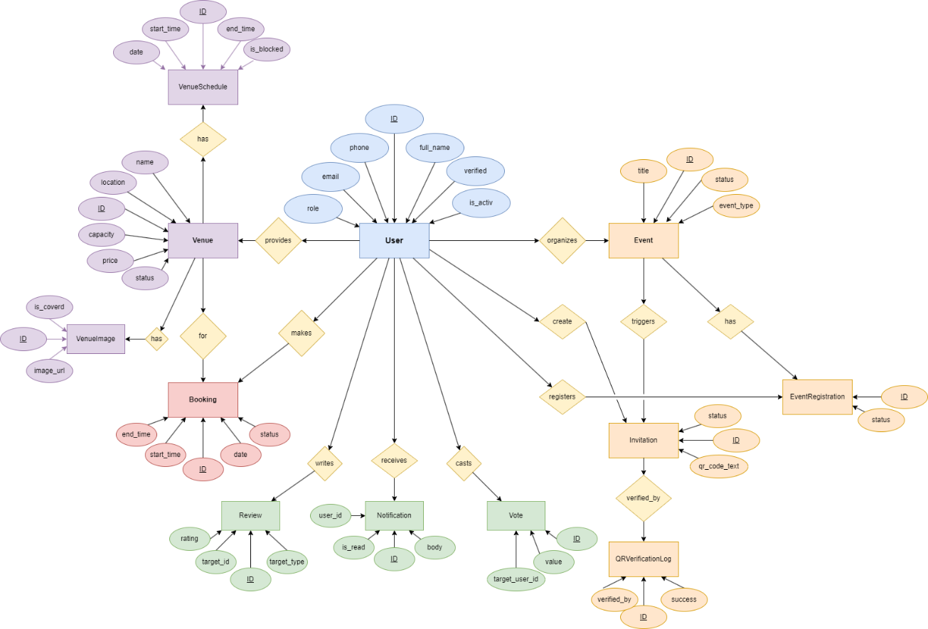

* **Class Diagram**

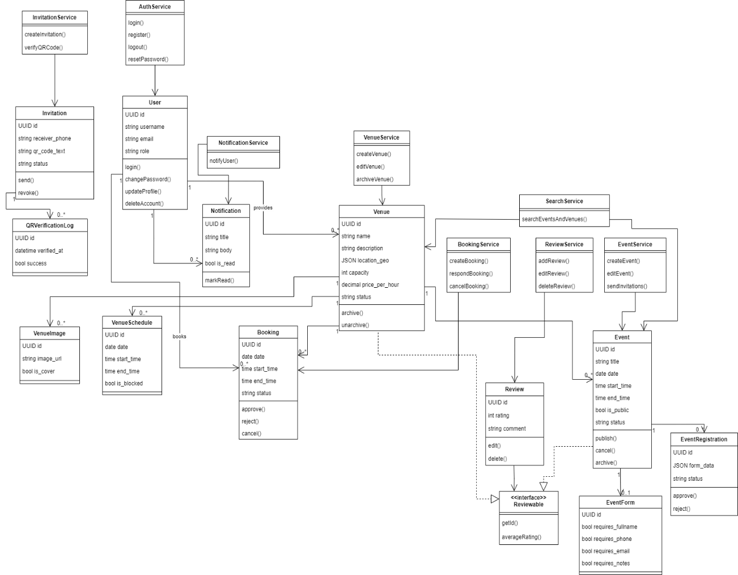

* **Component Diagram**

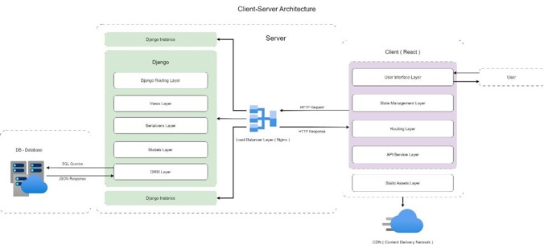

**3.Design Models (Physical Level)**

* **class Diagram**

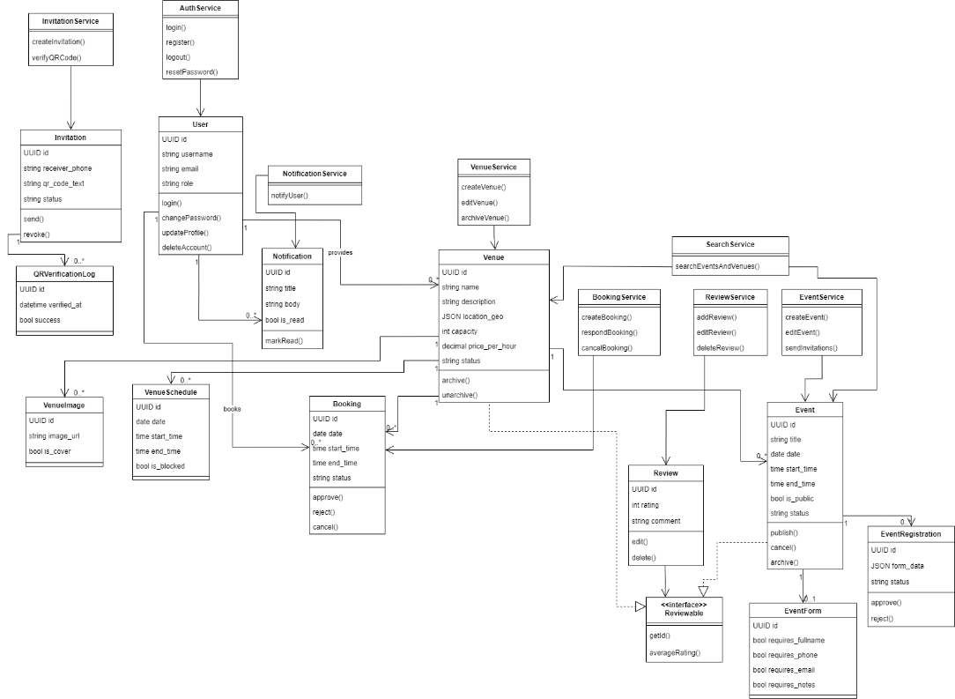

* **Infrastructure Considerations**

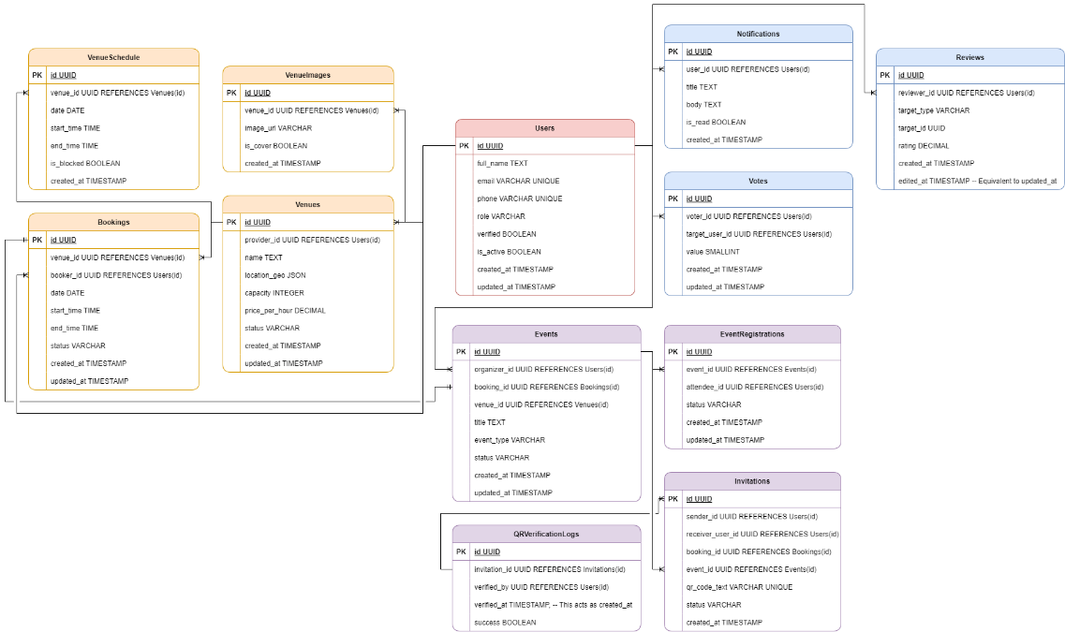

* **Physical Architecture Diagram**

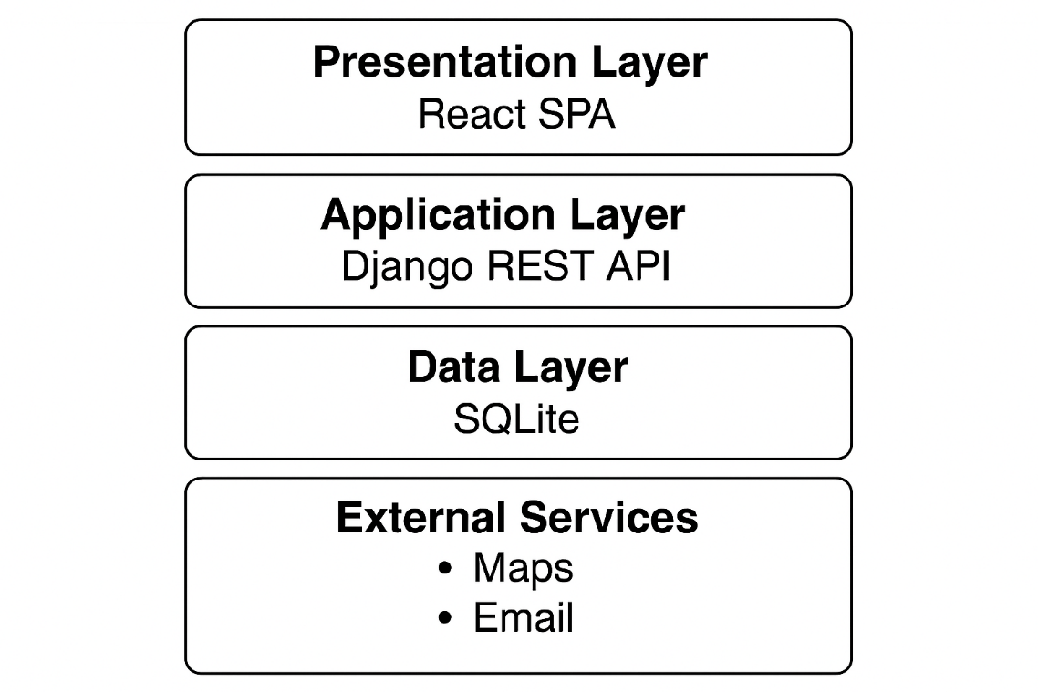

**4.Diagrams**

* **Road map**

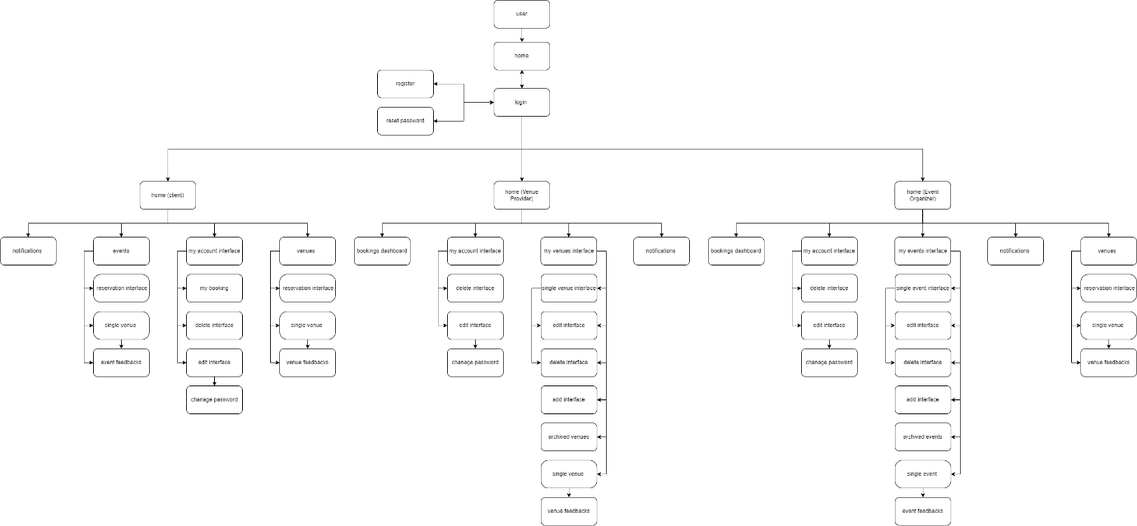

**5.Algorithms Used**

## **PBKDF2 (Password-Based Key Derivation Function 2)**

* **Core Idea:** A cryptographic algorithm that derives secure keys from user passwords using iterative hashing and a salt.
* **Usage:** Protects stored passwords by making brute-force and dictionary attacks computationally expensive.
* **Role in Recommendation Systems:** Ensures user account security and safe handling of authentication data.

## **NMF (Non-negative Matrix Factorization)**

* **Core Idea:** Decomposes a large user–item matrix into smaller non-negative matrices to reveal hidden patterns.
* **Usage:** Learns latent features that represent user preferences and item characteristics.
* **Role in Recommendation Systems:** Generates personalized recommendations by predicting missing values in the user–item matrix.

## **Pagination Algorithm (Page Number Pagination)**

* **Core Idea:** Splits large sets of results into smaller, numbered pages.
* **Usage:** Improves usability and system performance when displaying many recommendations.
* **Role in Recommendation Systems:** Organizes recommended items into manageable sections for better user experience.

## **Numerical Scoring Algorithm (Data Engineering)**

* **Core Idea:** Assigns numerical scores to items based on relevance, importance, or similarity to user preferences.
* **Usage:** Ranks items so the most suitable recommendations appear first.
* **Role in Recommendation Systems:** Provides the scoring backbone that determines which items are prioritized in the recommendation list.

**6.Updated Unit Testing**

**7.Updated Requirements Traceability Matrix**

### Table 4.888 Requirements Traceability Matrix

|  |  |  |  |  |  |  |
| --- | --- | --- | --- | --- | --- | --- |
| **Requirement ID** | **Requirement Name** | **Function Type** | **Design** | **Application Interface** | **Code** | **Test Case ID** |
| REQ-A01 | Login | [function](https://copilot.microsoft.com/chats/SxHDmbtPHdwnuNhCwJQty#function-req-a01) | [Login - activity diagram](https://copilot.microsoft.com/chats/SxHDmbtPHdwnuNhCwJQty#activity-diagram-req-a01) ; [Login - sequence diagram](https://copilot.microsoft.com/chats/SxHDmbtPHdwnuNhCwJQty#sequence-diagram-req-a01) | [user interfaces](https://copilot.microsoft.com/chats/SxHDmbtPHdwnuNhCwJQty#ui-req-a01) | [c1](https://copilot.microsoft.com/chats/SxHDmbtPHdwnuNhCwJQty#code-req-a01) | [initial test cases](https://copilot.microsoft.com/chats/SxHDmbtPHdwnuNhCwJQty#testcases-req-a01) |
| REQ-A02 | Logout | [function](https://copilot.microsoft.com/chats/SxHDmbtPHdwnuNhCwJQty#function-req-a02) | [Logout - activity diagram](https://copilot.microsoft.com/chats/SxHDmbtPHdwnuNhCwJQty#activity-diagram-req-a02) ; [Logout - sequence diagram](https://copilot.microsoft.com/chats/SxHDmbtPHdwnuNhCwJQty#sequence-diagram-req-a02) | [user interfaces](https://copilot.microsoft.com/chats/SxHDmbtPHdwnuNhCwJQty#ui-req-a02) | [c2](https://copilot.microsoft.com/chats/SxHDmbtPHdwnuNhCwJQty#code-req-a02) | [initial test cases](https://copilot.microsoft.com/chats/SxHDmbtPHdwnuNhCwJQty#testcases-req-a02) |
| REQ-A03 | Register (User Registration) | [function](https://copilot.microsoft.com/chats/SxHDmbtPHdwnuNhCwJQty#function-req-a03) | [Register (User Registration) - activity diagram](https://copilot.microsoft.com/chats/SxHDmbtPHdwnuNhCwJQty#activity-diagram-req-a03) ; [Register (User Registration) - sequence diagram](https://copilot.microsoft.com/chats/SxHDmbtPHdwnuNhCwJQty#sequence-diagram-req-a03) | [user interfaces](https://copilot.microsoft.com/chats/SxHDmbtPHdwnuNhCwJQty#ui-req-a03) | [c3](https://copilot.microsoft.com/chats/SxHDmbtPHdwnuNhCwJQty#code-req-a03) | [initial test cases](https://copilot.microsoft.com/chats/SxHDmbtPHdwnuNhCwJQty#testcases-req-a03) |
| REQ-A04 | View Venues | [function](https://copilot.microsoft.com/chats/SxHDmbtPHdwnuNhCwJQty#function-req-a04) | [View Venues - activity diagram](https://copilot.microsoft.com/chats/SxHDmbtPHdwnuNhCwJQty#activity-diagram-req-a04) ; [View Venues - sequence diagram](https://copilot.microsoft.com/chats/SxHDmbtPHdwnuNhCwJQty#sequence-diagram-req-a04) | [user interfaces](https://copilot.microsoft.com/chats/SxHDmbtPHdwnuNhCwJQty#ui-req-a04) | [c4](https://copilot.microsoft.com/chats/SxHDmbtPHdwnuNhCwJQty#code-req-a04) | [initial test cases](https://copilot.microsoft.com/chats/SxHDmbtPHdwnuNhCwJQty#testcases-req-a04) |
| REQ-A05 | View Venue Details | [function](https://copilot.microsoft.com/chats/SxHDmbtPHdwnuNhCwJQty#function-req-a05) | [View Venue Details - activity diagram](https://copilot.microsoft.com/chats/SxHDmbtPHdwnuNhCwJQty#activity-diagram-req-a05) ; [View Venue Details - sequence diagram](https://copilot.microsoft.com/chats/SxHDmbtPHdwnuNhCwJQty#sequence-diagram-req-a05) | [user interfaces](https://copilot.microsoft.com/chats/SxHDmbtPHdwnuNhCwJQty#ui-req-a05) | [c5](https://copilot.microsoft.com/chats/SxHDmbtPHdwnuNhCwJQty#code-req-a05) | [initial test cases](https://copilot.microsoft.com/chats/SxHDmbtPHdwnuNhCwJQty#testcases-req-a05) |
| REQ-A06 | View Bookings | [function](https://copilot.microsoft.com/chats/SxHDmbtPHdwnuNhCwJQty#function-req-a06) | [View Bookings - activity diagram](https://copilot.microsoft.com/chats/SxHDmbtPHdwnuNhCwJQty#activity-diagram-req-a06) ; [View Bookings - sequence diagram](https://copilot.microsoft.com/chats/SxHDmbtPHdwnuNhCwJQty#sequence-diagram-req-a06) | [user interfaces](https://copilot.microsoft.com/chats/SxHDmbtPHdwnuNhCwJQty#ui-req-a06) | [c6](https://copilot.microsoft.com/chats/SxHDmbtPHdwnuNhCwJQty#code-req-a06) | [initial test cases](https://copilot.microsoft.com/chats/SxHDmbtPHdwnuNhCwJQty#testcases-req-a06) |
| REQ-A07 | Add Booking | [function](https://copilot.microsoft.com/chats/SxHDmbtPHdwnuNhCwJQty#function-req-a07) | [Add Booking - activity diagram](https://copilot.microsoft.com/chats/SxHDmbtPHdwnuNhCwJQty#activity-diagram-req-a07) ; [Add Booking - sequence diagram](https://copilot.microsoft.com/chats/SxHDmbtPHdwnuNhCwJQty#sequence-diagram-req-a07) | [user interfaces](https://copilot.microsoft.com/chats/SxHDmbtPHdwnuNhCwJQty#ui-req-a07) | [c7](https://copilot.microsoft.com/chats/SxHDmbtPHdwnuNhCwJQty#code-req-a07) | [initial test cases](https://copilot.microsoft.com/chats/SxHDmbtPHdwnuNhCwJQty#testcases-req-a07) |
| REQ-A08 | Edit Booking | [function](https://copilot.microsoft.com/chats/SxHDmbtPHdwnuNhCwJQty#function-req-a08) | [Edit Booking - activity diagram](https://copilot.microsoft.com/chats/SxHDmbtPHdwnuNhCwJQty#activity-diagram-req-a08) ; [Edit Booking - sequence diagram](https://copilot.microsoft.com/chats/SxHDmbtPHdwnuNhCwJQty#sequence-diagram-req-a08) | [user interfaces](https://copilot.microsoft.com/chats/SxHDmbtPHdwnuNhCwJQty#ui-req-a08) | [c8](https://copilot.microsoft.com/chats/SxHDmbtPHdwnuNhCwJQty#code-req-a08) | [initial test cases](https://copilot.microsoft.com/chats/SxHDmbtPHdwnuNhCwJQty#testcases-req-a08) |
| REQ-A09 | Delete Booking | [function](https://copilot.microsoft.com/chats/SxHDmbtPHdwnuNhCwJQty#function-req-a09) | [Delete Booking - activity diagram](https://copilot.microsoft.com/chats/SxHDmbtPHdwnuNhCwJQty#activity-diagram-req-a09) ; [Delete Booking - sequence diagram](https://copilot.microsoft.com/chats/SxHDmbtPHdwnuNhCwJQty#sequence-diagram-req-a09) | [user interfaces](https://copilot.microsoft.com/chats/SxHDmbtPHdwnuNhCwJQty#ui-req-a09) | [c9](https://copilot.microsoft.com/chats/SxHDmbtPHdwnuNhCwJQty#code-req-a09) | [initial test cases](https://copilot.microsoft.com/chats/SxHDmbtPHdwnuNhCwJQty#testcases-req-a09) |
| REQ-A10 | View Events | [function](https://copilot.microsoft.com/chats/SxHDmbtPHdwnuNhCwJQty#function-req-a10) | [View Events - activity diagram](https://copilot.microsoft.com/chats/SxHDmbtPHdwnuNhCwJQty#activity-diagram-req-a10) ; [View Events - sequence diagram](https://copilot.microsoft.com/chats/SxHDmbtPHdwnuNhCwJQty#sequence-diagram-req-a10) | [user interfaces](https://copilot.microsoft.com/chats/SxHDmbtPHdwnuNhCwJQty#ui-req-a10) | [c10](https://copilot.microsoft.com/chats/SxHDmbtPHdwnuNhCwJQty#code-req-a10) | [initial test cases](https://copilot.microsoft.com/chats/SxHDmbtPHdwnuNhCwJQty#testcases-req-a10) |
| REQ-A11 | View Event Details | [function](https://copilot.microsoft.com/chats/SxHDmbtPHdwnuNhCwJQty#function-req-a11) | [View Event Details - activity diagram](https://copilot.microsoft.com/chats/SxHDmbtPHdwnuNhCwJQty#activity-diagram-req-a11) ; [View Event Details - sequence diagram](https://copilot.microsoft.com/chats/SxHDmbtPHdwnuNhCwJQty#sequence-diagram-req-a11) | [user interfaces](https://copilot.microsoft.com/chats/SxHDmbtPHdwnuNhCwJQty#ui-req-a11) | [c11](https://copilot.microsoft.com/chats/SxHDmbtPHdwnuNhCwJQty#code-req-a11) | [initial test cases](https://copilot.microsoft.com/chats/SxHDmbtPHdwnuNhCwJQty#testcases-req-a11) |
| REQ-A12 | Unified Search for Venues | [function](https://copilot.microsoft.com/chats/SxHDmbtPHdwnuNhCwJQty#function-req-a12) | [Unified Search for Venues - activity diagram](https://copilot.microsoft.com/chats/SxHDmbtPHdwnuNhCwJQty#activity-diagram-req-a12) ; [Unified Search for Venues - sequence diagram](https://copilot.microsoft.com/chats/SxHDmbtPHdwnuNhCwJQty#sequence-diagram-req-a12) | [user interfaces](https://copilot.microsoft.com/chats/SxHDmbtPHdwnuNhCwJQty#ui-req-a12) | [c12](https://copilot.microsoft.com/chats/SxHDmbtPHdwnuNhCwJQty#code-req-a12) | [initial test cases](https://copilot.microsoft.com/chats/SxHDmbtPHdwnuNhCwJQty#testcases-req-a12) |
| REQ-A13 | Unified Search for Events | [function](https://copilot.microsoft.com/chats/SxHDmbtPHdwnuNhCwJQty#function-req-a13) | [Unified Search for Events - activity diagram](https://copilot.microsoft.com/chats/SxHDmbtPHdwnuNhCwJQty#activity-diagram-req-a13) ; [Unified Search for Events - sequence diagram](https://copilot.microsoft.com/chats/SxHDmbtPHdwnuNhCwJQty#sequence-diagram-req-a13) | [user interfaces](https://copilot.microsoft.com/chats/SxHDmbtPHdwnuNhCwJQty#ui-req-a13) | [c13](https://copilot.microsoft.com/chats/SxHDmbtPHdwnuNhCwJQty#code-req-a13) | [initial test cases](https://copilot.microsoft.com/chats/SxHDmbtPHdwnuNhCwJQty#testcases-req-a13) |
| REQ-A14 | Filter Venues by Specific Criteria | [function](https://copilot.microsoft.com/chats/SxHDmbtPHdwnuNhCwJQty#function-req-a14) | [Filter Venues by Specific Criteria - activity diagram](https://copilot.microsoft.com/chats/SxHDmbtPHdwnuNhCwJQty#activity-diagram-req-a14) ; [Filter Venues by Specific Criteria - sequence diagram](https://copilot.microsoft.com/chats/SxHDmbtPHdwnuNhCwJQty#sequence-diagram-req-a14) | [user interfaces](https://copilot.microsoft.com/chats/SxHDmbtPHdwnuNhCwJQty#ui-req-a14) | [c14](https://copilot.microsoft.com/chats/SxHDmbtPHdwnuNhCwJQty#code-req-a14) | [initial test cases](https://copilot.microsoft.com/chats/SxHDmbtPHdwnuNhCwJQty#testcases-req-a14) |
| REQ-A15 | Filter Events by Specific Criteria | [function](https://copilot.microsoft.com/chats/SxHDmbtPHdwnuNhCwJQty#function-req-a15) | [Filter Events by Specific Criteria - activity diagram](https://copilot.microsoft.com/chats/SxHDmbtPHdwnuNhCwJQty#activity-diagram-req-a15) ; [Filter Events by Specific Criteria - sequence diagram](https://copilot.microsoft.com/chats/SxHDmbtPHdwnuNhCwJQty#sequence-diagram-req-a15) | [user interfaces](https://copilot.microsoft.com/chats/SxHDmbtPHdwnuNhCwJQty#ui-req-a15) | [c15](https://copilot.microsoft.com/chats/SxHDmbtPHdwnuNhCwJQty#code-req-a15) | [initial test cases](https://copilot.microsoft.com/chats/SxHDmbtPHdwnuNhCwJQty#testcases-req-a15) |
| REQ-A16 | View Registrations | [function](https://copilot.microsoft.com/chats/SxHDmbtPHdwnuNhCwJQty#function-req-a16) | [View Registrations - activity diagram](https://copilot.microsoft.com/chats/SxHDmbtPHdwnuNhCwJQty#activity-diagram-req-a16) ; [View Registrations - sequence diagram](https://copilot.microsoft.com/chats/SxHDmbtPHdwnuNhCwJQty#sequence-diagram-req-a16) | [user interfaces](https://copilot.microsoft.com/chats/SxHDmbtPHdwnuNhCwJQty#ui-req-a16) | [c16](https://copilot.microsoft.com/chats/SxHDmbtPHdwnuNhCwJQty#code-req-a16) | [initial test cases](https://copilot.microsoft.com/chats/SxHDmbtPHdwnuNhCwJQty#testcases-req-a16) |
| REQ-A17 | Add Registration | [function](https://copilot.microsoft.com/chats/SxHDmbtPHdwnuNhCwJQty#function-req-a17) | [Add Registration - activity diagram](https://copilot.microsoft.com/chats/SxHDmbtPHdwnuNhCwJQty#activity-diagram-req-a17) ; [Add Registration - sequence diagram](https://copilot.microsoft.com/chats/SxHDmbtPHdwnuNhCwJQty#sequence-diagram-req-a17) | [user interfaces](https://copilot.microsoft.com/chats/SxHDmbtPHdwnuNhCwJQty#ui-req-a17) | [c17](https://copilot.microsoft.com/chats/SxHDmbtPHdwnuNhCwJQty#code-req-a17) | [initial test cases](https://copilot.microsoft.com/chats/SxHDmbtPHdwnuNhCwJQty#testcases-req-a17) |
| REQ-A18 | Edit Registration | [function](https://copilot.microsoft.com/chats/SxHDmbtPHdwnuNhCwJQty#function-req-a18) | [Edit Registration - activity diagram](https://copilot.microsoft.com/chats/SxHDmbtPHdwnuNhCwJQty#activity-diagram-req-a18) ; [Edit Registration - sequence diagram](https://copilot.microsoft.com/chats/SxHDmbtPHdwnuNhCwJQty#sequence-diagram-req-a18) | [user interfaces](https://copilot.microsoft.com/chats/SxHDmbtPHdwnuNhCwJQty#ui-req-a18) | [c18](https://copilot.microsoft.com/chats/SxHDmbtPHdwnuNhCwJQty#code-req-a18) | [initial test cases](https://copilot.microsoft.com/chats/SxHDmbtPHdwnuNhCwJQty#testcases-req-a18) |
| REQ-A19 | Delete Registration | [function](https://copilot.microsoft.com/chats/SxHDmbtPHdwnuNhCwJQty#function-req-a19) | [Delete Registration - activity diagram](https://copilot.microsoft.com/chats/SxHDmbtPHdwnuNhCwJQty#activity-diagram-req-a19) ; [Delete Registration - sequence diagram](https://copilot.microsoft.com/chats/SxHDmbtPHdwnuNhCwJQty#sequence-diagram-req-a19) | [user interfaces](https://copilot.microsoft.com/chats/SxHDmbtPHdwnuNhCwJQty#ui-req-a19) | [c19](https://copilot.microsoft.com/chats/SxHDmbtPHdwnuNhCwJQty#code-req-a19) | [initial test cases](https://copilot.microsoft.com/chats/SxHDmbtPHdwnuNhCwJQty#testcases-req-a19) |
| REQ-A20 | View Venue Ratings | [function](https://copilot.microsoft.com/chats/SxHDmbtPHdwnuNhCwJQty#function-req-a20) | [View Venue Ratings - activity diagram](https://copilot.microsoft.com/chats/SxHDmbtPHdwnuNhCwJQty#activity-diagram-req-a20) ; [View Venue Ratings - sequence diagram](https://copilot.microsoft.com/chats/SxHDmbtPHdwnuNhCwJQty#sequence-diagram-req-a20) | [user interfaces](https://copilot.microsoft.com/chats/SxHDmbtPHdwnuNhCwJQty#ui-req-a20) | [c20](https://copilot.microsoft.com/chats/SxHDmbtPHdwnuNhCwJQty#code-req-a20) | [initial test cases](https://copilot.microsoft.com/chats/SxHDmbtPHdwnuNhCwJQty#testcases-req-a20) |
| REQ-A21 | Add Venue Rating | [function](https://copilot.microsoft.com/chats/SxHDmbtPHdwnuNhCwJQty#function-req-a21) | [Add Venue Rating - activity diagram](https://copilot.microsoft.com/chats/SxHDmbtPHdwnuNhCwJQty#activity-diagram-req-a21) ; [Add Venue Rating - sequence diagram](https://copilot.microsoft.com/chats/SxHDmbtPHdwnuNhCwJQty#sequence-diagram-req-a21) | [user interfaces](https://copilot.microsoft.com/chats/SxHDmbtPHdwnuNhCwJQty#ui-req-a21) | [c21](https://copilot.microsoft.com/chats/SxHDmbtPHdwnuNhCwJQty#code-req-a21) | [initial test cases](https://copilot.microsoft.com/chats/SxHDmbtPHdwnuNhCwJQty#testcases-req-a21) |
| REQ-A22 | Edit Venue Rating | [function](https://copilot.microsoft.com/chats/SxHDmbtPHdwnuNhCwJQty#function-req-a22) | [Edit Venue Rating - activity diagram](https://copilot.microsoft.com/chats/SxHDmbtPHdwnuNhCwJQty#activity-diagram-req-a22) ; [Edit Venue Rating - sequence diagram](https://copilot.microsoft.com/chats/SxHDmbtPHdwnuNhCwJQty#sequence-diagram-req-a22) | [user interfaces](https://copilot.microsoft.com/chats/SxHDmbtPHdwnuNhCwJQty#ui-req-a22) | [c22](https://copilot.microsoft.com/chats/SxHDmbtPHdwnuNhCwJQty#code-req-a22) | [initial test cases](https://copilot.microsoft.com/chats/SxHDmbtPHdwnuNhCwJQty#testcases-req-a22) |
| REQ-A23 | Delete Venue Rating | [function](https://copilot.microsoft.com/chats/SxHDmbtPHdwnuNhCwJQty#function-req-a23) | [Delete Venue Rating - activity diagram](https://copilot.microsoft.com/chats/SxHDmbtPHdwnuNhCwJQty#activity-diagram-req-a23) ; [Delete Venue Rating - sequence diagram](https://copilot.microsoft.com/chats/SxHDmbtPHdwnuNhCwJQty#sequence-diagram-req-a23) | [user interfaces](https://copilot.microsoft.com/chats/SxHDmbtPHdwnuNhCwJQty#ui-req-a23) | [c23](https://copilot.microsoft.com/chats/SxHDmbtPHdwnuNhCwJQty#code-req-a23) | [initial test cases](https://copilot.microsoft.com/chats/SxHDmbtPHdwnuNhCwJQty#testcases-req-a23) |
| REQ-A24 | View Event Ratings | [function](https://copilot.microsoft.com/chats/SxHDmbtPHdwnuNhCwJQty#function-req-a24) | [View Event Ratings - activity diagram](https://copilot.microsoft.com/chats/SxHDmbtPHdwnuNhCwJQty#activity-diagram-req-a24) ; [View Event Ratings - sequence diagram](https://copilot.microsoft.com/chats/SxHDmbtPHdwnuNhCwJQty#sequence-diagram-req-a24) | [user interfaces](https://copilot.microsoft.com/chats/SxHDmbtPHdwnuNhCwJQty#ui-req-a24) | [c24](https://copilot.microsoft.com/chats/SxHDmbtPHdwnuNhCwJQty#code-req-a24) | [initial test cases](https://copilot.microsoft.com/chats/SxHDmbtPHdwnuNhCwJQty#testcases-req-a24) |
| REQ-A25 | Add Event Rating | [function](https://copilot.microsoft.com/chats/SxHDmbtPHdwnuNhCwJQty#function-req-a25) | [Add Event Rating - activity diagram](https://copilot.microsoft.com/chats/SxHDmbtPHdwnuNhCwJQty#activity-diagram-req-a25) ; [Add Event Rating - sequence diagram](https://copilot.microsoft.com/chats/SxHDmbtPHdwnuNhCwJQty#sequence-diagram-req-a25) | [user interfaces](https://copilot.microsoft.com/chats/SxHDmbtPHdwnuNhCwJQty#ui-req-a25) | [c25](https://copilot.microsoft.com/chats/SxHDmbtPHdwnuNhCwJQty#code-req-a25) | [initial test cases](https://copilot.microsoft.com/chats/SxHDmbtPHdwnuNhCwJQty#testcases-req-a25) |
| REQ-A26 | Edit Event Rating | [function](https://copilot.microsoft.com/chats/SxHDmbtPHdwnuNhCwJQty#function-req-a26) | [Edit Event Rating - activity diagram](https://copilot.microsoft.com/chats/SxHDmbtPHdwnuNhCwJQty#activity-diagram-req-a26) ; [Edit Event Rating - sequence diagram](https://copilot.microsoft.com/chats/SxHDmbtPHdwnuNhCwJQty#sequence-diagram-req-a26) | [user interfaces](https://copilot.microsoft.com/chats/SxHDmbtPHdwnuNhCwJQty#ui-req-a26) | [c26](https://copilot.microsoft.com/chats/SxHDmbtPHdwnuNhCwJQty#code-req-a26) | [initial test cases](https://copilot.microsoft.com/chats/SxHDmbtPHdwnuNhCwJQty#testcases-req-a26) |
| REQ-A27 | Delete Event Rating | [function](https://copilot.microsoft.com/chats/SxHDmbtPHdwnuNhCwJQty#function-req-a27) | [Delete Event Rating - activity diagram](https://copilot.microsoft.com/chats/SxHDmbtPHdwnuNhCwJQty#activity-diagram-req-a27) ; [Delete Event Rating - sequence diagram](https://copilot.microsoft.com/chats/SxHDmbtPHdwnuNhCwJQty#sequence-diagram-req-a27) | [user interfaces](https://copilot.microsoft.com/chats/SxHDmbtPHdwnuNhCwJQty#ui-req-a27) | [c27](https://copilot.microsoft.com/chats/SxHDmbtPHdwnuNhCwJQty#code-req-a27) | [initial test cases](https://copilot.microsoft.com/chats/SxHDmbtPHdwnuNhCwJQty#testcases-req-a27) |
| REQ-A28 | View Organizers | [function](https://copilot.microsoft.com/chats/SxHDmbtPHdwnuNhCwJQty#function-req-a28) | [View Organizers - activity diagram](https://copilot.microsoft.com/chats/SxHDmbtPHdwnuNhCwJQty#activity-diagram-req-a28) ; [View Organizers - sequence diagram](https://copilot.microsoft.com/chats/SxHDmbtPHdwnuNhCwJQty#sequence-diagram-req-a28) | [user interfaces](https://copilot.microsoft.com/chats/SxHDmbtPHdwnuNhCwJQty#ui-req-a28) | [c28](https://copilot.microsoft.com/chats/SxHDmbtPHdwnuNhCwJQty#code-req-a28) | [initial test cases](https://copilot.microsoft.com/chats/SxHDmbtPHdwnuNhCwJQty#testcases-req-a28) |
| REQ-A29 | View Providers | [function](https://copilot.microsoft.com/chats/SxHDmbtPHdwnuNhCwJQty#function-req-a29) | [View Providers - activity diagram](https://copilot.microsoft.com/chats/SxHDmbtPHdwnuNhCwJQty#activity-diagram-req-a29) ; [View Providers - sequence diagram](https://copilot.microsoft.com/chats/SxHDmbtPHdwnuNhCwJQty#sequence-diagram-req-a29) | [user interfaces](https://copilot.microsoft.com/chats/SxHDmbtPHdwnuNhCwJQty#ui-req-a29) | [c29](https://copilot.microsoft.com/chats/SxHDmbtPHdwnuNhCwJQty#code-req-a29) | [initial test cases](https://copilot.microsoft.com/chats/SxHDmbtPHdwnuNhCwJQty#testcases-req-a29) |
| REQ-A30 | Filter Organizers by Specific Criteria | [function](https://copilot.microsoft.com/chats/SxHDmbtPHdwnuNhCwJQty#function-req-a30) | [Filter Organizers by Specific Criteria - activity diagram](https://copilot.microsoft.com/chats/SxHDmbtPHdwnuNhCwJQty#activity-diagram-req-a30) ; [Filter Organizers by Specific Criteria - sequence diagram](https://copilot.microsoft.com/chats/SxHDmbtPHdwnuNhCwJQty#sequence-diagram-req-a30) | [user interfaces](https://copilot.microsoft.com/chats/SxHDmbtPHdwnuNhCwJQty#ui-req-a30) | [c30](https://copilot.microsoft.com/chats/SxHDmbtPHdwnuNhCwJQty#code-req-a30) | [initial test cases](https://copilot.microsoft.com/chats/SxHDmbtPHdwnuNhCwJQty#testcases-req-a30) |
| REQ-A31 | Filter Providers by Specific Criteria | [function](https://copilot.microsoft.com/chats/SxHDmbtPHdwnuNhCwJQty#function-req-a31) | [Filter Providers by Specific Criteria - activity diagram](https://copilot.microsoft.com/chats/SxHDmbtPHdwnuNhCwJQty#activity-diagram-req-a31) ; [Filter Providers by Specific Criteria - sequence diagram](https://copilot.microsoft.com/chats/SxHDmbtPHdwnuNhCwJQty#sequence-diagram-req-a31) | [user interfaces](https://copilot.microsoft.com/chats/SxHDmbtPHdwnuNhCwJQty#ui-req-a31) | [c31](https://copilot.microsoft.com/chats/SxHDmbtPHdwnuNhCwJQty#code-req-a31) | [initial test cases](https://copilot.microsoft.com/chats/SxHDmbtPHdwnuNhCwJQty#testcases-req-a31) |
| REQ-A32 | Upvote | [function](https://copilot.microsoft.com/chats/SxHDmbtPHdwnuNhCwJQty#function-req-a32) | [Upvote - activity diagram](https://copilot.microsoft.com/chats/SxHDmbtPHdwnuNhCwJQty#activity-diagram-req-a32) ; [Upvote - sequence diagram](https://copilot.microsoft.com/chats/SxHDmbtPHdwnuNhCwJQty#sequence-diagram-req-a32) | [user interfaces](https://copilot.microsoft.com/chats/SxHDmbtPHdwnuNhCwJQty#ui-req-a32) | [c32](https://copilot.microsoft.com/chats/SxHDmbtPHdwnuNhCwJQty#code-req-a32) | [initial test cases](https://copilot.microsoft.com/chats/SxHDmbtPHdwnuNhCwJQty#testcases-req-a32) |
| REQ-A33 | Downvote | [function](https://copilot.microsoft.com/chats/SxHDmbtPHdwnuNhCwJQty#function-req-a33) | [Downvote - activity diagram](https://copilot.microsoft.com/chats/SxHDmbtPHdwnuNhCwJQty#activity-diagram-req-a33) ; [Downvote - sequence diagram](https://copilot.microsoft.com/chats/SxHDmbtPHdwnuNhCwJQty#sequence-diagram-req-a33) | [user interfaces](https://copilot.microsoft.com/chats/SxHDmbtPHdwnuNhCwJQty#ui-req-a33) | [c33](https://copilot.microsoft.com/chats/SxHDmbtPHdwnuNhCwJQty#code-req-a33) | [initial test cases](https://copilot.microsoft.com/chats/SxHDmbtPHdwnuNhCwJQty#testcases-req-a33) |
| REQ-A34 | View Recent Activities | [function](https://copilot.microsoft.com/chats/SxHDmbtPHdwnuNhCwJQty#function-req-a34) | [View Recent Activities - activity diagram](https://copilot.microsoft.com/chats/SxHDmbtPHdwnuNhCwJQty#activity-diagram-req-a34) ; [View Recent Activities - sequence diagram](https://copilot.microsoft.com/chats/SxHDmbtPHdwnuNhCwJQty#sequence-diagram-req-a34) | [user interfaces](https://copilot.microsoft.com/chats/SxHDmbtPHdwnuNhCwJQty#ui-req-a34) | [c34](https://copilot.microsoft.com/chats/SxHDmbtPHdwnuNhCwJQty#code-req-a34) | [initial test cases](https://copilot.microsoft.com/chats/SxHDmbtPHdwnuNhCwJQty#testcases-req-a34) |
| REQ-A35 | Display Map of Event and Venue Locations | [function](https://copilot.microsoft.com/chats/SxHDmbtPHdwnuNhCwJQty#function-req-a35) | [Display Map of Event and Venue Locations - activity diagram](https://copilot.microsoft.com/chats/SxHDmbtPHdwnuNhCwJQty#activity-diagram-req-a35) ; [Display Map of Event and Venue Locations - sequence diagram](https://copilot.microsoft.com/chats/SxHDmbtPHdwnuNhCwJQty#sequence-diagram-req-a35) | [user interfaces](https://copilot.microsoft.com/chats/SxHDmbtPHdwnuNhCwJQty#ui-req-a35) | [c35](https://copilot.microsoft.com/chats/SxHDmbtPHdwnuNhCwJQty#code-req-a35) | [initial test cases](https://copilot.microsoft.com/chats/SxHDmbtPHdwnuNhCwJQty#testcases-req-a35) |
| REQ-A36 | Browse Venues (Provider) | [function](https://copilot.microsoft.com/chats/SxHDmbtPHdwnuNhCwJQty#function-req-a36) | [Browse Venues (Provider) - activity diagram](https://copilot.microsoft.com/chats/SxHDmbtPHdwnuNhCwJQty#activity-diagram-req-a36) ; [Browse Venues (Provider) - sequence diagram](https://copilot.microsoft.com/chats/SxHDmbtPHdwnuNhCwJQty#sequence-diagram-req-a36) | [user interfaces](https://copilot.microsoft.com/chats/SxHDmbtPHdwnuNhCwJQty#ui-req-a36) | [c36](https://copilot.microsoft.com/chats/SxHDmbtPHdwnuNhCwJQty#code-req-a36) | [initial test cases](https://copilot.microsoft.com/chats/SxHDmbtPHdwnuNhCwJQty#testcases-req-a36) |
| REQ-A37 | Browse Archived Venues | [function](https://copilot.microsoft.com/chats/SxHDmbtPHdwnuNhCwJQty#function-req-a37) | [Browse Archived Venues - activity diagram](https://copilot.microsoft.com/chats/SxHDmbtPHdwnuNhCwJQty#activity-diagram-req-a37) ; [Browse Archived Venues - sequence diagram](https://copilot.microsoft.com/chats/SxHDmbtPHdwnuNhCwJQty#sequence-diagram-req-a37) | [user interfaces](https://copilot.microsoft.com/chats/SxHDmbtPHdwnuNhCwJQty#ui-req-a37) | [c37](https://copilot.microsoft.com/chats/SxHDmbtPHdwnuNhCwJQty#code-req-a37) | [initial test cases](https://copilot.microsoft.com/chats/SxHDmbtPHdwnuNhCwJQty#testcases-req-a37) |
| REQ-A38 | Add Venue | [function](https://copilot.microsoft.com/chats/SxHDmbtPHdwnuNhCwJQty#function-req-a38) | [Add Venue - activity diagram](https://copilot.microsoft.com/chats/SxHDmbtPHdwnuNhCwJQty#activity-diagram-req-a38) ; [Add Venue - sequence diagram](https://copilot.microsoft.com/chats/SxHDmbtPHdwnuNhCwJQty#sequence-diagram-req-a38) | [user interfaces](https://copilot.microsoft.com/chats/SxHDmbtPHdwnuNhCwJQty#ui-req-a38) | [c38](https://copilot.microsoft.com/chats/SxHDmbtPHdwnuNhCwJQty#code-req-a38) | [initial test cases](https://copilot.microsoft.com/chats/SxHDmbtPHdwnuNhCwJQty#testcases-req-a38) |
| REQ-A39 | Edit Venue | [function](https://copilot.microsoft.com/chats/SxHDmbtPHdwnuNhCwJQty#function-req-a39) | [Edit Venue - activity diagram](https://copilot.microsoft.com/chats/SxHDmbtPHdwnuNhCwJQty#activity-diagram-req-a39) ; [Edit Venue - sequence diagram](https://copilot.microsoft.com/chats/SxHDmbtPHdwnuNhCwJQty#sequence-diagram-req-a39) | [user interfaces](https://copilot.microsoft.com/chats/SxHDmbtPHdwnuNhCwJQty#ui-req-a39) | [c39](https://copilot.microsoft.com/chats/SxHDmbtPHdwnuNhCwJQty#code-req-a39) | [initial test cases](https://copilot.microsoft.com/chats/SxHDmbtPHdwnuNhCwJQty#testcases-req-a39) |
| REQ-A40 | Delete Venue | [function](https://copilot.microsoft.com/chats/SxHDmbtPHdwnuNhCwJQty#function-req-a40) | [Delete Venue - activity diagram](https://copilot.microsoft.com/chats/SxHDmbtPHdwnuNhCwJQty#activity-diagram-req-a40) ; [Delete Venue - sequence diagram](https://copilot.microsoft.com/chats/SxHDmbtPHdwnuNhCwJQty#sequence-diagram-req-a40) | [user interfaces](https://copilot.microsoft.com/chats/SxHDmbtPHdwnuNhCwJQty#ui-req-a40) | [c40](https://copilot.microsoft.com/chats/SxHDmbtPHdwnuNhCwJQty#code-req-a40) | [initial test cases](https://copilot.microsoft.com/chats/SxHDmbtPHdwnuNhCwJQty#testcases-req-a40) |
| REQ-A41 | Archive Venue | [function](https://copilot.microsoft.com/chats/SxHDmbtPHdwnuNhCwJQty#function-req-a41) | [Archive Venue - activity diagram](https://copilot.microsoft.com/chats/SxHDmbtPHdwnuNhCwJQty#activity-diagram-req-a41) ; [Archive Venue - sequence diagram](https://copilot.microsoft.com/chats/SxHDmbtPHdwnuNhCwJQty#sequence-diagram-req-a41) | [user interfaces](https://copilot.microsoft.com/chats/SxHDmbtPHdwnuNhCwJQty#ui-req-a41) | [c41](https://copilot.microsoft.com/chats/SxHDmbtPHdwnuNhCwJQty#code-req-a41) | [initial test cases](https://copilot.microsoft.com/chats/SxHDmbtPHdwnuNhCwJQty#testcases-req-a41) |
| REQ-A42 | Unarchive Venue | [function](https://copilot.microsoft.com/chats/SxHDmbtPHdwnuNhCwJQty#function-req-a42) | [Unarchive Venue - activity diagram](https://copilot.microsoft.com/chats/SxHDmbtPHdwnuNhCwJQty#activity-diagram-req-a42) ; [Unarchive Venue - sequence diagram](https://copilot.microsoft.com/chats/SxHDmbtPHdwnuNhCwJQty#sequence-diagram-req-a42) | [user interfaces](https://copilot.microsoft.com/chats/SxHDmbtPHdwnuNhCwJQty#ui-req-a42) | [c42](https://copilot.microsoft.com/chats/SxHDmbtPHdwnuNhCwJQty#code-req-a42) | [initial test cases](https://copilot.microsoft.com/chats/SxHDmbtPHdwnuNhCwJQty#testcases-req-a42) |
| REQ-A43 | Browse Bookings (Provider) | [function](https://copilot.microsoft.com/chats/SxHDmbtPHdwnuNhCwJQty#function-req-a43) | [Browse Bookings (Provider) - activity diagram](https://copilot.microsoft.com/chats/SxHDmbtPHdwnuNhCwJQty#activity-diagram-req-a43) ; [Browse Bookings (Provider) - sequence diagram](https://copilot.microsoft.com/chats/SxHDmbtPHdwnuNhCwJQty#sequence-diagram-req-a43) | [user interfaces](https://copilot.microsoft.com/chats/SxHDmbtPHdwnuNhCwJQty#ui-req-a43) | [c43](https://copilot.microsoft.com/chats/SxHDmbtPHdwnuNhCwJQty#code-req-a43) | [initial test cases](https://copilot.microsoft.com/chats/SxHDmbtPHdwnuNhCwJQty#testcases-req-a43) |
| REQ-A44 | Accept Booking (Provider) | [function](https://copilot.microsoft.com/chats/SxHDmbtPHdwnuNhCwJQty#function-req-a44) | [Accept Booking (Provider) - activity diagram](https://copilot.microsoft.com/chats/SxHDmbtPHdwnuNhCwJQty#activity-diagram-req-a44) ; [Accept Booking (Provider) - sequence diagram](https://copilot.microsoft.com/chats/SxHDmbtPHdwnuNhCwJQty#sequence-diagram-req-a44) | [user interfaces](https://copilot.microsoft.com/chats/SxHDmbtPHdwnuNhCwJQty#ui-req-a44) | [c44](https://copilot.microsoft.com/chats/SxHDmbtPHdwnuNhCwJQty#code-req-a44) | [initial test cases](https://copilot.microsoft.com/chats/SxHDmbtPHdwnuNhCwJQty#testcases-req-a44) |
| REQ-A45 | Reject Booking (Provider) | [function](https://copilot.microsoft.com/chats/SxHDmbtPHdwnuNhCwJQty#function-req-a45) | [Reject Booking (Provider) - activity diagram](https://copilot.microsoft.com/chats/SxHDmbtPHdwnuNhCwJQty#activity-diagram-req-a45) ; [Reject Booking (Provider) - sequence diagram](https://copilot.microsoft.com/chats/SxHDmbtPHdwnuNhCwJQty#sequence-diagram-req-a45) | [user interfaces](https://copilot.microsoft.com/chats/SxHDmbtPHdwnuNhCwJQty#ui-req-a45) | [c45](https://copilot.microsoft.com/chats/SxHDmbtPHdwnuNhCwJQty#code-req-a45) | [initial test cases](https://copilot.microsoft.com/chats/SxHDmbtPHdwnuNhCwJQty#testcases-req-a45) |
| REQ-A46 | Cancel Booking (Provider) | [function](https://copilot.microsoft.com/chats/SxHDmbtPHdwnuNhCwJQty#function-req-a46) | [Cancel Booking (Provider) - activity diagram](https://copilot.microsoft.com/chats/SxHDmbtPHdwnuNhCwJQty#activity-diagram-req-a46) ; [Cancel Booking (Provider) - sequence diagram](https://copilot.microsoft.com/chats/SxHDmbtPHdwnuNhCwJQty#sequence-diagram-req-a46) | [user interfaces](https://copilot.microsoft.com/chats/SxHDmbtPHdwnuNhCwJQty#ui-req-a46) | [c46](https://copilot.microsoft.com/chats/SxHDmbtPHdwnuNhCwJQty#code-req-a46) | [initial test cases](https://copilot.microsoft.com/chats/SxHDmbtPHdwnuNhCwJQty#testcases-req-a46) |
| REQ-A47 | Browse Events (Organizer) | [function](https://copilot.microsoft.com/chats/SxHDmbtPHdwnuNhCwJQty#function-req-a47) | [Browse Events (Organizer) - activity diagram](https://copilot.microsoft.com/chats/SxHDmbtPHdwnuNhCwJQty#activity-diagram-req-a47) ; [Browse Events (Organizer) - sequence diagram](https://copilot.microsoft.com/chats/SxHDmbtPHdwnuNhCwJQty#sequence-diagram-req-a47) | [user interfaces](https://copilot.microsoft.com/chats/SxHDmbtPHdwnuNhCwJQty#ui-req-a47) | [c47](https://copilot.microsoft.com/chats/SxHDmbtPHdwnuNhCwJQty#code-req-a47) | [initial test cases](https://copilot.microsoft.com/chats/SxHDmbtPHdwnuNhCwJQty#testcases-req-a47) |
| REQ-A48 | Browse Archived Events | [function](https://copilot.microsoft.com/chats/SxHDmbtPHdwnuNhCwJQty#function-req-a48) | [Browse Archived Events - activity diagram](https://copilot.microsoft.com/chats/SxHDmbtPHdwnuNhCwJQty#activity-diagram-req-a48) ; [Browse Archived Events - sequence diagram](https://copilot.microsoft.com/chats/SxHDmbtPHdwnuNhCwJQty#sequence-diagram-req-a48) | [user interfaces](https://copilot.microsoft.com/chats/SxHDmbtPHdwnuNhCwJQty#ui-req-a48) | [c48](https://copilot.microsoft.com/chats/SxHDmbtPHdwnuNhCwJQty#code-req-a48) | [initial test cases](https://copilot.microsoft.com/chats/SxHDmbtPHdwnuNhCwJQty#testcases-req-a48) |
| REQ-A49 | Create Event | [function](https://copilot.microsoft.com/chats/SxHDmbtPHdwnuNhCwJQty#function-req-a49) | [Create Event - activity diagram](https://copilot.microsoft.com/chats/SxHDmbtPHdwnuNhCwJQty#activity-diagram-req-a49) ; [Create Event - sequence diagram](https://copilot.microsoft.com/chats/SxHDmbtPHdwnuNhCwJQty#sequence-diagram-req-a49) | [user interfaces](https://copilot.microsoft.com/chats/SxHDmbtPHdwnuNhCwJQty#ui-req-a49) | [c49](https://copilot.microsoft.com/chats/SxHDmbtPHdwnuNhCwJQty#code-req-a49) | [initial test cases](https://copilot.microsoft.com/chats/SxHDmbtPHdwnuNhCwJQty#testcases-req-a49) |
| REQ-A50 | Edit Event | [function](https://copilot.microsoft.com/chats/SxHDmbtPHdwnuNhCwJQty#function-req-a50) | [Edit Event - activity diagram](https://copilot.microsoft.com/chats/SxHDmbtPHdwnuNhCwJQty#activity-diagram-req-a50) ; [Edit Event - sequence diagram](https://copilot.microsoft.com/chats/SxHDmbtPHdwnuNhCwJQty#sequence-diagram-req-a50) | [user interfaces](https://copilot.microsoft.com/chats/SxHDmbtPHdwnuNhCwJQty#ui-req-a50) | [c50](https://copilot.microsoft.com/chats/SxHDmbtPHdwnuNhCwJQty#code-req-a50) | [initial test cases](https://copilot.microsoft.com/chats/SxHDmbtPHdwnuNhCwJQty#testcases-req-a50) |
| REQ-A51 | Delete Event | [function](https://copilot.microsoft.com/chats/SxHDmbtPHdwnuNhCwJQty#function-req-a51) | [Delete Event - activity diagram](https://copilot.microsoft.com/chats/SxHDmbtPHdwnuNhCwJQty#activity-diagram-req-a51) ; [Delete Event - sequence diagram](https://copilot.microsoft.com/chats/SxHDmbtPHdwnuNhCwJQty#sequence-diagram-req-a51) | [user interfaces](https://copilot.microsoft.com/chats/SxHDmbtPHdwnuNhCwJQty#ui-req-a51) | [c51](https://copilot.microsoft.com/chats/SxHDmbtPHdwnuNhCwJQty#code-req-a51) | [initial test cases](https://copilot.microsoft.com/chats/SxHDmbtPHdwnuNhCwJQty#testcases-req-a51) |
| REQ-A52 | Archive Event | [function](https://copilot.microsoft.com/chats/SxHDmbtPHdwnuNhCwJQty#function-req-a52) | [Archive Event - activity diagram](https://copilot.microsoft.com/chats/SxHDmbtPHdwnuNhCwJQty#activity-diagram-req-a52) ; [Archive Event - sequence diagram](https://copilot.microsoft.com/chats/SxHDmbtPHdwnuNhCwJQty#sequence-diagram-req-a52) | [user interfaces](https://copilot.microsoft.com/chats/SxHDmbtPHdwnuNhCwJQty#ui-req-a52) | [c52](https://copilot.microsoft.com/chats/SxHDmbtPHdwnuNhCwJQty#code-req-a52) | [initial test cases](https://copilot.microsoft.com/chats/SxHDmbtPHdwnuNhCwJQty#testcases-req-a52) |
| REQ-A53 | Unarchive Event | [function](https://copilot.microsoft.com/chats/SxHDmbtPHdwnuNhCwJQty#function-req-a53) | [Unarchive Event - activity diagram](https://copilot.microsoft.com/chats/SxHDmbtPHdwnuNhCwJQty#activity-diagram-req-a53) ; [Unarchive Event - sequence diagram](https://copilot.microsoft.com/chats/SxHDmbtPHdwnuNhCwJQty#sequence-diagram-req-a53) | [user interfaces](https://copilot.microsoft.com/chats/SxHDmbtPHdwnuNhCwJQty#ui-req-a53) | [c53](https://copilot.microsoft.com/chats/SxHDmbtPHdwnuNhCwJQty#code-req-a53) | [initial test cases](https://copilot.microsoft.com/chats/SxHDmbtPHdwnuNhCwJQty#testcases-req-a53) |
| REQ-A54 | Browse Registrations (Organizer) | [function](https://copilot.microsoft.com/chats/SxHDmbtPHdwnuNhCwJQty#function-req-a54) | [Browse Registrations (Organizer) - activity diagram](https://copilot.microsoft.com/chats/SxHDmbtPHdwnuNhCwJQty#activity-diagram-req-a54) ; [Browse Registrations (Organizer) - sequence diagram](https://copilot.microsoft.com/chats/SxHDmbtPHdwnuNhCwJQty#sequence-diagram-req-a54) | [user interfaces](https://copilot.microsoft.com/chats/SxHDmbtPHdwnuNhCwJQty#ui-req-a54) | [c54](https://copilot.microsoft.com/chats/SxHDmbtPHdwnuNhCwJQty#code-req-a54) | [initial test cases](https://copilot.microsoft.com/chats/SxHDmbtPHdwnuNhCwJQty#testcases-req-a54) |
| REQ-A55 | Accept Registration | [function](https://copilot.microsoft.com/chats/SxHDmbtPHdwnuNhCwJQty#function-req-a55) | [Accept Registration - activity diagram](https://copilot.microsoft.com/chats/SxHDmbtPHdwnuNhCwJQty#activity-diagram-req-a55) ; [Accept Registration - sequence diagram](https://copilot.microsoft.com/chats/SxHDmbtPHdwnuNhCwJQty#sequence-diagram-req-a55) | [user interfaces](https://copilot.microsoft.com/chats/SxHDmbtPHdwnuNhCwJQty#ui-req-a55) | [c55](https://copilot.microsoft.com/chats/SxHDmbtPHdwnuNhCwJQty#code-req-a55) | [initial test cases](https://copilot.microsoft.com/chats/SxHDmbtPHdwnuNhCwJQty#testcases-req-a55) |
| REQ-A56 | Reject Registration | [function](https://copilot.microsoft.com/chats/SxHDmbtPHdwnuNhCwJQty#function-req-a56) | [Reject Registration - activity diagram](https://copilot.microsoft.com/chats/SxHDmbtPHdwnuNhCwJQty#activity-diagram-req-a56) ; [Reject Registration - sequence diagram](https://copilot.microsoft.com/chats/SxHDmbtPHdwnuNhCwJQty#sequence-diagram-req-a56) | [user interfaces](https://copilot.microsoft.com/chats/SxHDmbtPHdwnuNhCwJQty#ui-req-a56) | [c56](https://copilot.microsoft.com/chats/SxHDmbtPHdwnuNhCwJQty#code-req-a56) | [initial test cases](https://copilot.microsoft.com/chats/SxHDmbtPHdwnuNhCwJQty#testcases-req-a56) |
| REQ-A57 | Cancel Registration | [function](https://copilot.microsoft.com/chats/SxHDmbtPHdwnuNhCwJQty#function-req-a57) | [Cancel Registration - activity diagram](https://copilot.microsoft.com/chats/SxHDmbtPHdwnuNhCwJQty#activity-diagram-req-a57) ; [Cancel Registration - sequence diagram](https://copilot.microsoft.com/chats/SxHDmbtPHdwnuNhCwJQty#sequence-diagram-req-a57) | [user interfaces](https://copilot.microsoft.com/chats/SxHDmbtPHdwnuNhCwJQty#ui-req-a57) | [c57](https://copilot.microsoft.com/chats/SxHDmbtPHdwnuNhCwJQty#code-req-a57) | [initial test cases](https://copilot.microsoft.com/chats/SxHDmbtPHdwnuNhCwJQty#testcases-req-a57) |
| REQ-A58 | Export Registrations as Excel file | [function](https://copilot.microsoft.com/chats/SxHDmbtPHdwnuNhCwJQty#function-req-a58) | [Export Registrations as Excel file - activity diagram](https://copilot.microsoft.com/chats/SxHDmbtPHdwnuNhCwJQty#activity-diagram-req-a58) ; [Export Registrations as Excel file - sequence diagram](https://copilot.microsoft.com/chats/SxHDmbtPHdwnuNhCwJQty#sequence-diagram-req-a58) | [user interfaces](https://copilot.microsoft.com/chats/SxHDmbtPHdwnuNhCwJQty#ui-req-a58) | [c58](https://copilot.microsoft.com/chats/SxHDmbtPHdwnuNhCwJQty#code-req-a58) | [initial test cases](https://copilot.microsoft.com/chats/SxHDmbtPHdwnuNhCwJQty#testcases-req-a58) |
| REQ-A59 | View Booking (Organizer) | [function](https://copilot.microsoft.com/chats/SxHDmbtPHdwnuNhCwJQty#function-req-a59) | [View Booking (Organizer) - activity diagram](https://copilot.microsoft.com/chats/SxHDmbtPHdwnuNhCwJQty#activity-diagram-req-a59) ; [View Booking (Organizer) - sequence diagram](https://copilot.microsoft.com/chats/SxHDmbtPHdwnuNhCwJQty#sequence-diagram-req-a59) | [user interfaces](https://copilot.microsoft.com/chats/SxHDmbtPHdwnuNhCwJQty#ui-req-a59) | [c59](https://copilot.microsoft.com/chats/SxHDmbtPHdwnuNhCwJQty#code-req-a59) | [initial test cases](https://copilot.microsoft.com/chats/SxHDmbtPHdwnuNhCwJQty#testcases-req-a59) |
| REQ-A60 | Add Booking (Organizer) | [function](https://copilot.microsoft.com/chats/SxHDmbtPHdwnuNhCwJQty#function-req-a60) | [Add Booking (Organizer) - activity diagram](https://copilot.microsoft.com/chats/SxHDmbtPHdwnuNhCwJQty#activity-diagram-req-a60) ; [Add Booking (Organizer) - sequence diagram](https://copilot.microsoft.com/chats/SxHDmbtPHdwnuNhCwJQty#sequence-diagram-req-a60) | [user interfaces](https://copilot.microsoft.com/chats/SxHDmbtPHdwnuNhCwJQty#ui-req-a60) | [c60 للخانة الستون](https://copilot.microsoft.com/chats/SxHDmbtPHdwnuNhCwJQty#code-req-a60) | [initial test cases](https://copilot.microsoft.com/chats/SxHDmbtPHdwnuNhCwJQty#testcases-req-a60) |
| REQ-A61 | Edit Booking (Organizer) | [function](https://copilot.microsoft.com/chats/SxHDmbtPHdwnuNhCwJQty#function-req-a61) | [Edit Booking (Organizer) - activity diagram](https://copilot.microsoft.com/chats/SxHDmbtPHdwnuNhCwJQty#activity-diagram-req-a61) ; [Edit Booking (Organizer) - sequence diagram](https://copilot.microsoft.com/chats/SxHDmbtPHdwnuNhCwJQty#sequence-diagram-req-a61) | [user interfaces](https://copilot.microsoft.com/chats/SxHDmbtPHdwnuNhCwJQty#ui-req-a61) | [c61 للخانة الحادية والستون](https://copilot.microsoft.com/chats/SxHDmbtPHdwnuNhCwJQty#code-req-a61) | [initial test cases](https://copilot.microsoft.com/chats/SxHDmbtPHdwnuNhCwJQty#testcases-req-a61) |
| REQ-A62 | Delete Booking (Organizer) | [function](https://copilot.microsoft.com/chats/SxHDmbtPHdwnuNhCwJQty#function-req-a62) | [Delete Booking (Organizer) - activity diagram](https://copilot.microsoft.com/chats/SxHDmbtPHdwnuNhCwJQty#activity-diagram-req-a62) ; [Delete Booking (Organizer) - sequence diagram](https://copilot.microsoft.com/chats/SxHDmbtPHdwnuNhCwJQty#sequence-diagram-req-a62) | [user interfaces](https://copilot.microsoft.com/chats/SxHDmbtPHdwnuNhCwJQty#ui-req-a62) | [c62 للخانة الثانية والستون](https://copilot.microsoft.com/chats/SxHDmbtPHdwnuNhCwJQty#code-req-a62) | [initial test cases](https://copilot.microsoft.com/chats/SxHDmbtPHdwnuNhCwJQty#testcases-req-a62) |

**8.Conclusion**

In this chapter, we moved from the general execution plan into the **detailed design phase**, where the documented requirements were translated into clear technical models. We began with an introduction outlining the chapter’s objectives, followed by a presentation of **logical design models** such as the database schema, class diagram, and component diagram, which illustrate the relationships between entities and the system’s core functionalities. We then explored the **physical design models**, which demonstrate how the system will be deployed and operated on the proposed infrastructure.

We also presented **interface diagrams**, including the page tree and user interaction flows, which help clarify the expected user experience. Next, we reviewed the **algorithms used** for data processing and critical operations, highlighting how efficiency and accuracy are ensured.

In addition, we updated the **test plan** to include both unit tests and integration tests, and revised the **requirements traceability matrix** to ensure that every required function is covered by appropriate testing.

This chapter serves as a bridge between theoretical requirements and the practical execution plan, providing a **technically implementable design** that aligns with the project timeline and testing strategy. The following chapters will move into **detailed design and practical implementation**, ensuring that these models are transformed into a working system that meets the defined objectives.

**Chapter Six**

**Practical application**

**1. introduction**

In this chapter, we will move from the planning and design phase to the practical implementation phase of the proposed system. Practical implementation is a crucial step in realizing the project vision and transforming the theoretical designs into a tangible reality that users can interact with and benefit from. In this chapter, we will explain the tools and techniques used in system development, review some prototypes, and conduct the necessary tests to ensure the system's quality and effectiveness. Additionally, we will update the requirements traceability matrix and analyze the results obtained, with the aim of improving the system and ensuring its compliance with the specified requirements. This chapter reflects the efforts made to transform ideas into an efficient, functional system that achieves the desired objectives.

**2. Tools used**

To achieve the objectives of this project, a set of tools and techniques were used to contribute to the efficient and effective development and implementation of the system. The tools used in this project include:

* **Python**

It is considered Python is one of the most popular programming languages ​​due to its simplicity and power. It has been chosen for developing large parts of the system due to its flexibility and wide support for various libraries and frameworks.

* **Django**

Django is a high-level Python framework that helps build web applications quickly and securely. Django is based on the MVT (Model-View-Template) architectural pattern, which provides good code organization and simplifies the development process.

* **SQLite**

SQLite is a lightweight, embedded database management system that doesn't require a separate database server setup. It's chosen for data storage and management due to its ease of use and fast performance, making it suitable for small and medium-sized projects.

* **Vs code**

Visual Studio Code is an open-source text editor that supports multiple programming languages ​​and comes with features like autocompletion and instant debugging. It's used for developing and writing code.

* **CSS/html/java script**

**3. Miniatures:**

**4. Test Execution**

**5. Updating the Requirements Traceability Matrix**

**6. Results Analysis**

**7. Conclusion**

In this chapter, we discussed the practical application of the proposed system, where we reviewed the tools and techniques used in developing the system, such as the programming language Python, the Django framework, the SQLite database, and other supporting tools. We've provided mockups of user interfaces to illustrate how users interact with the system.

**Chapter Seven**

**Conclusions and future prospects**

**1.introduction**

The **Event Management and Organization** project aims to provide an integrated online platform that facilitates event organization through dedicated interfaces for clients, venue providers, and event organizers, with booking, management, and basic reporting features. During the project period, a functional version of the application was developed including the three user interfaces, a preliminary booking flow, an administrative dashboard, and core REST APIs. These outcomes meet the primary objective of digitizing event organization and improving stakeholder experience. The system is ready for final testing and delivery with basic documentation and an initial test

### **2.Key Achievements — System Framework Considered**

* **Core interface development:** Implemented dedicated interfaces for the Client, Venue Provider, and Event Organizer as a **React SPA**, including authentication and account management.
* **Client‑server model:** The system was designed using a **client‑server** architecture where the React frontend communicates with the backend via a **Django REST API** using **JSON over HTTPS**, ensuring separation of the UI from backend logic.
* **Booking and management system:** Implemented a preliminary booking workflow with availability checks and booking management by venue providers, with integration performed through secure API calls.
* **Backend and APIs:** Designed a functional database schema and developed core REST APIs for CRUD operations and integration between interfaces, with a clear separation of external services to simplify maintenance and iterative development.
* **Documentation and testing:** Prepared a brief user guide, unit and integration test cases, and executed initial tests to verify core functionality and the integrity of communications between the SPA and the APIs.

### **3.Lessons Learned (Adapted to the Project)**

* **Incremental documentation as an operational necessity:** Adopting continuous documentation for each design and development phase, technical decisions, and operational procedures made task handover easier during absences and reduced single‑person dependency during the implementation of the event management platform.
* **Strict scope control:** Defining clear requirements and a formal change‑management process enabled us to defer or reject non‑essential requests, preserving the schedule and delivery quality.
* **Careful selection of third‑party integrations:** Before relying on any external service, we evaluated alternatives and created mock interfaces for testing, which reduced the risk of service outages or unexpected operating costs.
* **Regular communication and effective coordination:** Weekly review meetings and early supervisor reviews improved early defect detection, accelerated problem resolution, and strengthened collaboration between frontend and backend developers.

### **4.Constraints and Issues Encountered (Adapted to the Project)**

* **Scope and implementation limits:** Some items were excluded from the final delivery, such as on‑site logistics and equipment management, to keep the scope focused on a digital solution and ensure the platform could be developed, tested, and deployed within available resources.
* **Technical and operational challenges:** We faced issues related to reliance on third‑party services (e.g., payment gateways or test hosting providers), incomplete test coverage due to limited time and testing environments, and budget constraints that restricted broader testing and advanced integrations.
* **Impact on deliverables and schedule:** These constraints led to postponing certain secondary features to later phases, narrowing the initial scope of integrations, and allocating buffer time for integration testing. As a result, the team concentrated on delivering a stable, extensible core rather than a fully comprehensive solution at launch.

### **5.Future prospects and recommendations**

* **Expand integrations and operational flexibility:** Integrate multiple payment gateways, connect the system with supplier management systems and external platforms via reliable APIs, and provide a flexible integration layer that allows adding new providers without major architectural changes.
* **Migrate to a robust server database:** Adopt **PostgreSQL** as the production database instead of SQLite to improve performance, concurrency, and reliability. This includes planning the migration, setting up staging environments for testing the migration, using appropriate migration tools, and configuring secure connections and credentials.
* **Enhance security and operational reliability:** Perform advanced security testing (penetration tests, vulnerability scans), apply end‑to‑end data encryption in transit and at rest, and implement a mature CI/CD pipeline with stable **staging** and **production** environments and monitored deployment processes.
* **Add intelligent and analytical features:** Incorporate usage analytics to track user behavior, develop a recommendation engine for venues based on preferences and booking history, and add rating and review mechanisms to improve user experience and enable data‑driven decisions.
* **Sustainable business and operational plan:** Prepare a study of revenue models (subscriptions, commissions, premium services), build strategic partnerships with venue providers and service vendors, and establish a post‑launch support and maintenance plan with clear service levels and a regular update schedule.

### **6.Conclusion**

The project delivered a functional core of an **Event Management** platform that meets the primary objectives of digitizing booking and management processes and providing tailored interfaces for key users. The system was designed using a client‑server model, where a **React SPA** communicates with a **Django REST API** over JSON and HTTPS, enabling separation of the UI from backend logic and facilitating maintainable, iterative development.

Despite time and budget constraints and the exclusion of some on‑site aspects, the team succeeded in building a stable and extensible foundation, with incremental documentation, initial testing, and a basic development pipeline. The planned migration to **PostgreSQL**, together with the proposed security and CI/CD improvements, will enhance reliability and performance when moving to production.

In the next phase, it is recommended to prioritize executing the PostgreSQL migration plan, expanding core integrations such as payment gateways and supplier management systems, and strengthening security testing and operational monitoring. By focusing on these priorities, the platform can be transformed into a production‑ready, commercially viable solution that serves event organizers, venue providers, and clients with greater efficiency and stability.

**2.Conclusions**

Through the analysis and implementation of the project, a set of main conclusions were reached that reflect the success of the system and the achievement of its objectives.:

1. Achieving Objectives: The electronic event management system has proven effective in facilitating the process of finding suitable venues and organizing events efficiently. The system has been able to meet the diverse needs of users by providing an easy-to-use interface and the ability to customize services to suit each user's requirements.

2. Improving the user experience: The user experience was significantly improved through the design of an intuitive and user-friendly user interface. User feedback was positive, noting the ease of accessing the information and services required quickly and accurately.

3. System Integration: The system demonstrated a high ability to integrate with other external systems, expanding its capabilities and enabling additional services. Users were able to benefit from a wide range of services and data provided by external systems, increasing the system's value to them.

4. Budget Management: The system provided powerful budget management and expense tracking tools, helping users control event costs and stay within budget. These tools were particularly useful for users who needed to organize large, complex events.

.5 User Satisfaction: User feedback was generally positive, with users expressing satisfaction with the system and the services it provides. This satisfaction reflects the significant success achieved in developing the system and meeting user needs.

**3.Future prospects**

To keep up with the ever-changing events market and achieve user satisfaction, there are some future directions that can be considered to improve and develop the system.:

**1. Add new features:** Can Adding new features such as group booking support, managing large and complex events, and providing more detailed analytical reports will help attract more users and meet their diverse needs.

**2. Improving security:** Enhancing system security and protecting user data by implementing advanced security standards and using modern encryption technologies. Security is a vital component of ensuring user confidence in the system.

**3. Multiple Language Support:** Expanding the system to support multiple languages ​​to meet the needs of users of different nationalities and cultures. This will expand the potential user base and promote the system's global reach.

**4. Social media integration:** Enable users to share event details and invitations via social media to increase exposure and reach a wider audience. This will help enhance communication between users and encourage them to use the system more.

**5. Mobile Application Development:** Develop mobile applications for iOS and Android systems to provide easy and seamless access to the system through smartphones and tablets. This will increase the system's usability and provide a convenient experience for users on the go.

**6. Data Analysis and Performance Improvement:** Using advanced analytics techniques to analyze data collected from system usage and detect patterns and trends. These analyses can help improve system performance and provide personalized services to each user based on their data and preferences.

**7. Expanding the user base**: Determine effective marketing strategies to increase the user base and encourage more individuals and organizations to use the system to organize their events.

**4.Conclusion**

This chapter reviews the key findings that reflect the system's success and achievement of its objectives. It also discusses the project's future prospects and ways to improve and develop it. By adhering to these future directions, the system can remain flexible and able to meet users' growing needs and provide an excellent and integrated user experience. Achieving these goals will contribute to the project's continued success and make it more attractive and effective for future users.

**the reviewer**

• Official Django website: For information about the Django framework and how to use it to build applications

link:

https://docs.djangoproject.com/

• Official Python website: For information about the Python programming language and its various libraries

link:

https://www.python.org/doc/

•Official SQLite website: For information about the database management system

link:

SQLite https://sqlite.org/docs.html